Liturgical Colors
The Church year consists of six liturgical seasons: Advent, Christmas, Ordinary Time after Epiphany, Lent, Easter, and Ordinary Time after Pentecost.

Just as certain types of clothes are worn during certain times of the year (i.e. summer and winter), the vestments worn by the priest at mass signifies meaning associated with the various seasons of the liturgical calendar. Have you ever been at Mass and wondered why a certain color vestment is being worn? Or why the altar is decorated in green, white, red, or purple? This is not a random choice but is a uniform system to create uniformity, structure, and movement through the liturgical calendar.
Liturgies celebrated during the different seasons of the liturgical year have distinctive music and specific readings, prayers, and rituals. All of these elements work together to reflect the spirit of the particular season. The colors of the vestments that the priest wears during the liturgy also help express the character of the mysteries being celebrated. These colors may also be used in linens and cloths which adorn the altar and ambo. Color communicates emotional and spiritual realities to the worshipping community. Liturgical color is more than simply decorative; rather it helps to express the changing seasonal moods which symbolize the shifting mood of the assembly gathered together to worship. Liturgical color helps to symbolize the deeper realities we celebrate and help us to worship in the spirit of the season. (Archdiocese of Boston)

________________ – Used in ordinary time. Green signifies new growth and life.

________________ – Special occasions, weddings, Christmas, Easter and major feasts. It is a symbol of purity, light, rejoicing, and of the resurrection, and is used on all special feasts of Our Lord.

________________ – Mass celebrating the Holy Spirit (fire) or martyrdom (blood)

________________ – Seasons of Lent and Advent and often at funerals. It is also associated with penance.

________________ - Used in offices for the dead, and on Good Friday ONLY.

________________ - Used on the third Sunday of Advent known as Gaudete Sunday

____________________
____________________
____________________
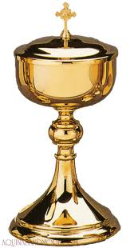
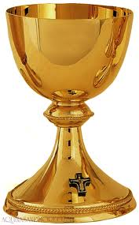
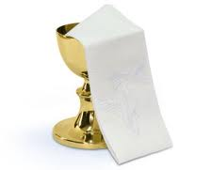

____________________
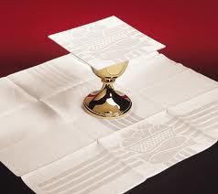

____________________

____________________

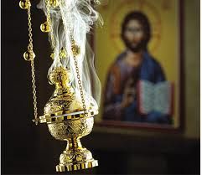

____________________

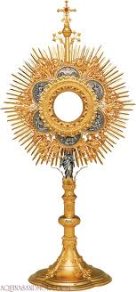

____________________
Before vesting for the liturgy, the priest first washes his hands and says: Give virtue to my hands, O Lord, that being cleansed from all stain I might serve you with purity of mind and body.

Amice ~ An amice is worn under the alb to cover other clothes. It is a white cloth with two long ribbon-like attachments to fasten around the shoulders of the priest.
Place upon me, O Lord, the helmet of salvation, that I may overcome the assaults of the devil.

Alb ~ a liturgical robe of white linen coming down to the ankles and usually tied with a cincture. It is simply the long linen tunic used by the Romans of old. It is the oldest liturgical vestment. (symbol of purity)
Purify me, O Lord, and cleanse my heart; that,
being made white in the Blood of the Lamb, I may come to eternal joy

Cincture ~ a belt or sash, especially one worn with an ecclesiastical vestment or the habit of a monk or nun.

• Stole ~ over the alb the priest wears a long, narrow garment, called the stole, draped around the neck and hanging down in front of the wearer. This can be one of four colors depending on the time in the Church Year.

• Chasuble ~ worn over the alb and stole by the priest. It is a circular garment with a hole in the center for the head. This can be one of four colors, depending on the time in the Church Year.

• Roman Collar ~ a stiff white collar worn by a priest; a distinctive symbol of the clergy

• Dalmatic ~ wide-sleeved garment worn over the alb by a deacon.

• Mitre ~ the hat of a Bishop

• Zucchetto ~ the skullcap worn by a Bishop or Pope. The Pope’s zucchetto is white. The Bishop’s zucchetto is red.
