Saint Project—with Prayer Cards
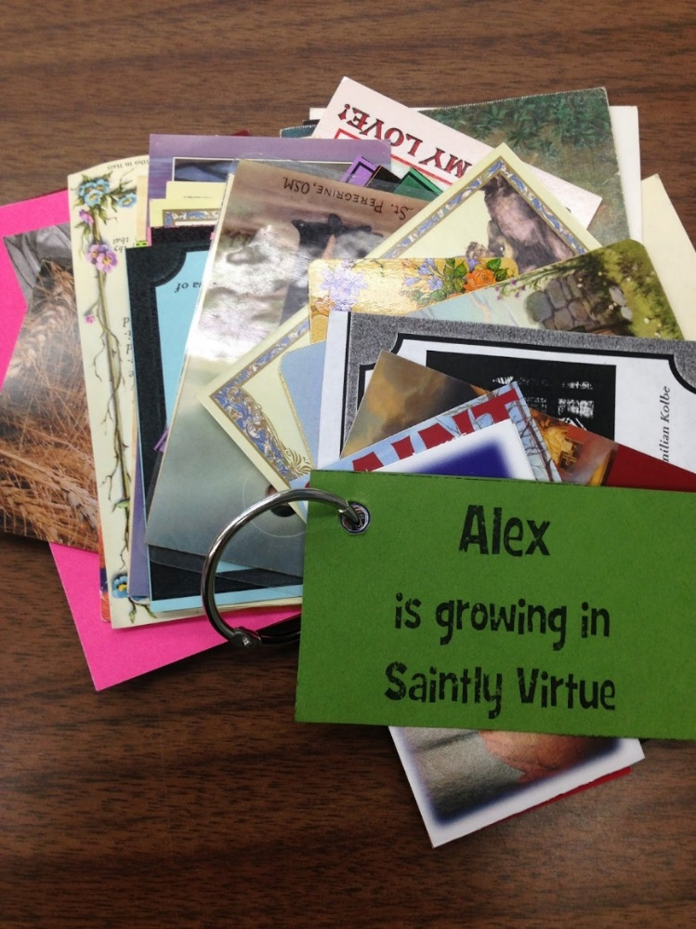
- I brought in many children’s Saint resources from our library and information I found on the web.
- We spent half of a class period looking through the Saint materials. Students had individual time to select a Saint, look over materials, and discuss with their family. If they chose to present with a partner, they met with their partner at this time to plan out their project.
- I then invited students to sign up for a Saint and presentation date. If two children wanted to present on the same date, I either tried to pair them up, or helped one of the students find an alternate Saint that they were happy with.
- I gave the sign up form to our administrative assistant, who created the Saint cards and had them laminated by the presentation dates.
- We hole punched the corners of the card and also had a laminated card with the child’s name, which said, “_(name)__ is growing in Saintly virtue”.
- In between presentations, as the next family was setting up, I put the next Saint prayer card out so kids could come and add them to their ringed collection. The kids actually got really excited about collecting them all, and if they were absent, they wanted to make sure to collect the ones they missed at the next class.
- The goal was to collect all the Saint prayer cards by the end of the presentations. We sometimes used the Saint cards following the presentation to say a short prayer or to look at the symbols the Saint was pictured with to understand more about that Saint to reinforce what they learned.
- Children’s presentations lasted from 5-10 minutes.

Saint Trading Card idea adapted from:
http://looktohimandberadiant.blogspot.com/2015/06/saint-trading-card-reward-system.html

