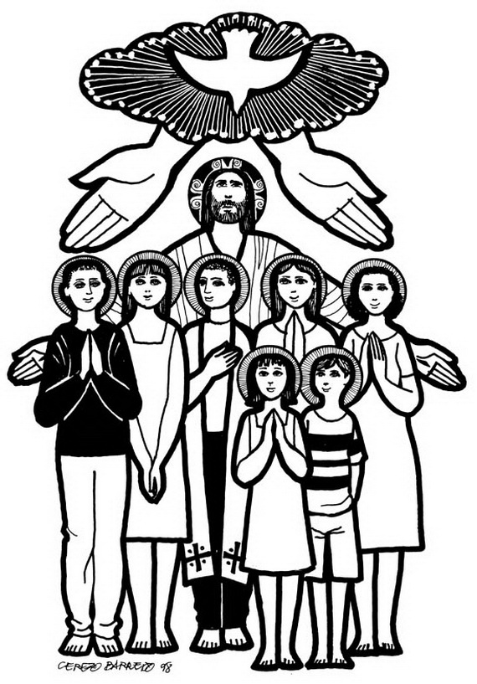
All Saints’ Day Party!
Parents:
- Please help your child choose a saint from the list below or find another one (catholic.org is a great resource) and come to class Nov. 1 with a costume (or just some accessories)to put on for the party that will help us guess which saint he/she is. (If you choose a saint not listed below then please bring a description of that saint printed off the computer.) We will have time to work on this during class and we will have some costumes/accessories available if children don’t get a chance to prepare at home.

- Please plan on attending the All Saints’ Day Party Nov. 1 after mass with your children. There will be snacks, games, prizes, and lots of fun! The 1st-5th grade students will dress up as a saint and be paired with an older student who will read the description of that saint. We will all try to guess who they are!
- If you are able to bring a snack to share for the party, that would be great!

Teachers: Class time for Saint Day (before mass/party)
- Split gr. 1-5 and gr. 6-11 to learn about saints
- Come together and match older kid with younger kid.
- Give each group a game sheet (squares will be drawn around the clues on the sheet).
- Have saint descriptions posted up around the room (or hand out a smaller version to each group).
- Race to read descriptions and write saint name in correct clue box on game sheet.

Served God by doing every little thing with great love (her “little way”) and promised to send a rose from heaven (see/smell/ given one) to those who ask for her prayers

The infant savior appeared to

Mary appeared to and asked her to have a chapel built and dig a whole where healing water poured forth

Was a Native American who had to run away to practice her Christian faith

Was given the task by Jesus to spread the message of His Divine Mercy

Chose to give life to her unborn child rather than save her own life

Lost his whole family by the time he was age 20. Became a very holy pope who loved young people

Was captured by pirates, escaped, and served God by helping the poor as a priest

Was a king who was famous for killing Goliath with a slingshot and stones to save God’s people

Was the first pope and an apostle of Jesus

Used to capture Christians to put them in jail until Jesus stopped him and he converted to being a great preacher of God’s Good News (the Gospel)

Was a priest who gave up his life to save the life of a father with 10 children

Only lived about 25 years, used his fortune to help the poor and sick, and loved mountain climbing

Gave up all to become a missionary in India and Japan

Lived in Africa until she was kidnapped by slave traders, eventually became freed, and served God as a sister

Was a humble carpenter who heard God’s voice in his dreams and became the foster father of Jesus

Died at age 12 when she refused to sin with a man and he killed her

Mary appeared to, caused miracles to happen and asked him to have the Bishop build a Church at that spot resulting in millions of Mexicans giving up worshiping false Gods to become Christian

Gave up her inheritance of millions of dollars to help Native and African American children

Lived in poverty helping the poor and the sick. Preached about God to all, even animals

Is known for helping millions of poor/sick people in India

Had the gift of the stigmata
(wounds of Christ), prophecy (knowing certain things about the future), levitation (being raised above the ground while praying), healing, and bilocation (being in two places at the same time)

Saints
Choose one to be, and study the rest to be a better guesser and win prizes!
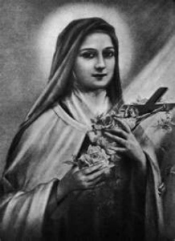
St. Therese
- Lived from 1873 to 1897 in France. Feast Day = October 1
- Carmelite Nun, Doctor of the Church, and Patron saint of missionaries,
- Known for her “little way” offering every sacrifice for God and trusting in Him with childlike faith in His love. She promised to send roses from heaven to those who ask for her prayers as her way of spending her time in heaven doing good on earth.
- “Without love, deeds, even the most brilliant, count as nothing.” –St. Therese
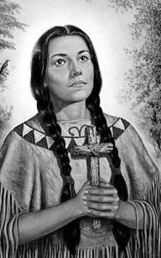
St. Kateri Tekakwitha
- Lived from 1656-1680 in New York and Canada. Feast Day = July 14
- Patron of orphans, ecologists, and the environment, the 1st North American Aboriginal Saint, a virgin, and laywoman, called “Lily of the Mohawks”
- Orphaned at age 4; treated badly for being Christian; fled to Canada to live out her faith through prayer, penance and good works; smallpox scars on her face disappeared miraculously after she died.
- “I am not my own; I have given myself to Jesus.” – St. Kateri

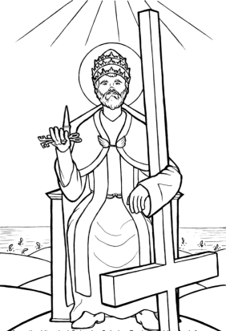
St. Peter
- Apostle of Jesus, Patron of Popes and Fishermen, Feast Day=February 22
- Jesus made him the first pope (leader of the church) giving him the “keys of the kingdom” and forgave him for being scared and saying he didn’t know Jesus 3 times. Peter was martyred (killed) for his faith.
- Legend says he was crucified upside down, not feeling worthy enough to be put to death in the same way as his savior.
- “Cast all your worries upon Jesus because He cares for you.” -1 Peter 5:7

St. Faustina
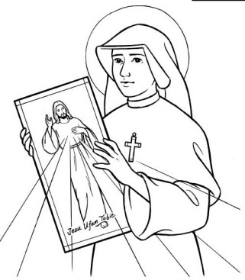
- Lived in Poland from 1905-1938; Nun, Mystic, and Patron saint of Mercy. Feast Day=Oct. 5
- Jesus appeard to St. Faustina with a message of His mercy (love/forgiveness) to spread throughout the whole world. The message was to ask for His Mercy, be merciful to others, and completely trust in Jesus. It included a special image of Jesus (hanging in our church sanctuary) and special prayers to pray.
- “For the sake of His sorrowful passion, have mercy on us and on the whole world.”

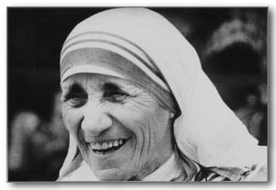
Blessed Teresa (Mother Teresa)
- Born in Albania in 1910; Nun; Started Missionaries of Charity in India; died in 1997; Feast Day=Sept. 5
- Known for her compassion to the poorest of poor in India after Jesus asked her to “Come be my light. I cannot do it alone.” She eventually opened homes all over the world to help the poor and sick.
- “Let no one ever come to you without leaving better and happier. Be the living
expression of God’s kindness: kindness in your face…in your eyes,…in your smile.”
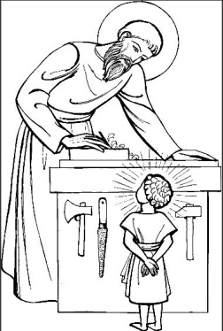
St. Joseph
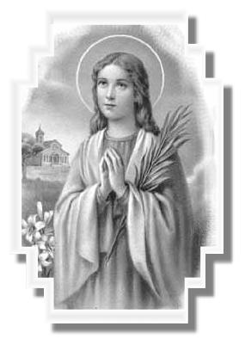
- Foster-Father of Jesus; patron of the universal church and marriage. Feast Days=March 19 and May 1
- Was a humble, pure, gentle, and wise protector of the Holy Family.

St. Maria Goretti
- Lived in Italy from 1890-1902 (age 12 when she did); patron of girls and purity. Feast Day=July 6
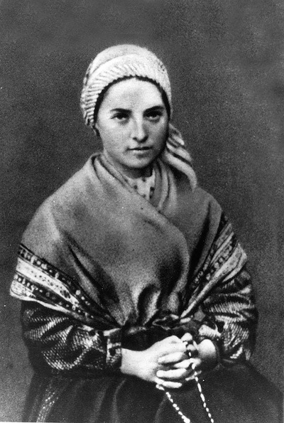
- After refusing to sin with a young man, she was stabbed by him. She forgave her murderer before dying the next day. He was arrested and 27 years later he repented and changed his ways after seeing Maria in a dream.
St. Bernadette
- Lived in France from 1844-1879; Nun; patron of those with illnesses. Feast Day=April 6
- From a poor family, often sick. Our Lady appeared to her telling her to pray and do penance for sinners, have a chapel built in Mary’s honor, and dig a hole from which a spring of water came out which many were healed by.
- “I shall spend every moment loving. One who loves does not notice her trials; or perhaps more accurately, she is able to love them.” – St. Bernadette
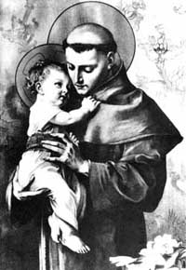
St. Anthony
- Lived in Italy 1195 to 1231; patron of lost items; monk/preacher. Feast Day=June 13
- Known for his purity and innocence and for his prayers (in heaven) for those who have lost items. He is often pictured with the baby Jesus because the Infant Savior appeared to him.
- “The life of the body is the soul; the life of the soul is God.” – St. Anthony

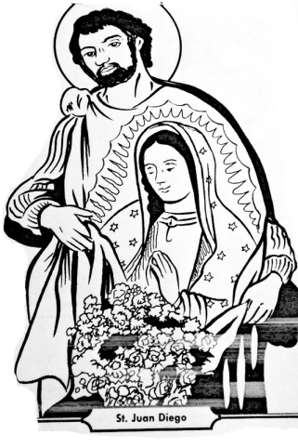
St. Juan Diego
- Lived in Mexico 1474-1548; patron of Christian Mothers; visionary. Feast Day=Dec. 9
- St. Juan was a weaver, farmer, and laborer who walked 15 miles to daily Mass. The Virgin Mary appeared to him and asked for a Church to be built. Through the appearance of miraculous roses (in winter) and the imprint of Our Lady’s image on Juan’s cloak, the bishop was convinced and built the Church. All this led millions of Mexicans who didn’t believe in God before to become Christians.
- “Let not your heart be disturbed. Are you not under my protection? Are you not happily within my fold? What else do you wish? Do not grieve nor be disturbed by anything.” (Mary’s words to Juan)

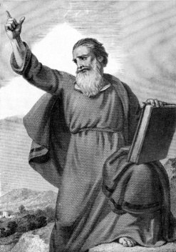
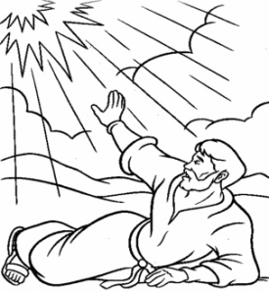
St. Paul
- Lived in Palestine 10-67; Patron of authors and publishers; author of Bible letters, martyr, Apostle to the Gentiles (non-Jews) to teach them about Christ; Feast Days=Jan. 25 and June 29
- Converted from persecuting Christians to being one of the most successful missionaries of the Early Church. He wrote letters to various churches he started 14 of which are included in the New Testament.

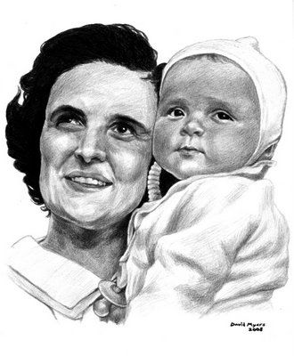
St. Gianna
- Lived in Italy 1922-1962; Patron saint of mothers, Doctors, and the unborn. Feast Day=April 28
- Holy wife, mother, and medical doctor who taught others the faith through an organization called Catholic Action and through the example of her prayers and compassion to all, especially the poor whom she gave medical care to for free.
- Had cancer when pregnant with her fourth child and chose to risk her own life in giving birth to her child rather than having a surgery that would hurt the baby. 1 week after she gave birth, she died. The child was named Gianna after her.
St. Maximilian
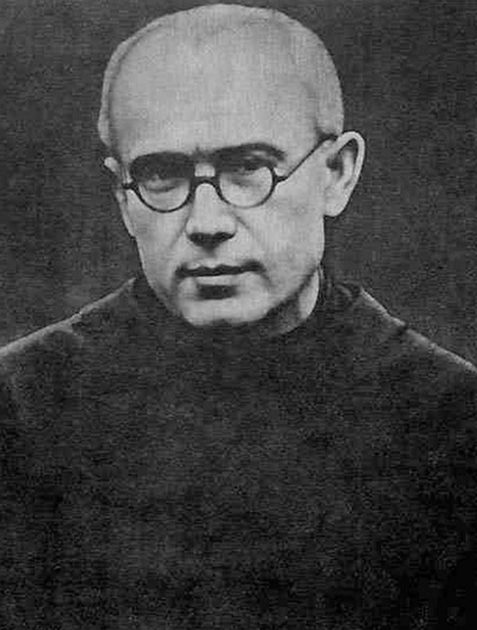
- Lived in Poland 1894-1941; priest, martyr, founder of militia of Mary Immaculate. Feast Day=Aug. 14
- Taught many about Mary the Mother of God and how she is our spiritual mother too.
- Arrested by the Nazis and volunteered to take the place of a father of 10 when prisoners were selected to be killed.

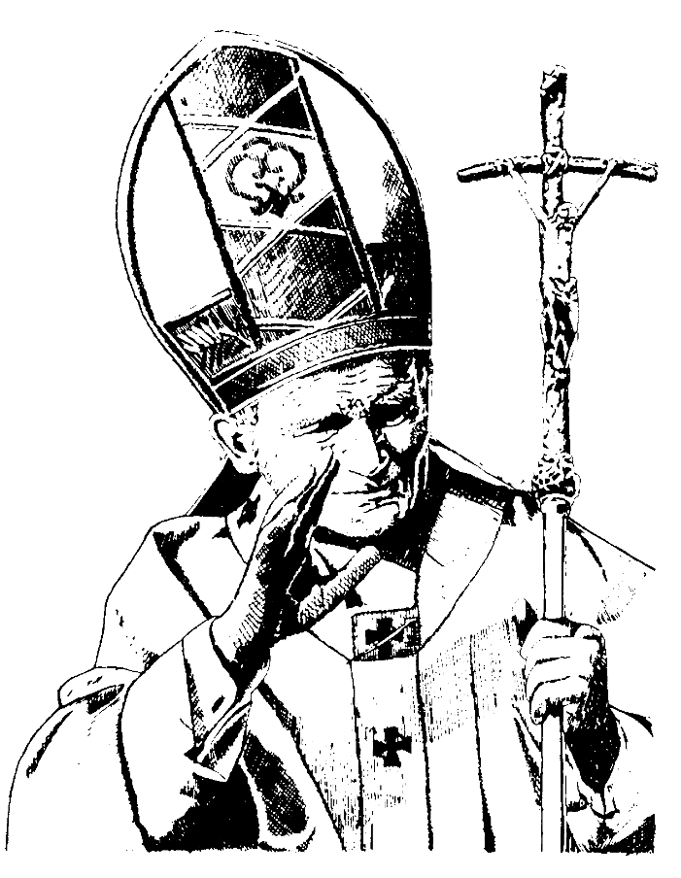
St. John Paul II
- Lived in Poland 1920-2005; Pope (1978-2005) Feast Day=Oct. 22
- Enjoyed soccer, skiing, and acting; went through many trials including having his whole family die by the time he was age 20; elected pope; wrote many important Catholic documents; traveled all over the world to encourage people to follow Christ; started World Youth Day and World Meeting of Families to strengthen the faithful; worked to bring peace between various Christian denominations and various religions; helped to restore democracy and religious freedom in communist countries; many were healed by his prayers.
- “Do not be afraid.”
- “It is Jesus that you seek when you dream of happiness. He is waiting for you when nothing else you find satisfies you.”
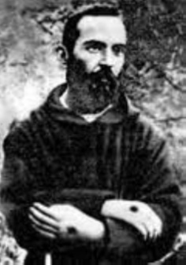
St. Padre Pio
- Lived in Italy 1887-1968; Monk and priest; patron of the unborn; Feast Day=Sept. 23
- Called to the priesthood at a young age; given the gifts of stigmata (the wounds of Christ), prophecy (knowing information about the future), levitation (rising off the ground during prayer), healing, and bilocation (being in 2 places at the same time); led many people back to their faith.
- “Prayer is the best weapon we possess [against evil]. It is the key that opens the Heart of God.”
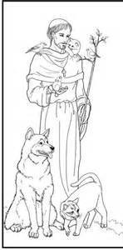
St. Francis
- Lived in Italy 1181-1226; Friar; preacher; mystic; Patron of animals. Feast Day=Oct. 4
- Gave up his life of great wealth and lived for God begging for food, praying and fasting; founded the Franciscan order; lived in poverty and helped the sick and the poor; had a special way with animals, preaching to them and they would listen and obey.
- “Where there is hatred let me sow love; where there is injury pardon; where there is doubt, faith; where there is despair, hope; where there is darkness, light; and where there is sadness, joy…”
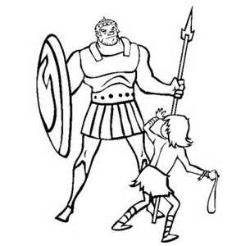
St. David the King
- Lived 1,000 years before Jesus was born; Feast Day=Dec. 29
- Famous for fighting the Philistine giant, Goliath and winning the war with a slingshot and God’s grace; became king of Israel; wrote many songs to God recorded in the book of Psalms in the Bible.
St. Francis Xavier
- Born in Spain; lived 1506-1552; priest; patron of missionaries; Feast Day=Dec. 3
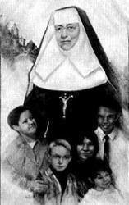
- Gave up a life of worldly honors to be a missionary in India and Japan when St. Ignatius challenged him quoting the Bible, “For what will it profit them if they gain the whole world but forfeit their life?”
- “Speak to them of the great mercy of God…Sometimes people are helped by your telling of your own lamentable past.”
St. Katherine Drexel
- Lived in Pennsylvania 1858-1955; nun; Feast Day=March 3
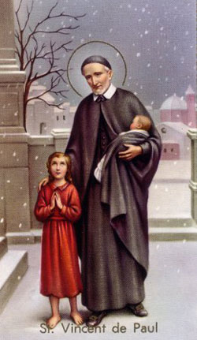
- Used her inheritance of millions of dollars to become a missionary and serve the Native Americans and African Americans through building Catholic schools and missions centers for them; started the Sisters of the Blessed Sacrament.
- "The Eucharist is a never-ending sacrifice. It is the Sacrament of love, the supreme love, the act of love."
St. Vincent de Paul
- Lived in France 1580-1660; Patron of charitable organizations; Feast Day=Sept. 27
- From a poor family; became a priest; African pirates captured him and he was carried away as a slave for two years until God helped him escape. He served God faithfully helping everyone from orphans to the elderly and starting organizations to serve the poor.
- “Make it a practice to judge persons and things in the most favorable light at all times and under all circumstances.”
St. Josephine Bakhita
- Lived in Sudan and Italy 1869-1947; nun, former slave, patron of Sudan, Feast Day=Feb. 8
- At age nine she was kidnapped by Arab slave traders. After much suffering with very mean owners, she ended up in Italy with a kind family serving as their babysitter. She learned about God, was baptized, freed from slavery, and became a sister.
- "If I were to meet the slave-traders who kidnapped me and even those who tortured me, I would kneel and kiss their hands,for if that did not happen, I would not be a Christian and Religious today."
Blessed Pier Giogio
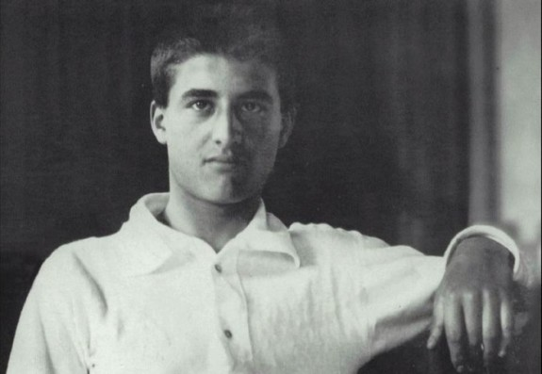

“As long as faith gives me strength I will always be joyful.”
-Blessed Pier Giorgio

- Lived 1901-1925 in Italy.
- He was born to a wealthy and politically influential family; his mother was a painter and his father was an agnostic (unsure whether God existed or not), the founder and editor of the liberal newspaper La Stampa, and became the Italian ambassador to Germany.
- A youth devoted to God, average student, outstanding athlete and mountain climber, he was extremely popular with his peers, known by the nickname “Terror” due to his practical jokes.
- He was tutored at home for years with his younger sister Luciana. He studied minerology in an engineering program after graduating high school.
- He worked often with Catholic groups like Apostleship of Prayer and the Company of the Most Blessed Sacrament that ministered to the poor and promoted Eucharistic adoration, devotion to Mary, and personal chastity. He became involved in political groups like the Young Catholic Workers Congress, the Popular Party, the Catholic Student Federation, Catholic Action and Milites Mariae that supported the poor, and worked for the Church‘s social teachings.
- Enrolled as a Dominican tertiary (someone who is part of a religious order but without becoming a priest, sister, or brother) on 28 May 1922, taking the name Girolamo (Jerome).
- He was especially devoted to the teachings of Saint Catherine of Siena and Saint Thomas Aquinas.
- He spent his fortune on the needy and visited the sick; during this ministry he contracted the disease that killed him.
- His body was found incorrupt (had not decomposed at all like normal) when moved to the Cathedral of Turin in 1981
- Feast Day=July 4

Blessed Pier Giogio

“As long as faith gives me strength I will always be joyful.”
-Blessed Pier Giorgio

- Lived 1901-1925 in Italy. Feast Day=July 4

- He was born to a wealthy and politically influential family. He was devoted to God an average student, outstanding athlete and mountain climber

- He worked often with Catholic groups that supported the poor, and worked for the Church‘s social teachings.

- He spent his fortune on the needy and visited the sick; during this ministry he contracted the disease that killed him.

- His body was found incorrupt (had not decomposed at all like normal) when moved to the Cathedral of Turin in 1981
z
Teachers – The plan for the morning is…

9-9:30 Videos Teachers please help make sure kids are listening, behaving, and understanding.

- Gr. 1-4 watch the Brother Francis video on Saints in the kitchen section of the hall (most can just sit on the floor)
- Gr. 5-11 watch the Chiara Bandana video (in center section)

9:30-9:40 Basic Saint Info. and Prayer Teachers please pray along/make sure everyone knows what’s going on and is participating.
Gr. 1-4
- Please ask a few questions so you know they understood the video:
  - What is a saint? A person in heaven with God (many of you may have relatives who are saints!) If the person lived a very loving life, we can be sure he/she is in heaven so we call him/her a saint. (It’s a long process to research their life but that is the basic idea)
  - Who is called to be a saint? Everyone!
  - What is a feast day? The day the saint died/went to heaven, the day we celebrate and remember him/her in a special way
  - What is a patron saint? An area of life that he/she is a special protector or guardian over (for example St. Francis loved and appreciated all nature so he is the patron saint of nature and we can ask for His prayers for anything but especially things related to nature. St. Gianna – unborn children- she gave up her life for the life of the child in her womb)
  - Do Catholics pray TO saints?
- No, we ask saints to pray for us, like asking a friend to pray for you
- They are close to God (In heaven with Him!) and may have had a similar interest or problem (patron saint), so we believe their prayers are very powerful

If they ask how the church decides if a person is a saint…
  - After the death of someone regarded as holy the local Bishop evaluates the person’s life and writings or martyrdom for heroic virtue and truth of teachings, then theologians at the Vatican evaluate him/her.
  - Pope proclaims the person “Venerable”
  - “Beatification” – next step requires one miracle (except in the case of martyrs) after his/her prayers were asked for. This is proof that the person is in heaven and can intercede for us. They are declared “Blessed”
  - “Canonization” – final step requires one more miracle.
  - Canonization doesn’t make one holy it recognizes what God has already done. The person is declared a “saint”
  - Not every holy person has been canonized.
Prayer:
- “We are going to take some time to pray together now and ask some of the saints to pray for us. First, take a deep breath, close your eyes and think about something or someone you would like to ask the saints to pray for you about (maybe you know you need help being more loving toward your parents, brothers/sisters, or someone at school. Maybe someone in your family is sick or does not know God. Think about all these things as we listen to this song and sing along on the parts that say “pray for us”
- Play the song on CatChat CD and have them sing along on the “pray for us” part
OR
- Have kids shout out different saints and everyone respond (say or sing), “pray for us”

Gr. 5-11:
  - Sharing/Prayer
- The video goes on to tell about various people who asked Chiara to pray for them and were miraculously healed physically or emotionally or spiritually. We believe as Catholics that we can talk to people in heaven since they are alive with God (a saint is someone who is in heaven – many of you may have relatives who are saints).
- Take some time now to think about Chiara’s life, how she chose to accept God’s will even though it was so difficult, the grace God gave her to have joy even in suffering.
- Share with someone next to you what struck you in the video, what you found most interesting/amazing (I’ll give you 1 min.).
- (instrumental music) Pray silently on your own to God or ask Chiara to pray for you for whatever is on your heart…Close your eyes/take a deep breath…perhaps you need help accepting something difficult in your life, perhaps someone you love is suffering and you want to ask for healing, perhaps you just need help doing what you know is right like Chiara did in her life… (Allow 2 min. or so)
- Answer Basic Questions (from above gr. 1-4 part)

9:40-10 Learn about specific saints (Gr. 1-11 Together) This may be crazy. Let kids pair up (1-5 gr. student with 6-11th gr. student) We want it to be fun, so groups of 3 are fine and they can choose their own partners. Please help to make sure everyone has a partner and knows what to do/reads about the saints. Direct them to the prize table when their paper is filled in.

- Kids in gr. 1-5 pair up with kids in gr. 6-11
- Grab a game sheet and a pen/pencil and go around to each of the saint descriptions up on the wall to read/figure out which saint description on the game sheet it matches.
- When kids are done, they can choose a prize.

10-10:25 Dress up as a saint (gr. 1-5 kids) and decide on clues for that saint (gr. 6-11 kids)
Teachers please help with costume ideas and clues. They will need a spot to keep their stuff until after mass. The steps or somewhere at that end of the hall would be great.
- Kids gr. 1-5 find a costume to be like your saint
- Kids gr. 6-11 help out with costume and write down at least 5 clues (facts/interesting stories) about that saint to help people guess during the game.

St. Therese
- Lived from 1873 to 1897 in France. Feast Day = October 1
- Carmelite Nun, Doctor of the Church, and Patron saint of missionaries,
- Known for her “little way” offering every sacrifice for God and trusting in Him with childlike faith in His love. She promised to send roses from heaven to those who ask for her prayers as her way of spending her time in heaven doing good on earth.
- “Without love, deeds, even the most brilliant, count as nothing.” –St. Therese

St. Kateri Tekakwitha
- Lived from 1656-1680 in New York and Canada. Feast Day = July 14
- Patron of orphans, ecologists, and the environment, the 1st North American Aboriginal Saint, a virgin, and laywoman, called “Lily of the Mohawks”
- Orphaned at age 4; treated badly for being Christian; fled to Canada to live out her faith through prayer, penance and good works; smallpox scars on her face disappeared miraculously after she died.
- “I am not my own; I have given myself to Jesus.” – St. Kateri

St. Peter
- Apostle of Jesus, Patron of Popes and Fishermen, Feast Day=February 22
- Jesus made him the first pope (leader of the church) giving him the “keys of the kingdom” and forgave him for being scared and saying he didn’t know Jesus 3 times. Peter was martyred (killed) for his faith.
- Legend says he was crucified upside down, not feeling worthy enough to be put to death in the same way as his savior.
- “Cast all your worries upon Jesus because He cares for you.” -1 Peter 5:7

St. Faustina
- Lived in Poland from 1905-1938; Nun, Mystic, and Patron saint of Mercy. Feast Day=Oct. 5
- Jesus appeard to St. Faustina with a message of His mercy (love/forgiveness) to spread throughout the whole world. The message was to ask for His Mercy, be merciful to others, and completely trust in Jesus. It included a special image of Jesus (hanging in our church sanctuary) and special prayers to pray.
- “For the sake of His sorrowful passion, have mercy on us and on the whole world.”

Blessed Teresa (Mother Teresa)
- Born in Albania in 1910; Nun; Started Missionaries of Charity in India; died in 1997; Feast Day=Sept. 5
- Known for her compassion to the poorest of poor in India after Jesus asked her to “Come be my light. I cannot do it alone.” She eventually opened homes all over the world to help the poor and sick.
- “Let no one ever come to you without leaving better and happier. Be the living
expression of God’s kindness: kindness in your face…in your eyes,…in your smile.”

St. Joseph
- Foster-Father of Jesus; patron of the universal church and marriage. Feast Days=March 19 and May 1
- Was a humble, pure, gentle, and wise protector of the Holy Family.

St. Maria Goretti
- Lived in Italy from 1890-1902 (age 12 when she did); patron of girls and purity. Feast Day=July 6
- After refusing to sin with a young man, she was stabbed by him. She forgave her murderer before dying the next day. He was arrested and 27 years later he repented and changed his ways after seeing Maria in a dream.

St. Bernadette
- Lived in France from 1844-1879; Nun; patron of those with illnesses. Feast Day=April 6
- From a poor family, often sick. Our Lady appeared to her telling her to pray and do penance for sinners, have a chapel built in Mary’s honor, and dig a hole from which a spring of water came out which many were healed by.
- “I shall spend every moment loving. One who loves does not notice her trials; or perhaps more accurately, she is able to love them.” – St. Bernadette

St. Anthony
- Lived in Italy 1195 to 1231; patron of lost items; monk/preacher. Feast Day=June 13
- Known for his purity and innocence and for his prayers (in heaven) for those who have lost items. He is often pictured with the baby Jesus because the Infant Savior appeared to him.
- “The life of the body is the soul; the life of the soul is God.” – St. Anthony

St. Juan Diego
- Lived in Mexico 1474-1548; patron of Christian Mothers; visionary. Feast Day=Dec. 9
- St. Juan was a weaver, farmer, and laborer who walked 15 miles to daily Mass. The Virgin Mary appeared to him and asked for a Church to be built. Through the appearance of miraculous roses (in winter) and the imprint of Our Lady’s image on Juan’s cloak, the bishop was convinced and built the Church. All this led millions of Mexicans who didn’t believe in God before to become Christians.
- “Let not your heart be disturbed. Are you not under my protection? Are you not happily within my fold? What else do you wish? Do not grieve nor be disturbed by anything.” (Mary’s words to Juan)

St. Paul
- Lived in Palestine 10-67; Patron of authors and publishers; author of Bible letters, martyr, Apostle to the Gentiles (non-Jews) to teach them about Christ; Feast Days=Jan. 25 and June 29
- Converted from persecuting Christians to being one of the most successful missionaries of the Early Church. He wrote letters to various churches he started 14 of which are included in the New Testament.

St. Gianna
- Lived in Italy 1922-1962; Patron saint of mothers, Doctors, and the unborn. Feast Day=April 28
- Holy wife, mother, and medical doctor who taught others the faith through an organization called Catholic Action and through the example of her prayers and compassion to all, especially the poor whom she gave medical care to for free.
- Had cancer when pregnant with her fourth child and chose to risk her own life in giving birth to her child rather than having a surgery that would hurt the baby. 1 week after she gave birth, she died. The child was named Gianna after her.

St. Maximilian Kolbe
- Lived in Poland 1894-1941; priest, martyr, founder of militia of Mary Immaculate. Feast Day=Aug. 14
- Taught many about Mary the Mother of God and how she is our spiritual mother too.
- Arrested by the Nazis and volunteered to take the place of a father of 10 when prisoners were selected to be killed as a punishment for one escaping.

St. John Paul II
- Lived in Poland 1920-2005; Pope (1978-2005) Feast Day=Oct. 22
- Enjoyed soccer, skiing, and acting; went through many trials including having his whole family die by the time he was age 20; elected pope; wrote many important Catholic documents; traveled all over the world to encourage people to follow Christ; started World Youth Day and World Meeting of Families to strengthen the faithful; worked to bring peace between various Christian denominations and various religions; helped to restore democracy and religious freedom in communist countries; many were healed by his prayers.
- “Do not be afraid.”
- “It is Jesus that you seek when you dream of happiness. He is waiting for you when nothing else you find satisfies you.”

St. Padre Pio
- Lived in Italy 1887-1968; Monk and priest; patron of the unborn; Feast Day=Sept. 23
- Called to the priesthood at a young age; given the gifts of stigmata (the wounds of Christ), prophecy (knowing information about the future), levitation (rising off the ground during prayer), healing, and bilocation (being in 2 places at the same time); led many people back to their faith.
- “Prayer is the best weapon we possess [against evil]. It is the key that opens the Heart of God.”
St. Francis
- Lived in Italy 1181-1226; Friar; preacher; mystic; Patron of animals. Feast Day=Oct. 4
- Gave up his life of great wealth and lived for God begging for food, praying and fasting; founded the Franciscan order; lived in poverty and helped the sick and the poor; had a special way with animals, preaching to them and they would listen and obey.
- “Where there is hatred let me sow love; where there is injury pardon; where there is doubt, faith; where there is despair, hope; where there is darkness, light; and where there is sadness, joy…”

St. David the King
- Lived 1,000 years before Jesus was born; Feast Day=Dec. 29
- Famous for fighting the Philistine giant, Goliath and winning the war with a slingshot and God’s grace; became king of Israel; wrote many songs to God recorded in the book of Psalms in the Bible.

St. Francis Xavier
- Born in Spain; lived 1506-1552; priest; patron of missionaries; Feast Day=Dec. 3
- Gave up a life of worldly honors to be a missionary in India and Japan when St. Ignatius challenged him quoting the Bible, “For what will it profit them if they gain the whole world but forfeit their life?”
- “Speak to them of the great mercy of God…Sometimes people are helped by your telling of your own lamentable past.”

St. Katherine Drexel
- Lived in Pennsylvania 1858-1955; nun; Feast Day=March 3
- Used her inheritance of millions of dollars to become a missionary and serve the Native Americans and African Americans through building Catholic schools and missions centers for them; started the Sisters of the Blessed Sacrament.
- "The Eucharist is a never-ending sacrifice. It is the Sacrament of love, the supreme love, the act of love."

St. Vincent de Paul
- Lived in France 1580-1660; Patron of charitable organizations; Feast Day=Sept. 27
- From a poor family; became a priest; African pirates captured him and he was carried away as a slave for two years until God helped him escape. He served God faithfully helping everyone from orphans to the elderly and starting organizations to serve the poor.
- “Make it a practice to judge persons and things in the most favorable light at all times and under all circumstances.”

St. Josephine Bakhita
- Lived in Sudan and Italy 1869-1947; nun, former slave, patron of Sudan, Feast Day=Feb. 8
- At age nine she was kidnapped by Arab slave traders. After much suffering with very mean owners, she ended up in Italy with a kind family serving as their babysitter. She learned about God, was baptized, freed from slavery, and became a sister.
- "If I were to meet the slave-traders who kidnapped me and even those who tortured me, I would kneel and kiss their hands,for if that did not happen, I would not be a Christian and Religious today."

