Priest Assignments and Locations:
Fr. Jim Lucas – St. Thomas More Shrine
- Summer Baake’s Family
- Ella Heyndrickx’s Family
- Adeline Kuehn’s Family
- Finn Schanke’s Family

Fr. Gerald Falk – Reconciliation Room
- Sabrina Janda’s Family
- India Woolf’s Family
- Kaya Lange’s Family
- Jackson Schmidtke’s Family
- Madeleine Savoie’s Family

Fr. Bill Hoffman – 14th Station of the Cross
- Alexa Kaminski’s Family
- Isaac Mettelmann’s Family
- Talon Fritsch’s Family
- Jaden Tapelt’s Family

Fr. Brian Wideman – Holy Family Shrine
- Jack Mullard’s Family
- Faye Hehli’s Family
- Sydney Neilitz’s Family
- Talia Yurjevich’s Family

Fr. Dennis Ryan – 1st Station of the Cross
- Jackson Skorr’s Family
- Elizabeth Heim’s Family
- Abigail Ourada’s Family
- Haley Bengston’s Family

Fr. Jim Leary – Bride’s Room (outside church)
Kiki Harke will indicate when the next family should come out of church. The family may be seated outside the bride room while their child is in confession.

- Isabelle & Ivy VanAsten’s Family
- Carter Hermus’ Family
- David Romenesko’s Family
- Camdyn Marx’s Family

Rite of Reconciliation

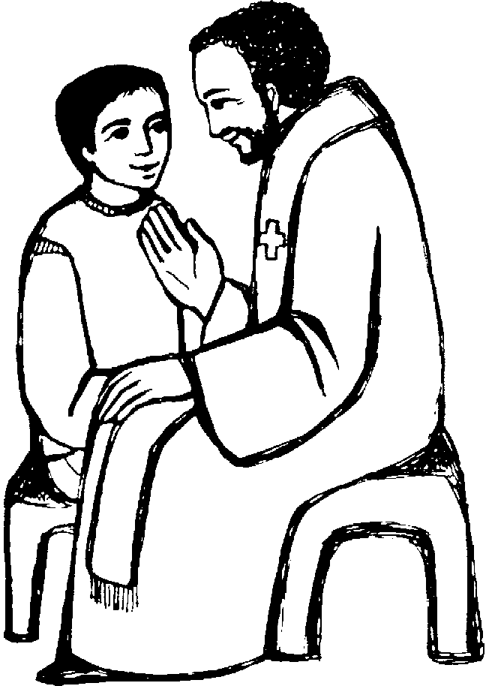

Wednesday, November 18, 2015
Presider: Fr. Jim Lucas

St. Thomas More Parish,
Appleton, WI

Rite of Reconciliation Service 2015
Prelude: Thy Word
Refrain:
Thy word is a lamp unto my feet
And a light unto my path.
Thy word is a lamp unto my feet
And a light unto my path.

Verse 1:
When I feel afraid,
And think I've lost my way.
Still, you're there right beside me.
Nothing will I fear
As long as you are near;
Please be near me to the end.

Verse 2:
I will not forget
Your love for me and yet,
My heart forever is wandering.
Jesus by my guide,
And hold me to your side,
And I will love you to the end.

Amy Grant | Michael W. Smith© 1984 Word Music, LLC (a div. of Word Music Group, Inc.) Meadowgreen Music Company (Admin. by Capitol CMG Publishing) For use solely with the SongSelect Terms of Use. All rights reserved. www.ccli.com CCLI License # 11173035

Opening Hymn: We Are the Light of the World
Verse 1:
Blessed are they who are poor in spirit,
Theirs is the kingdom of God.
Bless us, O Lord, make us poor in spirit;
Bless us, O Lord, our God.

They will behold the Lord.
Bless us, O Lord, make us pure and holy;
Bless us, O Lord, our God.

Verse 7:
Blessed are they who bring peace among us,
They are the children of God.
Bless us, O Lord, may your peace be with us;
Bless us, O Lord, our God.

Text: 10 6 10 6 with refrain; based on the Beatitudes, adapt. by Jean Anthony Greif, 1898–1981, alt. Music: Jean Anthony Greif. Text and music © 1966, Vernacular Hymns Publishing Co. All rights reserved. Used with permission. This arrangement available exclusively from OCP.

Concluding Prayers and Blessing
Presider: As we look upon these candles,
May their flames be a visible reminder
That we are God’s light in the world.
We remember that God has forgiven our sins
All the Saints in heaven rejoice with us today
Because we are made clean and close to God.
Our God loves us very much.

Let us take a moment to thank God for his great mercy
And our happiness as His children. [pause]
May God strengthen us to change our behavior,
To love better, and to have courage
To be His light in the world.

Lord’s Prayer
Sign of Peace
Closing Prayer
Blessing
Closing Song: We Are the Light of the World (remaining verses)
Verse 5:
Blessed are they who show others mercy,
They will know mercy too.
Bless us, O Lord, hear our cry for mercy;
Bless us, O Lord, our God.

Refrain:
We are the light of the world,
may our light shine before all,
that they may see the good that we do,
and give glory to God.

Verse 6:
Blessed are hearts that are clean and holy,
Refrain:
We are the light of the world,
may our light shine before all,
that they may see the good that we do,
and give glory to God.

Verse 2:
Blessed are they who are meek and humble,
They will inherit the earth.
Bless us, O Lord, make us meek and humble;
Bless us, O Lord, our God.
Reading: 1 John 1:5-7 (2nd Grade Catechist, Kiki Harke)
Now this is the message that we have heard from him and proclaim to you: God is light, and in him there is no darkness at all. If we say, “We have fellowship with him,” while we continue to walk in darkness, we lie and do not act in truth. But if we walk in the light as he is in the light, then we have fellowship with one another, and the blood of his Son Jesus cleanses us from all sin.
Psalm 27: The Lord is My Light
Gospel Reading: Mt 5:14-16 (Fr. Jim Lucas)
ALL: Please Stand for Gospel Reading.
You are the light of the world. A city set on a mountain cannot be hidden. Nor do they light a lamp and then put it under a bushel basket; it is set on a lampstand, where it gives light to all in the house. Just so, your light must shine before others, that they may see your good deeds and glorify your heavenly Father.
(please be seated)
Homily: Fr. Jim Lucas
Examination of Conscience
Presider: Have I remembered to pray every day?
All: Lord, help your light to shine in me.
Presider: Have I used God’s name in a bad or unkind way?
All: Lord, help your light to shine in me.
Presider: Do I come to worship at Mass every Sunday?
All: Lord, help your light to shine in me.
Presider: Have I disobeyed my parents or others who care of me? All: Lord, help your light to shine in me.
Presider: Have I lost my temper or been mean to anyone?
All: Lord, help your light to shine in me.
Presider: Have I done anything to hurt my own or someone else’s body?
All: Lord, help your light to shine in me.
Presider: Have I taken anything that belongs to someone else?
All: Lord, help your light to shine in me.
Presider: Have I always told the truth?
All: Lord, help your light to shine in me.
Presider: Have I been jealous of things other people own or of another person’s lifestyle?
All: Lord, help your light to shine in me.
Act of Contrition
ALL: Please Stand for the Act of Contrition.
ALL RECITE: My God, I am sorry for my sins with all my heart.
In choosing to do wrong and failing to do good,
I have sinned against You whom I should love above all things.
I firmly intend, with Your help, to do penance, to sin no more,
and to avoid whatever leads me to sin. Amen.
(please be seated)
Individual Confessions
Fr. Jim will then assign priests and Emily Shackleton will give directions for how to proceed with the evening.
- We encourage all family members to go to confession. This is a free choice, but we invite you to experience God’s love and mercy through this beautiful sacrament as a witness for your child.
- If a parent would like to go to a different priest for confession, they may do so when that priest is free.
- All visitors are invited to receive the sacrament of reconciliation when a priest becomes available.

