First Reconciliation Parent Meeting
Celebrate: God’s Mercy Endures Forever!
September 29/30, 2015
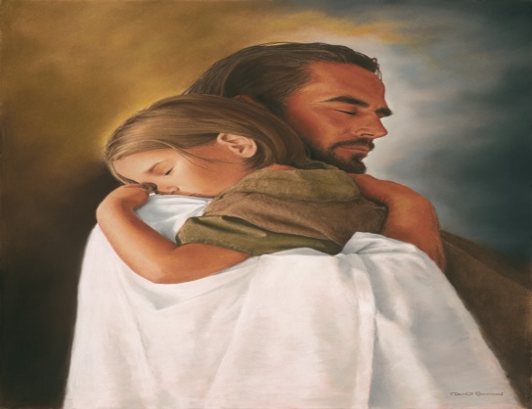
- Family Mini Retreat (15 min)
  - Welcome and introductions
  - Sharing our Stories: Families of Forgiveness
  - A Prayer for Mercy
- Reflection on God’s Grace- Betty Schwandt (20 min)
- Celebrating God’s Love (20 min.)
  - Family Sessions, classroom preparation, community preparation
  - Sign up for retreat and first reconciliation service, to be turned in by the end of the meeting
  - Questions
“The joy of God is the joy of forgiveness. It is the joy of the shepherd who finds his lost sheep; the joy of the woman who finds her lost coin; the joy of the father who welcomes home his lost son.”
-Pope Francis, 2013

