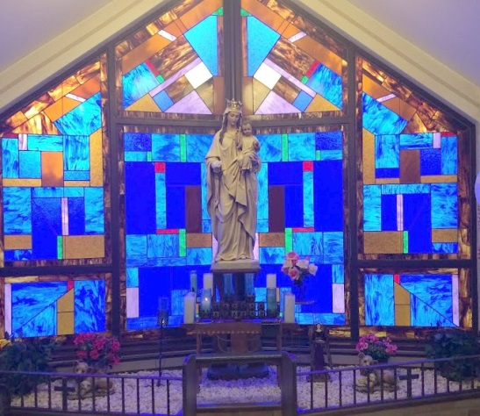
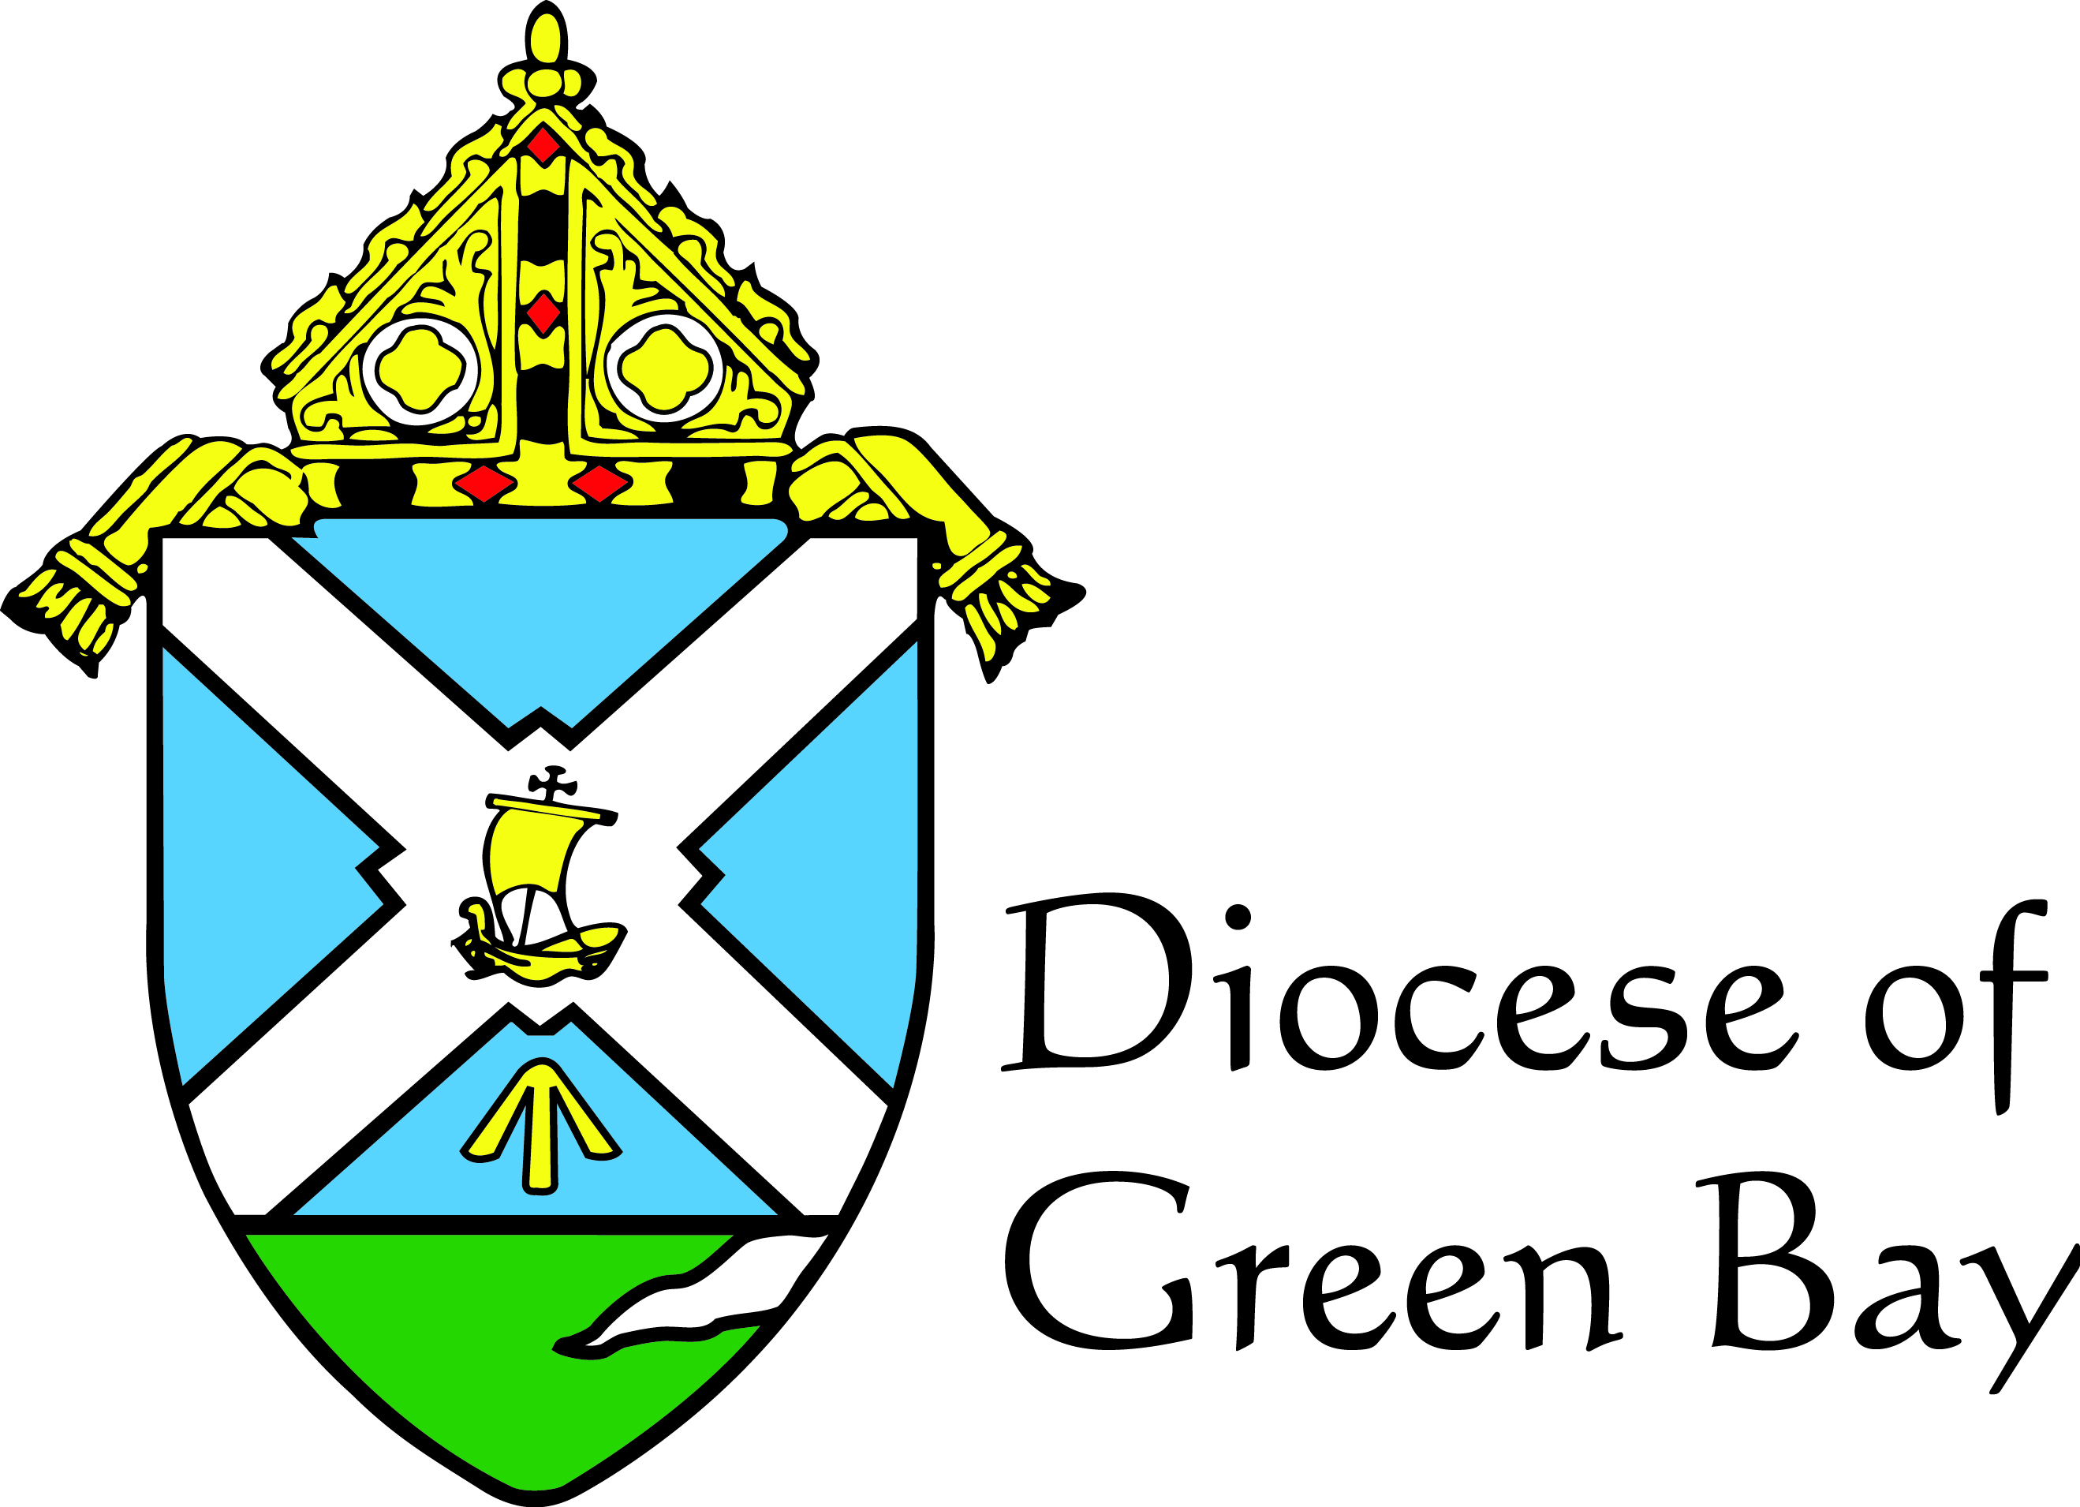
Education Department
1825 Riverside Dr | Green Bay, WI 54301

Dr. Joe Bound – Director of Education
Phone (920) 272-8266

Maria Schuette – Director of Religious Education and Youth Ministry
Phone (920) 272-8285

Sr. Jacqueline Spaniola – Assistant Director of Religious Education and Youth Ministry
Phone (920) 272-8288

www.gbdyouthalive.weebly.com/accreditation
Why do I want my parish religious education program accredited?
- It brings a professionalism and credibility to your program
- It increases awareness of the program to the wider parish community
- It allows for objective team members from outside of the parish to highlight the great ways your parish is evangelizing and catechizing
- It allows your parish to look at areas that could use renewal and exchange ideas with the team on how to improve areas you’d like to renew!
- It brings order to an often difficult and overwhelming task
- It allows for continuity and excellence as the program is passed from one religious education director or coordinator to another
- It provides a direction for your parish so it can meet the needs of its families rather than being preoccupied with other miniscule tasks
- It reminds and challenges your entire parish to be centered on Christ. It asks the question – what can our parish do to better support and pray for our young people?

Picture taken from St. Isidore the Farmer Parish who was accredited in

October 2015

An opportunity for growth, renewal, and recognition of the valuable work found in our religious education programs
Religious Education
Accreditation
What is accreditation?
Ever wonder what a great Religious Education program looks like? The accreditation process uses a team of people from within the diocese to affirm, encourage, and challenge parishes to evengelize with enthusiasm, pray with intentionality, and catechise with truth and charity according to the Diocesan Quality Indicators. The Diocean Quality Indicators highlight 12 general areas and corresponding subpoints which outline what a great program looks like. The accreditation members visit the parish and affirm and challenge them using the Diocesan Quality Indicators as a basic rubric.
Why accreditation?
For years, public and private schools have been invited to participate in the accreditation process. This process allows for each school to be reviewed objectively using a set of standards. Using this tool, the team is able to objectively give schools tangible affirmations, suggestions, and areas for improvement according to an ideal set of quality indicators. The Education Department in the Diocese of Green Bay observed very little recognition and ability for parish programs to review their program as a whole. Thus, the accreditation process was created to support, affirm, and renew our religious education programs within the Diocese and with our dependence on the Lord, make each program a quality “school” of evangelization and discipleship!
How do we apply?
A parish willing to begin the accreditation process is asked to submit a letter to the education department (a sample letter is listed on our resource website www.gbdyouthalive.weebly.com/accreditation).

How long is the process?
The accrediation process takes a year from when the letter is first accepted. A diocesan representative will be in contact once the letter is accepted and the timeline will be established to allow for the best materials to be submitted.
How are the Diocesan Quality Indicators measured?
The visiting team looks at written evidence and collects information and observations through interviews (people chosen by the Religious Education director or coordinator) as well as observations of the religious education sessions!
We aren’t a perfect parish. How are we supposed to meet all that is expected?
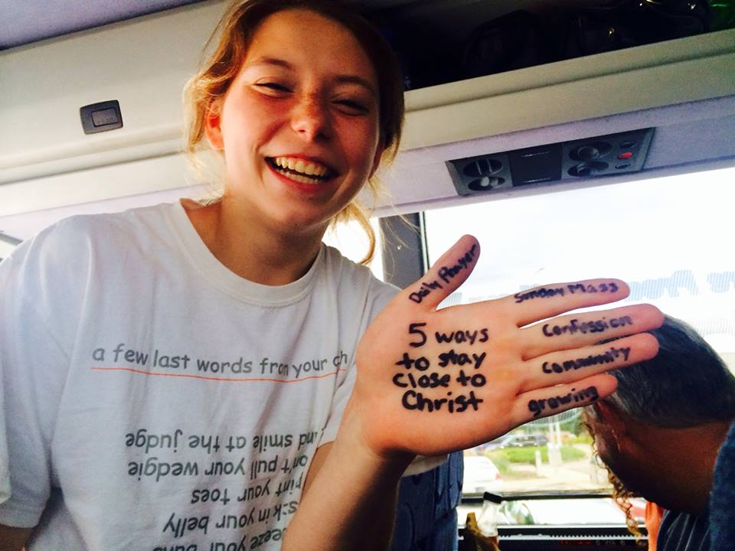
No parish is perfect and that is not what the visiting team is expecting to see. Pope Francis told the young people of World Youth Day to make their dioceses and parishes a mess, so don’t feel intimidated! This process will not only give an objective view to how the program can be better, but it will give the religious education program the recognition it deserves for all of the time, effort, prayers, sweat, joy, and tears that goes into a program centered on Christ!

