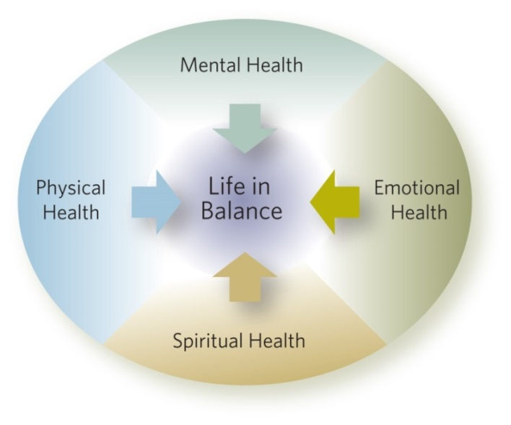
Many of us these days are confused by why things aren’t going quite right in our lives, or why we don’t feel “right”. More than likely we feel overwhelmed physically and emotionally due to the excessive business and overbooking of our schedules. Take a minute to study the circle chart above. Do you find your “Life in Balance?”
If so, GREAT! If not, this might be your answer:
We take time to eat right, exercise, and see a doctor when we are sick. We go to school to learn and most of the time, get our homework done all in hopes to provide for a “better future.” We communicate and care about others in hopes to nurture and grow in our relationships; and often last on our list, and IF we have time we might say a prayer or 2 and MAYBE go to Mass.
As Catholics, we are ALL called to a life in Christ through our Baptism. Jesus wants YOU to know Him and love Him. This makes it essential for us to grow spiritually, and the way we do this, is through the discipline of prayer. Prayer is how we have a relationship with Jesus. In fact, it is the ONLY way we will EVER experience this relationship that He so desires with us.
HCYM is excited to walk with you as your faith grows deeper and your relationship with Jesus grows stronger. Our hope is to offer and teach you a variety of prayer methods. Some you will like, and some, not so much. We do this to give you opportunities to discover which “way to pray “best fits YOU!
This prayer guide is designed for your personal use, to help keep track of which way(s) of prayer you like best. On the back of this paper are many, but not all ways to pray. This is where you will keep track as you experience the type of prayer, the date, like/dislike, and notes as to why/why not, ect. This will serve as a guide when we meet with you one-on –one to discuss your faith journey binder.
Adoration: Date:__________________ Like/Dislike
Date:__________________ Like/Dislike
Notes:
Liturgy of the Hours: Date:_________________ Like/Dislike
Date:_________________ Like/Dislike
Notes:
Rosary: Date:____________________ Like/Dislike
Date:____________________ Like/Dislike
Notes:
Divine Chaplet: Date:_____________________ Like/Dislike
Date:_____________________ Like/Dislike
Notes:
Guided Meditation: Date:________________________ Like/Dislike
Date:________________________ Like/Dislike
Notes:
Lectio Divina: Date:______________________ Like/Dislike
Date:______________________ Like/Dislike
Notes:
Journaling: Date:_________________________ Like/Dislike
Date:_________________________ Like/Dislike
Notes:

