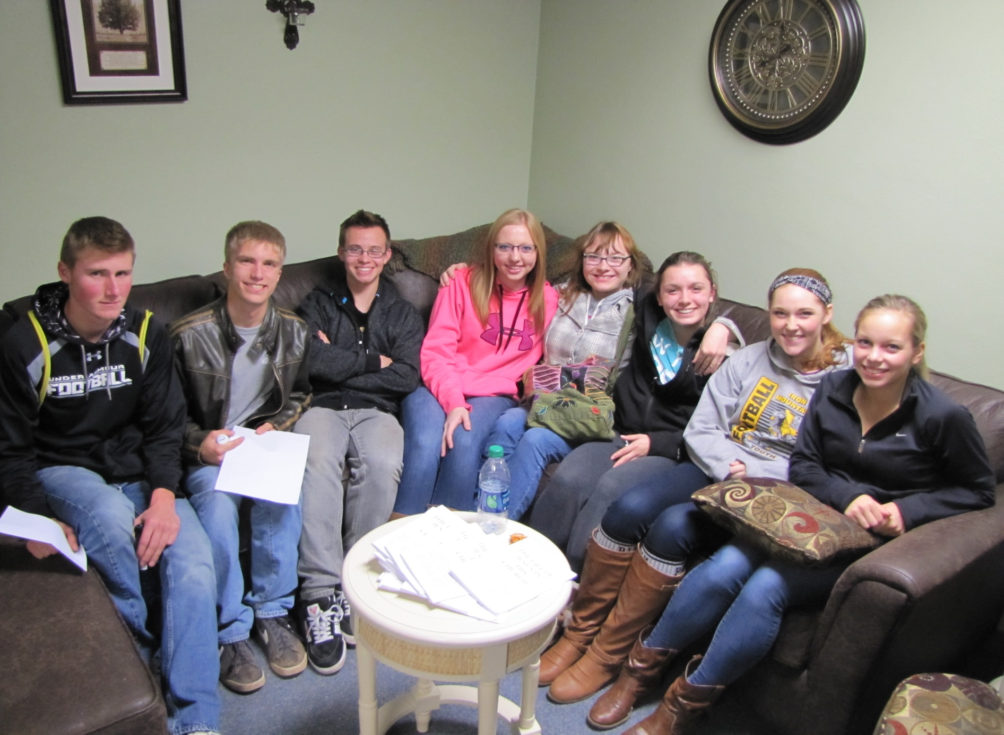

Confirmation class 2014

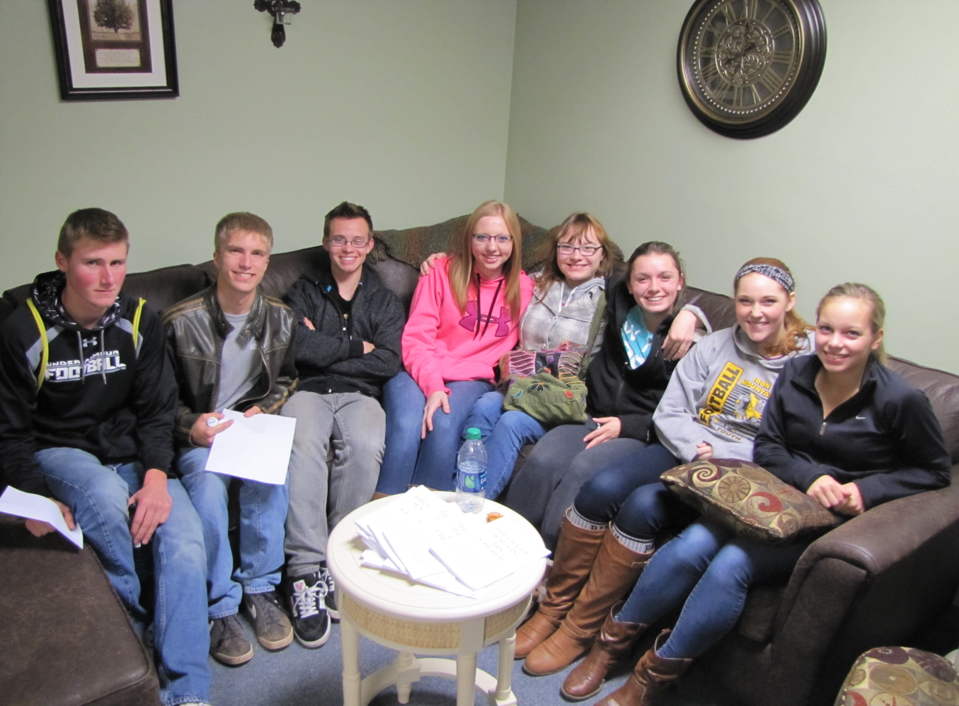

Confirmation class 2014

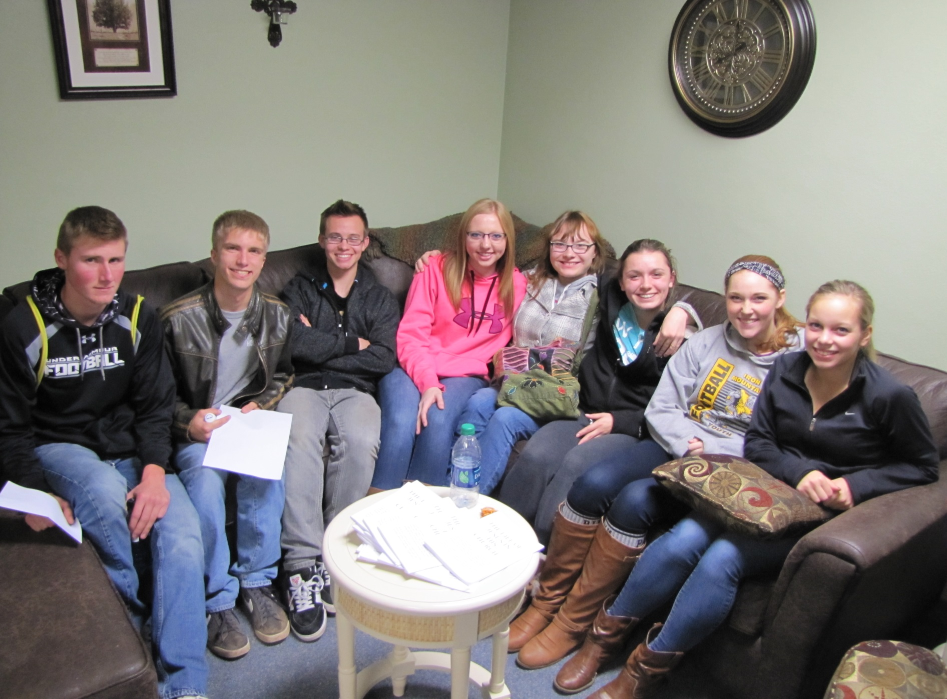

Confirmation class 2014

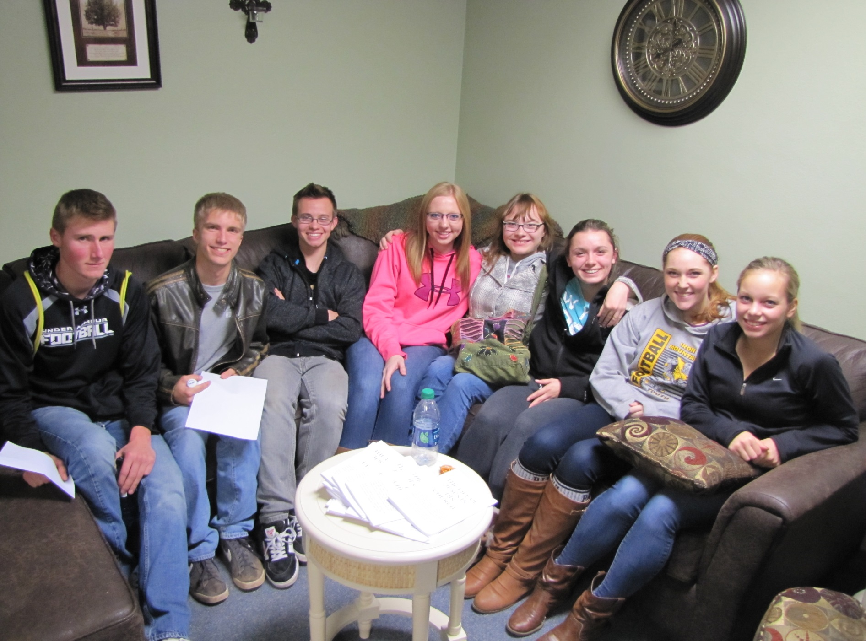

Confirmation class 2014

Please pray for our 2014 Confirmation Class: from left to right we have Patrick Moreau, Tyler Lindquist, Bradley Linsmeyer, Haylee Geib, Maria Sparapani, Maria Miller, Katelyn Nawn, and Shanna Nordell

**Holy Spirit, strengthen these young people with Your gifts of grace, to love and serve as disciples of Christ. Grant that they may live in, with, and through Christ. Fill them with the joy of Your presence. Increase in them the gifts of your Spirit: the Spirit of wisdom, knowledge, understanding, counsel, fortitude, piety, and fear of the Lord; and may the fruits of the Spirit shine forth in their lives.**

**Amen**

Please pray for our 2014 Confirmation Class: from left to right we have Patrick Moreau, Tyler Lindquist, Bradley Linsmeyer, Haylee Geib, Maria Sparapani, Maria Miller, Katelyn Nawn, and Shanna Nordell

**Holy Spirit, strengthen these young people with Your gifts of grace, to love and serve as disciples of Christ. Grant that they may live in, with, and through Christ. Fill them with the joy of Your presence. Increase in them the gifts of your Spirit: the Spirit of wisdom, knowledge, understanding, counsel, fortitude, piety, and fear of the Lord; and may the fruits of the Spirit shine forth in their lives.**

**Amen**

Please pray for our 2014 Confirmation Class: from left to right we have Patrick Moreau, Tyler Lindquist, Bradley Linsmeyer, Haylee Geib, Maria Sparapani, Maria Miller, Katelyn Nawn, and Shanna Nordell

**Holy Spirit, strengthen these young people with Your gifts of grace, to love and serve as disciples of Christ. Grant that they may live in, with, and through Christ. Fill them with the joy of Your presence. Increase in them the gifts of your Spirit: the Spirit of wisdom, knowledge, understanding, counsel, fortitude, piety, and fear of the Lord; and may the fruits of the Spirit shine forth in their lives.**

**Amen**

Please pray for our 2014 Confirmation Class: from left to right we have Patrick Moreau, Tyler Lindquist, Bradley Linsmeyer, Haylee Geib, Maria Sparapani, Maria Miller, Katelyn Nawn, and Shanna Nordell

**Holy Spirit, strengthen these young people with Your gifts of grace, to love and serve as disciples of Christ. Grant that they may live in, with, and through Christ. Fill them with the joy of Your presence. Increase in them the gifts of your Spirit: the Spirit of wisdom, knowledge, understanding, counsel, fortitude, piety, and fear of the Lord; and may the fruits of the Spirit shine forth in their lives.**

**Amen**