LOVE BEGINS HERE 2020
GROUP LEADER GUIDE
“Not all of us can do great things.
But we can do small things with great love.”

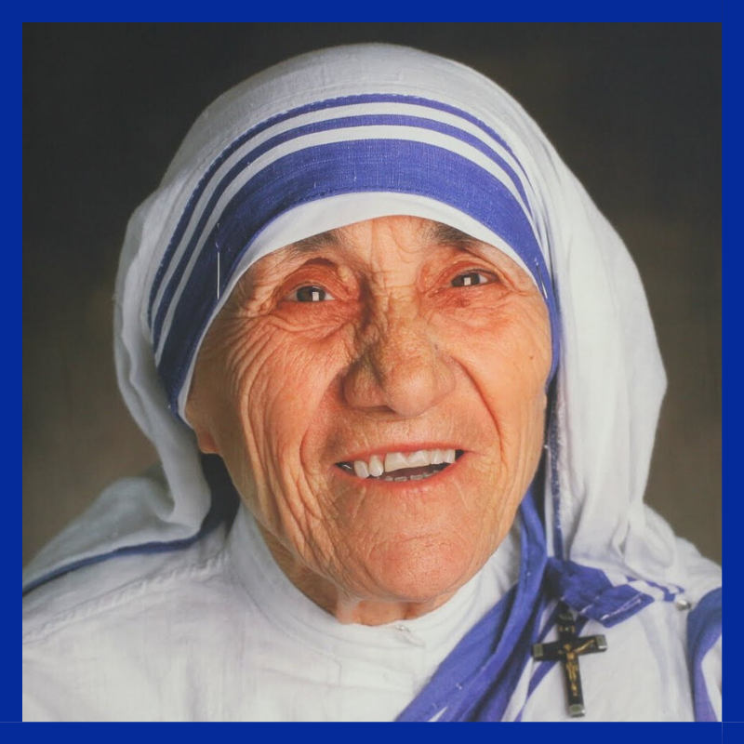

LBH 2020
Dear Parish Leader,
My name is Lynn Terrien and I am the Love Begins Here Coordinator for the Diocese of Green Bay. It brings me great joy that all of you are a part of Love Begins Here right in the Diocese of Green Bay. I am happy that you are by my side to follow in the footsteps of St. Teresa of Calcutta and for your constant YES to God. There is much anticipation as the summer months are approaching, and I cannot wait to meet all of the missionaries who will be serving with us on LBH.
The first thing I would like you to know is that if you have questions at any point, please get in touch. I can be contacted via email at lterrien@gbdioc.org. Also, my office phone is 1-920-272-8302. I would love to meet with you, speak with you over the phone, email or do whatever else to provide you with the help you need as the summer draws near.
This booklet will provide you with lots of information about LBH 2020. I do not want to overwhelm you, but rather give you as many resources as possible to help you get started in preparing for this summer as it is fast approaching. Stay tuned via email as we will be in touch on a regular basis!
With that, I invite you to get started on exploring the inspiring and life-changing world of Love Begins Here.

Blessings,
Lynn Terrien

Resources: Love Begins Here Website
Updates: Love Begins Here Facebook Page
Instagram: lbh_greenbay

To help make sure you stay on track as these dates come and go,
we suggest using the following time sensitive checklist!

December
- Familiarize yourself with all resources listed on page 2. *Most answers are on Love Begins Here Website
- Start publicizing LBH in your newsletters, on your website and in the classroom. Share the dates with families.
- Hang promotional posters around your Parish: LBH 2020 Poster
January
- Create an initial interest form in your Parish to collect positive responses from your youth/families.
- Create and mail postcards to potential missionaries.
February
- Make complete registration packets available in your parish.
- As registrations come in, continually update your Google Doc.
- Share LBH Promo Films with your Faith Formation classes and youth groups. If you want Lynn to come and speak to promote LBH, let her know.
- Hold an informational meeting with interested young people and their families.
- Recruit chaperones. (The number of chaperones you need to provide is a minimum of 1 adult for every 4 youth. You also need to make sure you have room in vehicles for transporting everyone from your parish throughout their LBH experience.)
- Plan any fundraising opportunities you want to make available to your youth. Cost for Middle School is

$100, cost for High School is $120.

March
- Publish bulletin announcements reminding families of the LBH deadlines this month.
- Continually update your Google Doc.
- Brainstorm three creative ways you can advertise LBH this month. Fill them in below.
1. _______________________________________________________________________
2. _______________________________________________________________________
3. _______________________________________________________________________
- Pay close attention to the impending April 30th deadline. Don’t wait until the last minute.
April
- Stay in touch with LBH staff so you are aware of space that is still open on your weeks. This will let you know if you are able to add on more kids to the mission trips you’re registered for.
- Make sure you have transportation in order for the summer (It is important to plan enough seats in the vehicles you are using during the week, not just to and from the Mission Trips. Plan for at least the number of people you are bringing. The chaperones are counted on to provide transportation during LBH Mission Trips).
- Put in a check request for your missionary registration. ALL payments from the parish should come in one group check. Checks can be made out to Love Begins Here – YM Office and mailed to PO Box 23825, Green Bay, WI 54305-3825
- Mail your check so it arrives to the Green Bay Diocese by May 15th.
- Give your chaperones the date of our training day : June 4th.
May
- Hold a meeting with your teen missionaries and their families (and chaperones, if possible) about some of the specific details they will need to know about LBH. Agenda items could include:
- Times/Locations of Departure and Return (*Most Middle School Missions start on Sun at 5 pm and end at 11:30am on Wednesday. High School Mission trips start on Sun at 5 pm and end at 11:30am on Thursday.) *Exception week of July 5th due to the holiday.
- Share packing list / medication form
- Share Sample Weekly Schedule (updated)
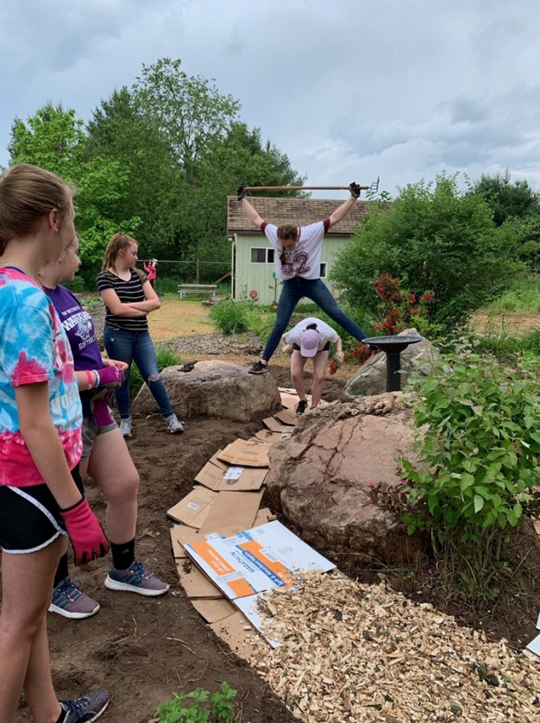
  - Share LBH Social Media Accounts : Love Begins Here Facebook Page, Instagram: lbh_greenbay
- Recruit others in your Parish to pray for your teens by name during their Mission Trips and for LBH, in general! Think about having them write notes to share with your missionaries during Parish Time each night.
- Pray daily for the mission of LBH, the Core Team and the youth who are attending from your parish.
- Get pumped for this incredible summer!
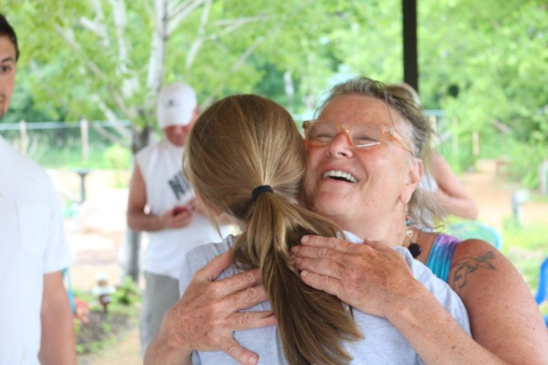

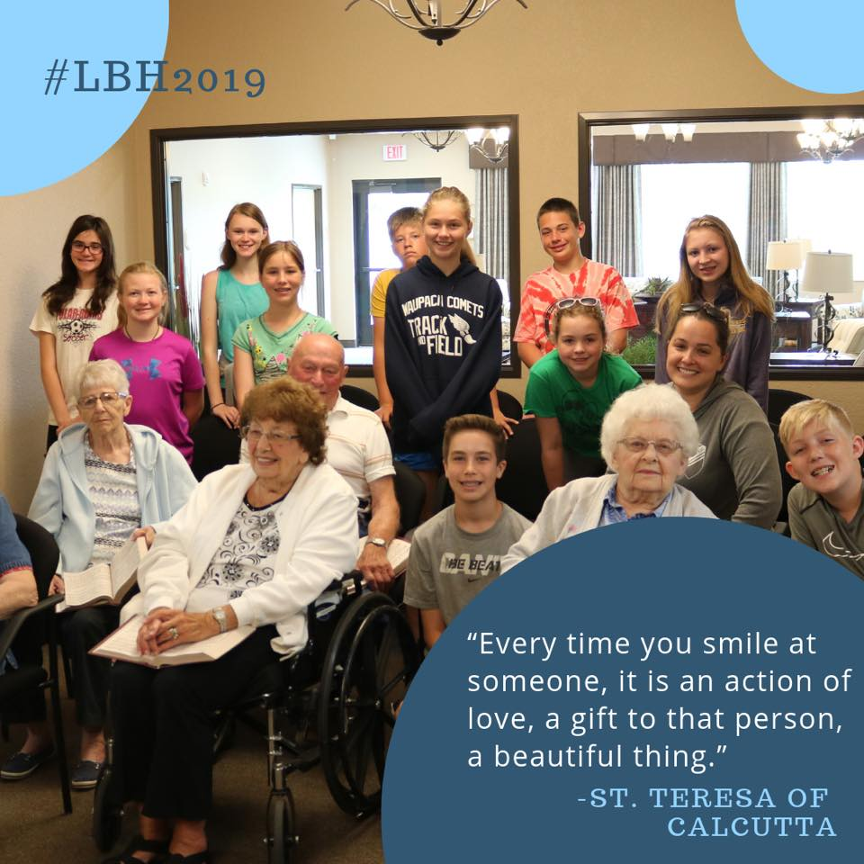
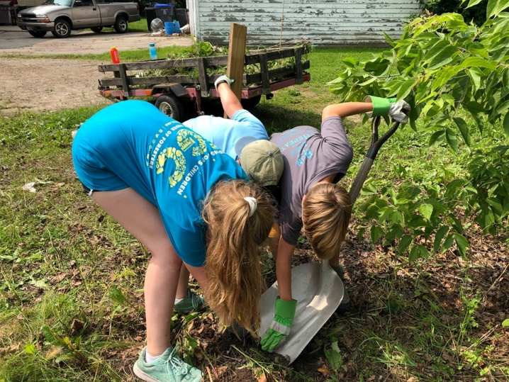

The following dates are important to keep in mind as we journey
towards another summer of local, life-changing mission trips together:

Thursday, April 30th – Final Registration Deadline
This is the BIG DAY. In order for your spots to be confirmed, your teens and chaperones will need to complete their individual registration form at www.gbresources.org/gbyc.html. You, as the group leader, will be given the link to view the incoming registrations via Google Sheets. If information is not complete, your teens and chaperones are not registered.
- Thanks for working with us towards these registration deadlines. At this time in the apostolate, we need to turn our focus in May to training the Core Team, communicating with our host parishes, and making sure that we have the perfect amount of work lined up for our teens to complete while they are on their mission trips.
- These early deadlines will also give you plenty of time to communicate effectively with your families, so their teens are well prepared for their mission trip experience.

Friday, May 15th – Payments Due
All payments must be received by this date. Please collect individual payments and send one collective group check (earmarked for your mission week), and mail: Love Begins Here

Thursday, June 4th – ALL Chaperone Training Day
On this day, we would ask for all 2020 LBH chaperones attend our training session in Green Bay. The location will be at the Chancery building on the Diocesan Office Campus (1825 Riverside Drive, Green Bay, WI 54305). Please get this date out to all of your chaperones as soon as possible. This will begin at 6:00 p.m.
- LBH welcomes adults 21 and older to serve as chaperones who help the teens make the most of their experience. We are especially interested in partnering with adults who are passionate about God, working with teens and service work.
- Parish Group Leaders must insure that all LBH chaperones are in line with Diocesan Safe Environment policies. Chaperones are expected to stay on-site during the week with the missionaries.
- Chaperones are needed to drive early to a morning Mass or late in the evening to where missionaries are swimming and showering. We understand that it is a large sacrifice for adults to spend a week of their summer on the mission field.
- What we will expect is that chaperones have gas in their car to provide transportation during the week and are prepared to spend approximately $20 on taking their car groups out to ice cream during each week they chaperone. We would suggest that as parishes organize chaperones they consider how to reimburse their chaperones for these expenses.

YOU ARE EXCITED ABOUT LOVE BEGINS HERE…..
THAT IS AWESOME!
YOU MAY BE WONDERING…..
HOW CAN I GET YOUTH SIGNED UP FOR LBH?
STEP ONE - - SHARE THE MISSION: Share with them the idea behind Love Begins Here - local, life changing mission work; help others while learning about yourself and the faith. You can also encourage them to think hard about what Mother Teresa said to the world when she accepted the Nobel Peace Prize in 1979: “And so here I am talking with you - I want you to find the poor here, right in your own home first. And begin love there. Be that good news to your own people. And find out about your next-door neighbor - do you know who they are?” Saint Teresa did not want us to come to India to join her in service to the poor. She wanted us to begin right in our own backyards. Love Begins Here is the perfect way to do that.
STEP TWO - - SHARE THE EXPERIENCE: Tell them - with confidence - that they will enjoy coming on Love Begins Here. There are many ways to do this. You could show them some of the many LBH films where they will see other teens having a lot of fun. Give out copies of the LBH Promo Books. All of these resources were inspired by the youth who love LBH, with their peers in mind. This may help them envision having the same life changing experience. Also, use the sample bulletin and Mass announcements we have provided!
STEP THREE - - SHARE SOME ADVICE: You are wise. Probably beyond your years. Feel free to share any of the following and elaborate where necessary. ... Serving others really changes your life. ... In serving the poor, you are able to serve Jesus Christ and know Him more intimately. ... It’s okay to miss a week of work. You are young. Think of it as a personal vacation. ... The people who go on Love Begins Here are cool.
STEP FOUR - - CONTACT THE LBH STAFF: While they can’t promise to solve all your problems, we want to help brainstorm, create you more publicity materials, or even pay your youth a visit.
COSTS: High School Missionary Fees - $120
Middle School Missionary Fees - $100
Chaperones Lead Missionary Fees - FREE
EXAMPLE OF A BULLETIN ANNOUNCEMENT
Christianity is a call to love and a call to serve. We invite you to put your faith in action this summer and serve alongside hundreds of high school and middle school missionaries through a local mission program called Love Begins Here. Inspired by Blessed Mother Teresa’s call to begin love in one’s own community, Love Begins Here invites you to encounter the Lord in an intimate way through service, community, and fun.
• Include dates of the mission trips that your parish has been assigned.
• Include the cost. Some parishes subsidize the cost for their teens or charge a little extra to cover chaperone cost.
• LBH Fees are: High School - $120 + Middle School - $100
• “I really found myself this week and came alive with the joy I felt when I was serving others and gifting myself to our neighbors and those who are in need.” - First Year LBH Missionary. Answer the call to serve this summer and come, be His light to the world
• Include your contact information or however you want them to get a hold of you to register.

EXAMPLE OF A MASS/RELIGIOUS ED. ANNOUNCEMENT
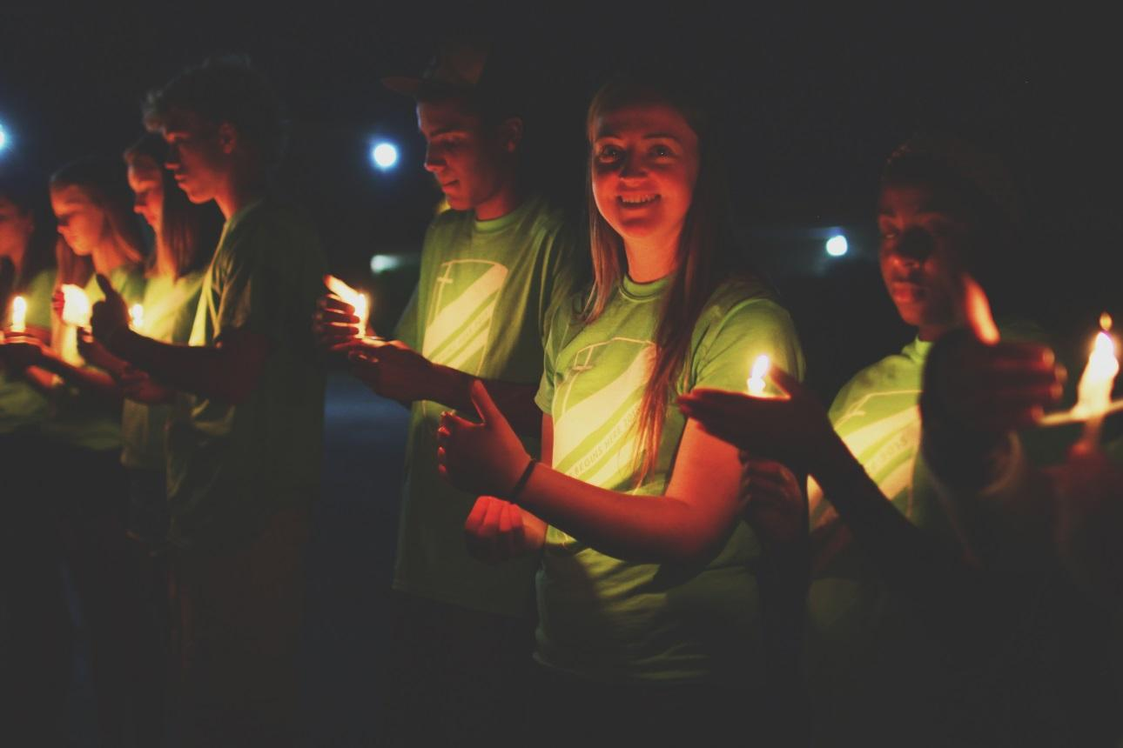
Hey everyone (or insert any colloquial phrase that interests you here)! I just wanted to take a minute to share with you an opportunity for local service this summer. I’ll be taking high school and/or middle school students on local service trips this summer with a program through the Diocese of Green Bay called Love Begins Here. I will be taking kids on these dates <> If you are interested in learning more about Love Begins Here you can reach me here <> or check out Love Begins Here on Facebook. Peace be with you!

