Outline First Reconciliation Parent Child Meeting
October 20/21st, 2015
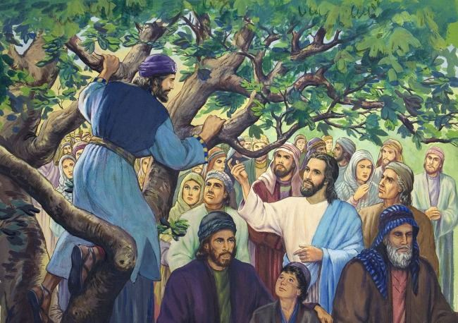
Faith Focus: We are given rules to help us make good and loving choices.
- Welcome (5 min)- Sanctuary
- Prayer and Reflection- Zacchaeus, The Story of Forgiveness (15 minutes) Sanctuary
- Breakout Sessions- Rules to Live By (40 minutes)
- Group 1- Parent Room
- Group 2- Rooms 110/111
- Group 3-Good Samaritan Hall
First Reconciliation Preparation Reminders
- Retreat dates are Nov. 7/8 3-6. Please bring your child's reconciliation book with you as we will be using it during the retreat.
- Please let me know if you have questions about the family sessions as you work through them.
- Just a heads up that child care will not be provided at the retreat.
- Celebration Dates and times are:
- Saturday, November 14th, 10:00 a.m., MBS, (St. Peter), Oshkosh
- Tuesday, November 17th, 5:00 p.m., St. Raphael Church**
- Tuesday, November 17th, 7:00 p.m., St. Raphael Church**
- Thursday, November 19th , 6:00 p.m., St. Mary, OMRO

Break Out Session Numbers

Time and Day/ Number of Families | Jessie | Lucy/Dawn | Tanya
T 4:15 (19) | 6 | 7 | 6
T 5:30 (15) | 5 | 5 | 5
W 4:15 (21) | 7 | 7 | 7
W 5:30 (21) | 7 | 7 | 7

Break out rooms
Group 1: Chapel/Good Samaritan Hall
Group 2: 110/111
Group 3: Parent Room

Wednesday: 5th grade goes to 106

Set up for Howie October 20/21

Tuesday and Wednesday
Gathering space
- 4 tables set up going into for name tags
Sanctuary
30 chairs in semi-circle
Room 110/111
- Break down wall
- Tables and chairs for 24 people
Parent Room:
- Tables and chairs for 20 people

Tuesday ONLY
Chapel
- Tables and chairs for 18 people

Wednesday ONLY
Good Samaritan Hall
- 6 tables angled toward white board with four chairs at each.
- White board set up under “the big screen”

