Outline First Eucharist Parent Child Class
Feb. 3/4
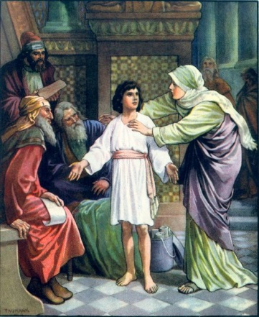
Faith Focus: Children will learn the significance of the items located inside the Church, their importance in the Eucharist, and how they connect to our everyday lives.
- Welcome and Story: Jesus is found in Temple (10 min)
- Church Tour: Families Rotate (45 minutes)
- Station 1- Paula Rieder
- Station 2- Deacon John Ingala
- Station 3- Karen Dean
- Station 4- Fr. Michael Warden/Fr. Doug LeCaptain

- Closing Prayer (5 min.)

