**Preparing a child for**

**First Communion**

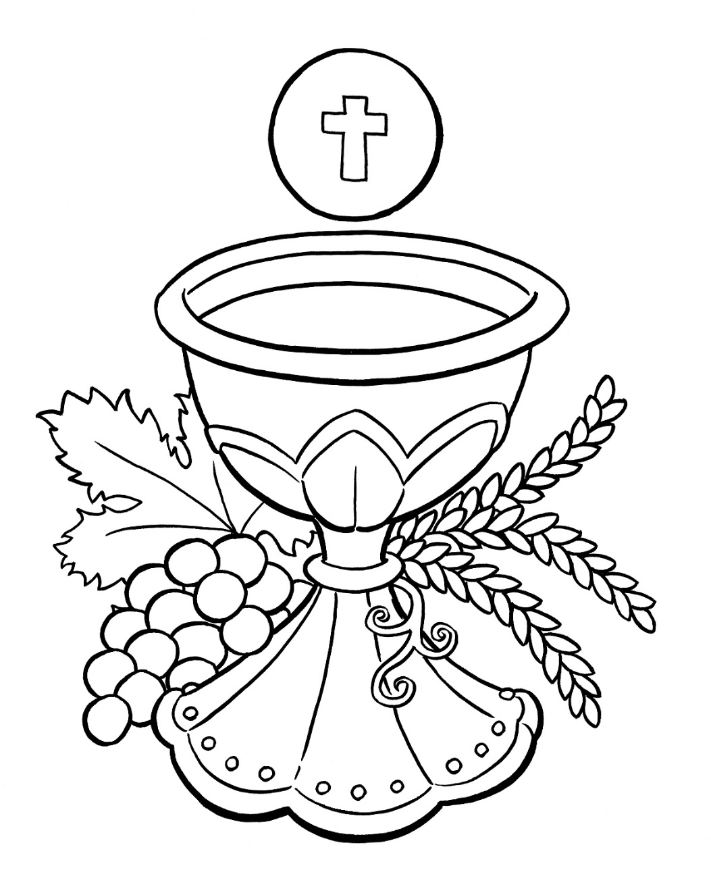

**A Parent’s Guide…**

**Congratulations!**

**You are about to prepare your child to receive another Sacrament of Initiation. Baptism was the first Sacrament of Initiation your child received; probably as a baby.**

**It was YOUR will that your child was baptized and YOU took the responsibility of training your child in the practice of the faith…**

“*You have asked to have your child baptized. In doing so you are accepting the responsibility of training him (her) in the practice of the faith. It will be your duty to bring him (her) up to keep God's commandments as Christ taught us, by loving God and our neighbor. Do you clearly understand what you are undertaking? Parents: We do.”*

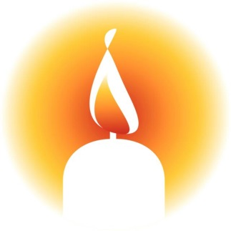

*“Parents and godparents, this light is entrusted to you to be kept burning brightly. This child of yours has been enlightened by Christ. He (she) is to walk always as a child of the light. May he (she) keep the flame of faith alive in his (her) heart. When the Lord comes, may he (she) go out to meet him with all the saints in the heavenly kingdom.”*

**Now your child has reached the age of reason. They are now better able to understand the great gift Jesus has given us in the Eucharist.**

Pope Pius X is the Pope that allowed young, baptized children to receive Jesus in the Eucharist; before that time only adults could receive.

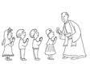One day, the Pope asked a young child, “Whom do you receive in Holy Communion?”

The child answered, “Jesus Christ”

The Pope asked, “Who is Jesus Christ?”

The child answered, “Jesus Christ is God”

The Pope then allowed the child to receive his First Holy Communion. This is what we need to know in order to receive Jesus in the Eucharist.

Unlike Baptism, the Eucharist is a Sacrament that can be received often; even every single day (as in, “give us this day our daily bread”).

The Church obliges the faithful to take part in the Divine Liturgy on Sundays and feast days…” (CCC 1389). This obligation is the responsibility of both you and your child to attend Mass every weekend.

**Coming to Mass every weekend is VERY important.**

This Sacrament of Initiation…

* *Increases our union with Jesus*
* *Preserves, increases, and renews the life of grace received at Baptism*
* *Separates us from sin – wipes away venial sin*
* *Strengthens us to love*
* *Preserves us from future mortal sin*
* 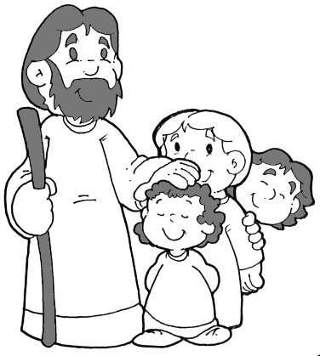*Renews, strengthens, and deepens this incorporation into the Church, already achieved by Baptism (CCC 1391-1396)*

As parents, we care for our children and provide for their needs as best we can. There are some needs we, as parents, cannot give. Only Jesus can give your child these necessities. The best, most caring, gift we can give our child is a rock solid relationship with Jesus. Receiving Jesus in the Eucharist is the most intimate connection with Jesus possible on earth.

**What’s in a Name?**

**This Sacrament is called by many names. Each name reveals a unique aspect (Cf. CCC 1328-1332).**

**Let’s look at some of those names and see what different aspects they reveal…**

**Eucharist** means ‘Thanksgiving’

This name recalls the great works of God in

creation,

redemption, and

sanctification.

Using this name reminds us of our need to thank God for all He has done, is doing, and will do. Especially thanking Him for the gift of the Eucharist: “It is truly right to give Him thanks and praise”

Let us be like that 10th leper who came back in order to thank Jesus for healing him (Luke 17:11-19).

The **Holy Sacrifice of the Mass** reminds the faithful that Jesus is truly “the Lamb of God who takes away the sins of the world”. The sacrifice of Jesus is re-presented every time the Mass is celebrated. “It completes and surpasses all the sacrifices of the Old Covenant” (CCC 1330).It is Jesus’ body, given up for us and Jesus’ blood, shed for the forgiveness of sins:

Jesus said to them, “Amen, amen, I say to you, unless you eat the flesh of the Son of Man and drink his blood, you do not have life within you. Whoever eats my flesh and drinks my blood has eternal life, and I will raise him on the last day. For my flesh is true food, and my blood is true drink. Whoever eats my flesh and drinks my blood remains in me and I in him (John 6:54-56).

When we call this Sacrament **Communion,** we remember it unites us to Jesus and the entire Church (on earth, in purgatory, or in heaven). The Church is the Body of Christ; united in the Holy Spirit (Cf. 1 Corinthians 12)

The **Mass** is referring to the liturgy where the Sacrament is celebrated. It comes from the word *missio*, which is a sending forth. We are sent in order to bring Jesus into the world we live. When you say, “let us go to Mass” you are reminding yourself that God gives His gifts for a purpose***.***

God’s gifts are not just for you!

They are meant to be lived and shared!

In the Mass we join the angels and saints in worshiping God:“In the earthy liturgy we share in a foretaste of that heavenly liturgy…” (CCC 1090).

**PREPARATION…**

“To respond to this invitation we must prepare ourselves for so great and so holy a moment” (CCC 1385).

* Examine our conscience – Are we in a state of grace?
  + “Anyone conscious of a grave sin must receive the sacrament of Reconciliation before coming to communion” (CCC 1385).
  + “According to the Church’s command, ‘after having attained the age of discretion, each of the faithful is bound by an obligation faithfully to confess serious sins at least once a year’” (CCC 1457).
  + “Children must go to the sacrament of Penance before receiving Holy Communion for the first time.” (CCC 1457).
* Observe the fast (CCC 1387)
  + No eating or drinking ONE HOUR prior to receiving Jesus in the Eucharist.
  + This includes gum chewing!
* 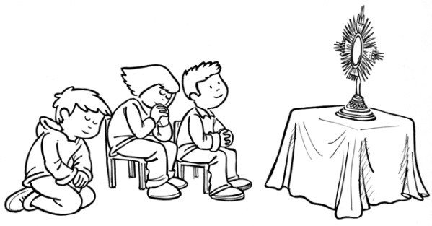Our “Bodily demeanor (gestures, clothing) ought to convey the respect, solemnity, and joy of this moment when Christ becomes our guest” (CCC 1387).

Other ideas…

* Visit Jesus in the Blessed Sacrament either at St. Anthony Parish or the Eucharistic Chapel in Iron Mountain
* Make the sign of the cross every time you walk or drive by a Catholic Church
* Pray regularly at home with your child
* Teach your child vocal, mental, and contemplative prayer
* Spend time reading Bible stories to your child
* Teach your child how to offer up sacrifices for the love of Jesus

Our faith is caught, not taught…

The best preparation you can give your child for his/her First Holy Communion is through your example of living our Catholic faith every day! Make sure to go to Mass and frequent the Sacrament of Reconciliation…

**The Sacrament of Reconciliation…**

1. **In the name of the Father, and of the Son, and of the Holy Spirit. Amen.**
2. **Forgive me, Father, for I have sinned. This is my first confession**
3. **These are my sins…**
4. **For these sins and the sins of my whole life, I am sorry**

1. *Listen to Father – Remember the penance he gives you!*
2. **O my God, I am heartily sorry for all my sins, because in choosing to do wrong and failing to do good, I have sinned against You who are all good and deserving of all my love. I firmly intend now, with the help of Your grace, to do penance and to amend my life. Our Savior Jesus died to set us free, so in His name, Lord, have mercy on me. Amen.**
3. *"*God, the Father of mercies, through the death and resurrection of His Son has reconciled the world to Himself and sent the Holy Spirit among us for the forgiveness of sins; through the ministry of the Church may God give you pardon and peace, and I absolve you from your sins in the name of the Father, and of the Son, + and of the Holy Spirit.*"*

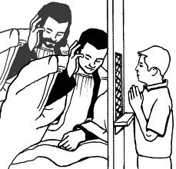

1. *you answer:* **"Amen"**

**What do you do after leaving the confessional?**

After leaving the confessional, I do the penance the priest has given me and say another prayer to thank God for forgiving my sins.

**Remember:**

* Do not be afraid. Tell the truth.
* Tell all the sins you can remember.
* Do not forget to tell a sin on purpose.
* Say your Act of Contrition from your heart - really mean what you are saying.
* This sacrament will give us peace and strength
* Do the penance given to you!

**St. Thérèse is a great Saint in the Church; she was even named a Doctor of the Church! At the young age of 24, she died peacefully surrounded by her Carmelite Sisters. Here is her description of her First Holy Communion on the 8th of May, 1884 in her own words…**

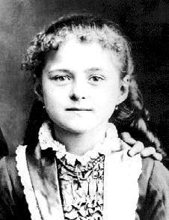At last the most wonderful day of my life arrived, and I can remember every tiny detail of those heavenly hours: my joyous waking up at dawn, the tender, reverent kisses of the mistresses and older girls, the room where we dressed -- filled with the white "snowflakes" in which one after another we were clothed -- and above all, our entry into chapel and the singing of the morning hymn: "O Altar of God, Where the Angels are Hovering." I would not tell you everything, even if I could, for there are certain things which lose their fragrance in the open air, certain thoughts so intimate that they cannot be translated into earthly language without losing at once their deep and heavenly meaning. How lovely it was, that first kiss of Jesus in my heart -- it was truly a kiss of love. I knew that I was loved and said, "I love You, and I give myself to You forever." Jesus asked for nothing, He claimed no sacrifice. Long before that, He and little Thérèse had seen and understood one another well, but on that day it was more than a meeting -- it was a complete fusion. We were no longer two, for Thérèse had disappeared like a drop of water lost in the mighty ocean. Jesus alone remained -- the Master and the King. Had she not asked Him to take away her liberty, the liberty she feared? She felt so weak and frail that she wanted to unite herself forever to His Divine Strength. And her joy became so vast, so deep, that now it overflowed. Soon she was weeping, to the astonishment of her companions, who said to one another later on: "Why did she cry? Was there something on her conscience? Perhaps it was because her mother was not there, or the Carmelite sister she loves so much." It was beyond them that all the joy of Heaven had entered one small, exiled heart, and that it was too frail and weak to bear it without tears. As if the absence of my mother could make me unhappy on the day of my First Communion! As all Heaven entered my soul when I received Jesus, my mother came to me as well. Nor could I cry because you were not there, we were closer than ever before. It was joy alone, deep ineffable joy that filled my heart.

That afternoon I was chosen to read the "Act of Consecration to Our Lady." I suppose they chose me because I had lost my earthly mother so young. Anyway, I put my whole heart into it and begged Our Lady to guard me always. I felt sure she was looking at me with that lovely smile which had cured me and delivered me, and I knew all I owed her; for it was she herself, that morning of the 8th of May, who placed Jesus in my soul, "the flower of the field and the lily of the valley."

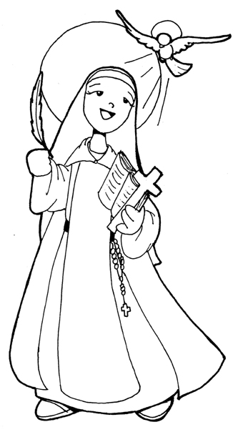When evening came that lovely day, Father led his little queen by the hand to Carmel, and there I saw you made the bride of Christ. I saw your veil, all white like mine, and your crown of roses. There was no bitterness in all my joy, for I hoped to join you and wait for Heaven at your side.

I was very moved by the family feast prepared at Les Buissonets and delighted with the little watch which Father gave me. Yet my happiness was very tranquil, with an inward peace no earthly thing could touch. Night came at last to end my lovely evening, for darkness falls even on the brightest day. Only the first day of Communion in Eternity will never end.

Source: *Story of a Soul* [St. Thérèse's autobiography], Rockford, Illinois: TAN Books and Publishers, Inc.

Quotes from Saints about the Blessed Sacrament..

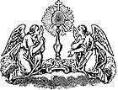

“Do you want the Lord to give you many graces? Visit Him often. Do you want Him to give you few graces? Visit Him rarely. Do you want the devil to attack you? Visit Jesus rarely in the Blessed Sacrament. Do you want him to flee from you? Visit Jesus often. Do you want to conquer the devil? Take refuge often at the feet of Jesus. Do you want to be conquered by the devil? Forget about visiting Jesus. My dear ones, the visit to the Blessed Sacrament is an extremely necessary way to conquer the devil. Therefore, go often to visit Jesus and the devil will not come out victorious against you.” - St. John Bosco

“Certainly amongst all devotions, after that of receiving the sacraments, that of adoring Jesus in the Blessed Sacrament holds first place, is most pleasing to God, and most useful to ourselves. Do not then, O devout soul, refuse to begin this devotion; and forsaking the conversation of men, dwell each day, from this time forward, for at least half or quarter of an hour, in some church, in the presence of Jesus Christ under the sacramental species. Taste and see how sweet is the Lord.” - St. Alphonsus Liguori

**“Perpetual Eucharistic Adoration with exposition needs a great push. People ask me: ‘What will convert America and save the world?’ My answer is prayer. What we need is for every parish to come before Jesus in the Blessed Sacrament in holy hours of prayer.” - Mother Teresa of Calcutta**

“When the Sisters are exhausted, up to their eyes in work; when all seems to go awry, they spend an hour in prayer before the Blessed Sacrament. This practice has never failed to bear fruit: they experience peace and strength.” - Mother Teresa of Calcutta

“Know also that you will probably gain more by praying fifteen minutes before the Blessed Sacrament than by all the other spiritual exercises of the day. True, Our Lord hears our prayers anywhere, for He has made the promise, ‘Ask, and you shall receive,’ but He has revealed to His servants that those who visit Him in the Blessed Sacrament will obtain a more abundant measure of grace.” - St. Alphonsus Liguori

Keep close to the Catholic Church at all times, for the Church alone can give you true peace, since she alone possesses Jesus, the true Prince of Peace, in the Blessed Sacrament - St. Padre Pio

"He loves, He hopes, He waits. If He came down on our altars on certain days only, some sinner, on being moved to repentance, might have to look for Him, and not finding Him, might have to wait. Our Lord prefers to wait Himself for the sinner for years rather than keep him waiting one instant." -St. Julian Peter Eymard

“If souls but understood the Treasure they possess in the Divine Eucharist, it would be necessary to encircle the tabernacles with the strongest ramparts for, in the delirium of a devouring and holy hunger, they would press forward themselves to feed on the Bread of Angels. The Churches would overflow with adorers consumed with love for the Divine prisoner no less by night than by day.” - Bl. Dina Belanger

“To withdraw from creatures and repose with Jesus in the Tabernacle is my delight; there I can hide myself and seek rest. There I find a life which I cannot describe, a joy which I cannot make others comprehend, a peace such as is found only under the hospitable roof of our best Friend.” - St. Ignatius

**“I encourage Christians regularly to visit Christ present in the Blessed Sacrament, for we are all called to abide in the presence of God.” - Pope John Paul II**

“Be with Him willingly; don’t lose so good an occasion for conversing with him as is the hour after having received Communion. If obedience should command something, Sisters, strive to leave your soul with the Lord. If you immediately turn your thought to other things, if you pay no attention, and take no account of the fat that he is within you, how will he be able to reveal himself to you? This, then is a good time for our Master to teach us, and for us to listen to him, kiss his feet because he wanted to teach us, and beg him not to leave.” - Teresa of Avila

**“But after having received the Lord, since you have the person himself present, strive to close the eyes of the body and open those of the soul and look into your own heart.” Teresa of Avila.**

“So His majesty is being merciful enough to all of us who love him, by letting us know that it is he who is present in the most Blessed Sacrament. He doesn’t want to show himself openly, communicate his grandeurs, and give his treasures except to those who he knows desire him greatly; these are his true friends.” – Teresa of Avila

“Certainly, I think that if we were to approach the most Blessed Sacrament with great faith and love, once would be enough to leave us rich. How much richer from approaching so many times as we do. The trouble is we do so out of routine, and it shows. O miserable world, you have so covered the eyes of those who live in you that they do not see the treasures by which they could win everlasting riches. “ –Teresa of Avila

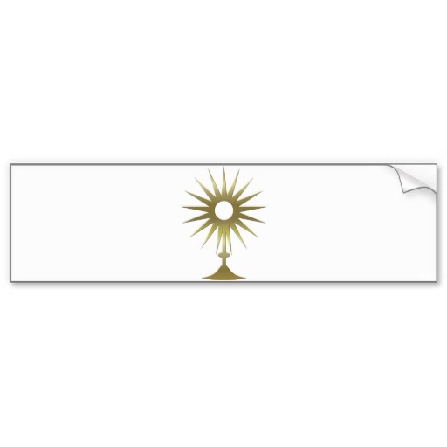

Signs of the Sacrament

Bread…

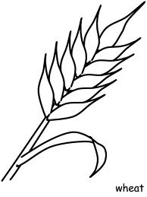Bread is a symbol of life. Bread is eaten in most places around the world and has been a staple of life at different times in history. Wheat provides a source of nutrition for many cultures. Jesus gives us life in the Eucharist. Unleavened bread is used because God’s people needed to leave Egypt in a hurry. They didn’t have time to add yeast and let the bread rise. We need to remember that our journey is leading us towards heaven; don’t take the time and wait for sin to grow in your life. Keep on moving towards God.

Wine…

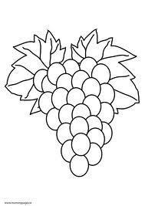Jesus turned many jugs of water into wine at the wedding feast of Cana to help a marriage celebration be even more joyous. Jesus, in our time, turns the wine we bring forward at Mass into His blood that our joy may be full. The wine used at Mass must be made from grapes that have fermented. The bread and the wine are the MATTER for the Sacrament of Holy Communion. The FORM are the words Jesus used at the Last Supper.

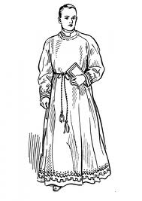Priest…

Jesus is always the true priest at every celebration of the Mass. Jesus has called special men to serve at the Altar so they can be a symbol of His presence in the world. Only a Catholic priest can celebrate the Mass and pray for the Holy Spirit to turn the bread and wine into the Body and Blood of Jesus. Without a priest, there would be no Eucharist. At the Last Supper Jesus instituted the Ministerial priesthood. These priests are different from the “common priesthood” of all baptized believers. He taught His Apostles that a priest must be the servant of all. It is a great honor to be a priest and serve God’s people!

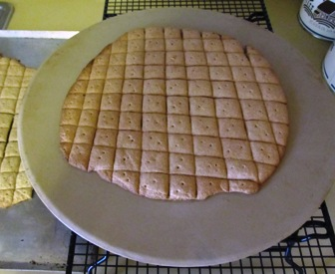**Try this Communion Bread recipe at home..**  
  
For each loaf use:

½ cup whole wheat flour

½ cup unbleached white flour

½ cup water

Combine and knead until well mixed (Keep a mixture of both flours handy to use if more flour is needed). Knead for at least 5-8 minutes, let dough rest for 5-10 minutes, and knead again. (The kneading and rest periods are very important in preparing this unleavened dough). Roll out dough and cut or form into a loaf 6-7 inches round (size of a 3-lb. coffee can) by ½ inch thick. Score loaves with a scoring mold. Place loaves on ungreased baking sheet (a very light coating of non-stick spray may be used if they want to stick to the pan). Bake at 375 to 425 degrees for approximately twenty to thirty minutes (depends on each oven, size of loaf and type of baking sheet -a cast iron skillet bakes more evenly and in less time than a cookie sheet).

**Enrollment in the Brown Scapular…**

**What is A Scapular?**

The Brown Scapular of Our Lady of Mount Carmel;

The Scapular is a Roman Catholic devotion to Mary under her title of Our Lady of Mount Carmel. It is worn as a sign of love and devotion for the Mother of God. The Carmelite Order, to which the Scapular belongs, originated on Mt. Carmel in the Holy Land and the Scapular is itself a reflection in miniature of the Habit (scapular: a sleeveless outer garment falling from the shoulders) which the monks wear as a sign of their vocation and devotion. Over the years the scapular, at least for lay people, became much reduced in size to but small pieces of wool cloth suspended front and back.

The Scapular came to symbolize the special dedication of Carmelites to Mary, the Mother of God, and to express trust in her motherly protection as well as the desire to be like her in her commitment to Christ and to others. Thus it became a sign of Mary.

**Rules and Rituals of the Scapular**

 People are enrolled in the Scapular only once by a priest or authorized person.

* The Scapular can be replaced afterwards by a medal, which has on one side the image of the Sacred Heart of Jesus and on the other, the image of Mary.
* 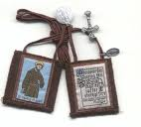The Scapular holds us to live as authentic Christians in line with the teaching of the Gospel, to receive the sacraments, to profess our special devotion to the Blessed Virgin, which should be expressed each day, at least by saying the Hail Mary three times.

**The Value and Meaning of the Scapular**

 The Blessed Virgin teaches us:

* To be open to God, and to his will, shown to us in the events of our lives;
* To Listen to the Word of God in the Bible and in life, to believe in it and to put into practice its demands;
* To pray at all times, as a way of discovering the presence of God in all that is happening around us;
* To be involved with people, being attentive to their needs.

The Scapular finds its roots in the tradition of the Order, which has seen in it a sign of Mary’s motherly protection. It has therefore, a centuries old spiritual meaning approved by Church.

* It stands for a commitment to follow Jesus, like Mary, the perfect model of all the disciples of Christ. This commitment finds its origin in baptism by which we become children of God.
* It leads us into the community of Carmel, a community of religious men and women, which has existed in the Church for over eight centuries.
* It reminds us of the example of the saints of Carmel, with whom we establish a close bond as brothers and sisters to one another.
* It is an expression of our belief that we will meet God in eternal life, aided by the intercession and prayers of Mary.

**The Carmelite Scapular is not:**

* a magical charm to protect you
* an automatic guarantee of salvation
* an excuse for not living up to the demands of the Christian life

**It is a sign:**

* which has been approved by the Church for over seven centuries;
* which stands for the decision to
* follow Jesus like Mary:
* be open to God and to his will
* be guided by faith, hope, and love
* to pray at all times
* to discover God present in all that happens around us.

**Praying the Family Rosary**

C:\Users\Dawn\AppData\Local\Microsoft\Windows\Temporary Internet Files\Content.IE5\8A21KY43\MC900390618[1].wmfThe Family Rosary is one of those bedrock devotions for the family recommended by the saints and spiritual masters. The Blessed Virgin Mary herself asked all Christians to pray the "one third {i.e. 5 decades} of the Holy Rosary daily" in her message at Fatima.   
  
The Rosary is the "rose garden" of sanctify for children. As the Holy Spirit teaches us: "Train up a child in the way he should go: and when he is old, he will not depart from it” (Proverbs 22:6).  
  
Saint Louis de Montfort gives us eight reasons for praying the Rosary *daily*:  
  
1. It gradually gives us a perfect knowledge of Jesus Christ.  
2. It purifies our souls, washing away sin.  
3. It gives us victory over all our enemies  
4. It makes it easy for us to practice virtue  
5. It sets us on fire with love of Our Blessed Lord  
6. It enriches us with graces and merits  
7. It supplies us with what is needed to pay all our debts to God and to our fellow men, and finally, it obtains all kinds of graces for us from God  
8. It gives us the knowledge of Jesus Christ and the science of salvation through our meditations on His life, death, Passion and glory.  
  
Okay, are you convinced? The family Rosary is the most powerful tool you have for edifying your family in grace.  
So how do you get a bunch of children under the age of reason (or above the age of reason) to pray 5 decades of the Rosary every day? How can they sit still for 15 minutes? Is it possible?

Below are some tips on how to maintain the daily family Rosary.

**Twelve Tips for Praying the Family Rosary Daily**

1. Pray using alternation (One person, prays first half of Our Father and everyone else prays second half - same goes for Hail Mary and Glory be, alternate the lead every decade/night).
2. Pray the Rosary after dinner but right before bed - this means homework needs to be finished before dinner. *Homework kills the Rosary* if you don't stay on top of it. You'll also need to say goodbye to watching prime time television - since this is the ideal window of praying together as a family.
3. Pray the Holy Rosary always at the same place at the exact same time. Devotions become strong - even invincible - by constant custom and habit.
4. Pray the Rosary in a special room, and it is nice to set up a little altar/prayer table with a Bible on it, candles, a statue or image, holy water, or a relic.
5. Dim the lights and light the candles when you begin. If you let the little ones light the candles - they will love it. Kids love fire. Make this a "special time" different from other times. You can even burn incense on feast days for something special. (You can purchase incense sticks or cones)
6. Maybe begin with a hymn or Bible reading to slow things down and set the tone.
7. The parents should set the example, maybe kneeling for the whole Rosary. This communicates importance and solemnity to the Rosary. Children attach importance to what the parent does, e.g. mowing lawn, going to work, driving, etc.
8. Make it a rule that the child who prays all the responses and volunteers to lead a mystery (10 beads) gets to stay up 10 minutes more than everyone that night – (could be to watch an extra 10 minutes TV or to have a book read to them). This may be the most important tip. Kids under 7 or 8 need this sort of incentive. If you tell a 6 year old, pray the Rosary so that you receive grace and sanctity - they don't get it. If you say, pray the Rosary so that you can stay up and read a book with me - they'll hit their knees and pray like angels.
9. The one who gets to stay up also gets to blow out the candle at the end. This gives another incentive to pray the prayers - especially for the younger ones. For some reason, blowing out the candle is a really big deal to younger children. (Kids love fire!!!). You'd be amazed how a four year old will attempt to stay still if he can only place a grain of incense on a flame or blow out a candle. (Did I mention that kids love fire?)
10. End with invoking everyone's patron saint (your children's names, confirmation names, and other patrons). E.g. "Saint Thomas: pray for us. Saint Jude: pray for us. Saint Anne: pray for us." Always finish with St Joseph and then Holy Mary Mother of God. Then say "Sacred Heart of Jesus: have mercy on us," three times. You can also pray an Our Father and Hail Mary for the Pope.
11. If family Rosary is new, start with one decade for a week. Then go to three for a week. Then go to five decades on the third week. Then don't ever stop.
12. After the daily Rosary is established in your home, have each child announce a mystery and pray the whole decade. This gives them confidence in praying and makes it natural. Plus, they'll learn to memorize all the mysteries of the Holy Rosary - which means they will have memorized the biblical account of Christ's life, death, and glory! This is why the Rosary is called "the Bible on beads."

*If you do this, then you'll be producing saints for the future.*

**Glorious Mysteries (Sunday and Wednesday)**

1st – The Resurrection of Jesus

2nd – The Ascension of Jesus

3rd – Descent of Holy Spirit-

Pentecost

4th – Assumption of Mary to Heaven

5th – Crowning of Mary in Heaven

**Luminous Mysteries (Thursday)**

1st – Baptism of Jesus in the Jordan

2nd – Wedding at Cana

3rd – Proclamation of the Kingdom

4th – The Transfiguration

5th – Institution of the Eucharist at

the Last Supper

**Joyful Mysteries (Monday and Sunday)**

1st – The Annunciation

2nd – The Visitation

3rd – The Nativity- Jesus’ Birth

4th – The Presentation of Jesus

5th – Finding Jesus in the Temple

**Sorrowful Mysteries (Tuesday and Friday)**

1st – Agony in the Garden

2nd – The Scourging

3rd – Crowning with thorns

4th – Carrying the Cross

5th – Crucifixion

**Prayers of the Rosary…**

**The Sign of the Cross:**

In the name of the Father, and of the Son, and of the Holy Spirit. AMEN

**Our Father**, Who art in heaven; hallowed be Thy name; Thy kingdom come; Thy will be done on earth as it is in Heaven. Give us this day our daily bread; and forgive us our trespasses as we forgive those who trespass against us, and lead us not into temptation; but deliver us from evil. Amen.

**Hail Mary**, full of grace, the Lord is with thee: blessed art thou among women, and blessed is the fruit of thy womb, Jesus. Holy Mary, Mother of God, pray for us sinners, now and at the hour of our death. Amen.

**Glory be to the Father**, and to the Son, and to the Holy Spirit. As it was in the beginning, is now, and ever shall be, world without end. Amen

**Other Prayers to Learn…**

**St. Michael** the Archangel, defend us in battle. Be our defense against the wickedness and snares of the Devil. May God rebuke him, we humbly pray, and do thou, O Prince of the heavenly hosts, by the power of God, thrust into hell Satan, and all the evil spirits, who prowl about the world seeking the ruin of souls. Amen.

**Angel of God**, my guardian dear, To whom God's love commits me here, Ever this day (or night), be at my side, To light and guard, Rule and guide. Amen.

**Grace Before Meals**: Bless us, O Lord, and these Thy gifts, which we are about to receive from Thy bounty, through Christ our Lord. Amen.

**Grace After Meals**: We give You thanks for all Your benefits, O Almighty God, who lives and reigns world without end. Amen.

May the souls of the faithful departed, through the mercy of God, rest in peace. Amen.

Calendar of Events 2015-2016:

**October**

Sunday, 18th parent meeting at 9:15am (meet in church then 2:20 room)

**December**

Saturday, 12th Reconciliation Retreat 10:00 a.m. – noon

Saturday, 19th Reconciliation Celebration 10:00 a.m.

**January**

Attend assigned interview with Fr. Matt ____________________________

*(Write in the date you signed up for)*

Sunday, 17th Rite of Enrollment during Mass (your child will come forward and sign his/her name)

**March**

Saturday, 12th First Communion Retreat and Potluck 9am-1pm

**April**

Saturday, 16th tentative - Field trip to the Carmelite Monastery

Saturday, 30th Confessions and rehearsal for First Communion starting at 9:00 a.m. with parents

**May**

**Sunday, 1st First Communion during Mass and enrollment in Brown Scapular.** *Appropriate dress: Girls in white dress and veil (NO GLOVES while receiving Jesus!); Boys in dress pants, white shirt, and tie.*

Sunday, 8th Second Communion during Mass

Sunday, 15th Third Communion during Mass

Sunday, 22th Fourth Communion during Mass…

**Class times are listed on the regular RE Calendar: If your child misses a class please call and get the make-up work to do at home.**

**Class and Mass attendance is mandatory.**

FIRST COMMUNION INFORMATION

PLEASE PRINT

NAME: _____________________________________________________

(FIRST) (Middle) (Last)

(Spell your child’s name clearly and as you would like it written on the certificate)

PHONE #:_______________________________________

ADDRESS: __________________________________________________

(Street Address) (City) (State) (Zip Code)

E-MAIL ADDRESS: __________________________________________

DATE OF BIRTH: ____________________AGE:____________________

FATHER’S NAME: ____________________________________________

(Last) (First) (Middle)

MOTHER’S NAME: ____________________________________________

(Last) (First) (Maiden)

DATE OF BAPTISM: _________________

PLACE OF BAPTISM (Church name): _________________________

CITY: ___________________STATE: ______ZIP CODE: _____________

**How many people in your family will attend the potluck?____________**

**What will you bring as a dish to pass? ___________________________**