Parent Faith Sharing in Class

Parents, please come to our class in two weeks, Oct. 15, to share your faith with us. We’ve found that personal stories really make an impact on kids especially in the pre-teen years. You may not feel that your story is important or worth sharing, but God works in ways we don’t always understand. Our story may touch someone else in a very meaningful way, etc. We look forward to learning from you, and sharing with you. Please don’t feel nervous. We all have something to share that will inspire others. Below are some possible questions you could share your answers to:

- What experiences have helped you to grow in your faith?

- What is your favorite way to pray?

- What do you appreciate most about being Catholic, and if you were not always Catholic how and why did you convert?

- When do you feel closest to God?

- Who are some of the Christian role models you’ve had in life (people you know and/or favorite saints)?

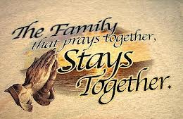
- Describe a time when God brought you through a difficult experience or a miracle that happened in your life or the life of someone you know personally.

- What is your favorite Bible verse or story and why?

Parent Sharing Possible Schedule
(change this however you’d like)

- Have everyone introduce themselves (including you and the kids) and say something about themselves (family info., where work, a moment they saw God in the past week)
- Take turns sharing about each question or have each person share about all questions and then move on.
  - Teacher and kids can share too if they want to. Please let the kids know/ask them.
- If you finish early, you could all go into church to join in the rosary or do a review type game with parents against kids or mixed teams, or read a Bible story and have everyone share what struck them most/questions (lectio divina).

