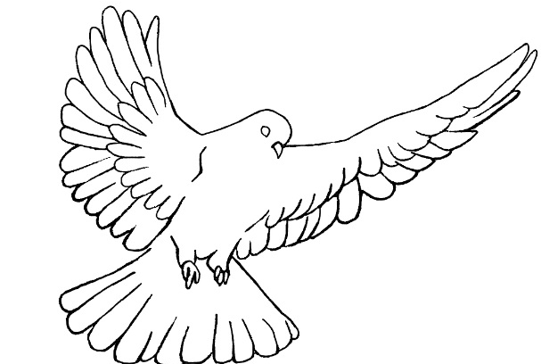
Protective Behavior Booklet

TEACHER GUIDE

3rd – 4th Grade

A Safe Environment Curriculum

Protective Behavior
St. Anthony Parish
3rd & 4th Grade

Learning objectives:
- The Holy Spirit lives in His children (Temples of the Holy Spirit)
- We protect our body and soul from harm
- We put on the armor of God to keep safe
- We feel safe with our friends: they help protect us and we help protect them
- We need to know how to handle people who do not help us feel safe

Materials Needed:
- Song “Fruits of the Spirit”
- Lesson plan
- Handouts:
  - Booklet for each student to color and take home

♪ Fruits of the Spirit ♫
The fruit of the Spirit’s not a coconut – coconut (watermelon, banana, etc.)
The fruit of the Spirit’s not a coconut – coconut. If you want to be a coconut – coconut - you might as well hear it; you can’t be a fruit of the Spirit. Because the fruits are love, joy, peace, patience, kindness, goodness, faithfulness, gentleness, and self-control.
Love, joy, peace, patience, kindness, goodness, faithfulness, gentleness, and self-control

Prayer:
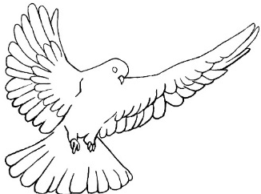
Breathe into me, Holy Spirit, that my thoughts may all be holy. Move in me, Holy Spirit, that my work, too, may be holy. Attract my heart, Holy Spirit, that I may love only what is holy. Strengthen me, Holy Spirit, that I may defend all that is holy. Protect me, Holy Spirit, that I may always be holy. (Saint Augustine)

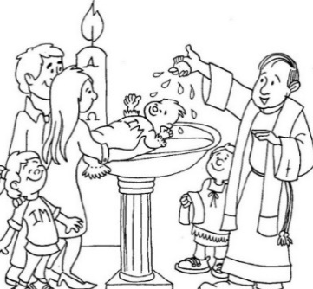
We are Temples of the Holy Spirit
At our baptism, the Holy Spirit came into our souls to live. We are embodied souls – our soul isn’t IN our body. A scientist or doctor can’t SEE our soul and we can’t SEE other people’s souls. God creates our soul when we are first conceived by our parents. A soul is what gives LIFE to our body. Our soul lives forever; it is immortal.

Humans are made in the image and likeness of God. This means God gives us a free will and an intellect. We are free to know, love, and serve God. We can also choose to reject God and refuse to serve Him. The angels were given this choice and their decision was final. The good angels live in heaven with God. We decide either for or against God every second, minute, and hour of every day; but our decision isn’t final until our life on earth is complete. Have you ever changed your mind about something? Allow comments. Can you imagine the angels NOT changing their minds. God invites angels and humans into a friendship with Him (not dogs, or cats, or trees, or rocks). God does not FORCE us to be His friend. You could talk about the many advantages of being a friend with God, who is LOVE. (If appropriate for your students, you could discuss how the angels who did not want to live with God are now trying to get us not to be God’s friend.) Do you want to be God’s friend? Give some concrete examples of what it means to return God’s love (going to Mass, praying, following His commandments, being nice to other people, etc) When we pray we talk to our good friend, God…

Our soul is like a spiritual castle where we have a room for God to live. We enter into this castle when we pray (Mt 6:6). We decide how to decorate the rooms of this castle and we decide how clean or dirty it is. Ask what they think their castle would look like if they could see it. Allow comments…

Just like the castles from years past, we need to protect our body and soul from the attacks of our enemies. We protect the Holy Spirit’s home when we protect our body and soul from harm. Discuss the tactics used to protect a castle: high, thick walls; moat; guards; storage of food; water supply; etc.

How do we protect our body from harm?
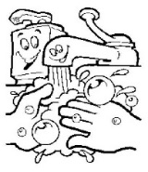
Safe environment
Good decisions
Good health
Talk about physical safety: Traffic safety, fire alarms, washing our hands to get germs off, eating well, exercising, locking our doors, fire and tornado drills (Take time to discuss and, maybe, go through a fire or tornado drill for the classroom. You could even discuss their plan for at home)

How do we protect our souls from harm?
Pray
Go to Mass Confession

Sacramentals Good decisions

Discuss each of the words listed above: Pray: prayers we memorize, thinking about God, and resting in God’s heart. Go to Mass: every weekend! Confession: frequently (once a month is a good suggestion). Sacramentals: like the rosary, a medal, a crucifix, holy water, etc (maybe give each student a sacramental to take home). Good decisions: following God’s commands and the rules of those who are in charge of us (A good decision considers our safety and the safety of other people)

Cleaning day …
When we choose to sin, we clutter our soul with junk and crowd out the Holy Spirit.
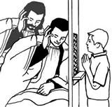

Going to confession cleans our souls and makes room for the Holy Spirit to live. This is especially important when Jesus comes “under our roof” in Holy Communion. Remind the students when we say this at Mass, right before we receive communion. Talk about being in a State of Grace when we receive Jesus. This means we don’t know of anything we’ve done or not done that broke our friendship with God.
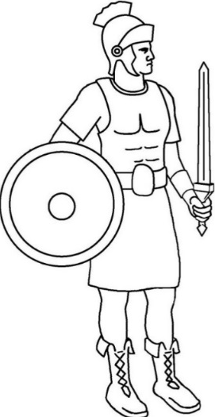
Roman soldiers wore armor for protection. St. Paul compared this physical armor to the armor a Christian needs to wear in order to protect himself or herself both physically and spiritually (Eph.6:13:17).
Point out that this armor is invisible because it primarily protects our soul. Our body is protected because we are making good decisions that keep us safe from harm. We wear the armor of God when we are in a State of Grace.

The Helmet protects our eyes, ears, and mind. We need to be careful about what shows we watch, the games we play, the words we hear, the songs we listen to, the pictures we see, the internet sites we visit, and the thoughts we think. Have you ever watched a show that gave you a nightmare? It is really hard to take those images, sounds, and ideas out of our head. How can we avoid seeing, hearing, or thinking what might harm us? They could leave the room, find another activity, avoid the person(s) who may not make them feel safe or aren’t making good decisions.

The Breastplate protects our vital organs (like our heart). In our heart we desire either to do good or bad. We are free to choose the good only when we don’t let our hearts get attached to anything that is bad. Have you ever tried to get rid of a bad habit? A bad habit makes it really hard to choose what we know is best for us (like the habit of biting our nails can cause painful sores on our fingers; we need to discipline ourselves in order to stop the habit). Can you name other bad habits or attachments that are hard to detach from?
What does it mean to “discipline ourselves”? Other bad habits might include teasing your sibling; talking back to your parents; getting angry when you don’t get your way; eating too many sweets; watching too much TV; playing too many video games; etc
Disciplining ourselves means that we don’t need another person to stop us from doing something harmful. Give examples of how they might already be disciplining themselves (not eating the whole basket of candy at once; doing their homework without being told; controlling their anger inside their heart without anyone seeing they are angry; etc.)

The Shield is our Faith in God. God loves us and wants only what is good for us. This shield helps us believe in God in order to follow His rules. God’s rules help protect us from harm just like a shield. What are some of God’s rules that protect us from harm? Examples might include: breaking some of God’s laws may put us in jail (killing, stealing, lying under oath, etc); Keeping God first in our heart protects us from being too attached to things and people that may betray us; Going to Mass and receiving the Eucharist feeds our soul the bread of LIFE; If we fight with other people then they often hurt us back;

The Sword is the WORD OF GOD. Reading the Bible and praying teaches us what God wants us to do. When we enter into our spiritual castle to pray, we can talk to the Holy Spirit. This means sometimes we talk and sometimes we listen. What does the Holy Spirit tell you to do in some “What If” situations?
GAME: Ask the students some “what if” questions and ask them to pray about what the Holy Spirit would want them to do in each of these scenarios. (questions below – or make up your own) Make sure to discuss how to listen to the Holy Spirit: He will always tell you to do or not do something that is obedient to God; He doesn’t cause us anxiety or fear; He gives us a peaceful feeling of RIGHTNESS – it settles in our soul nicely (maybe compare to when they eat something that digests well versus something that makes them sick); Sometimes there may be more than one ‘right’ answer.
      - What if you get lost in a store, who could you ask for help?
      - What if some older kids asked you to go to the park with them, what would you do first?
      - What if you were really cold or wet walking home from school and someone you thought maybe lived down the street offered to give you a ride home, what would you do?
      - What if someone in a car asked you for directions and then seemed to follow you, what would you do?
      - What if a really nice person you don’t know asks you to help find a lost puppy or kitty, what would you do?
      - What if someone you didn’t know asks to take pictures of you?
      - What if someone came to school and said something bad had happened and you were supposed to go with that person, what would you do?
Note that it doesn’t always take a lot of time to talk to the Holy Spirit. We can ask quickly and He can answer quickly. Sometimes the answer may take longer.
The belt is for honesty. We need to speak the truth at all times. Lying may put our body and soul at risk. You need to tell someone you trust if you don’t feel safe. God is truth, so His children should always speak the truth. Who are God’s children? Remind them that everyone who is baptized is claimed by God as His adopted child – that NEVER goes away. We can, however, choose not to act like God’s child. God’s children should do what He commands.
Address how lies might put them at risk. Secrets that are harmful to you or another person need to be told. (Story: When I was a little girl (4yrs old) I hid in the little refrigerator in our camper. My little sister (3 yrs old) told our Dad that I hid in there – even though I told her NOT TO TELL (we were playing hide-and-seek with our older sister). I would have suffocated in that refrigerator if she kept that secret.

The “skirt” like armor protects our private parts. We need to wear our clothes and not let others see or touch the private areas of our body (unless a doctor or parent needs to help you because of a medical condition). We shouldn’t try to see or touch the private parts of other people’s bodies either. It is important to wear clothes that are modest and respectful of our body’s privacy. What does “modest” mean? A person who dresses modestly wants other people to see them as a child of God. A person who dresses immodesty wants other people to see their skin. We keep our private areas private (discuss the difference between public and private: your house is private, the grocery store is public; a bathroom stall is private, even if it is in a public bathroom). Being modest also means keeping to yourself any bad words or thoughts (again the difference between public and private)

Shoes protect our feet so we can travel only to the places God sends us. We need to make sure we don’t go places that God wouldn’t want us to be. Let your parent or guardian always knows where you are. What places might cause you harm if you went there? Places that might be unsafe include a mountain during a thunderstorm; the ocean during a hurricane; a shore during a tsunami; a cave with a grizzly bear family living in it; any place a person is violent; a movie theatre showing an R rated movie; etc (use your judgement on what to discuss. Always gear your discussion to the most innocent in the classroom)

It is NOT GOOD to be ALONE
In the beginning, as God created the whole world, He said it was “GOOD”. When he saw Adam without another person in the world, God said it was “NOT GOOD FOR MAN TO BE ALONE” (Gen 2:18). Then God made Eve to be Adam’s companion. This teaches us that we need friends. We need our family and people around us who love and care for us.
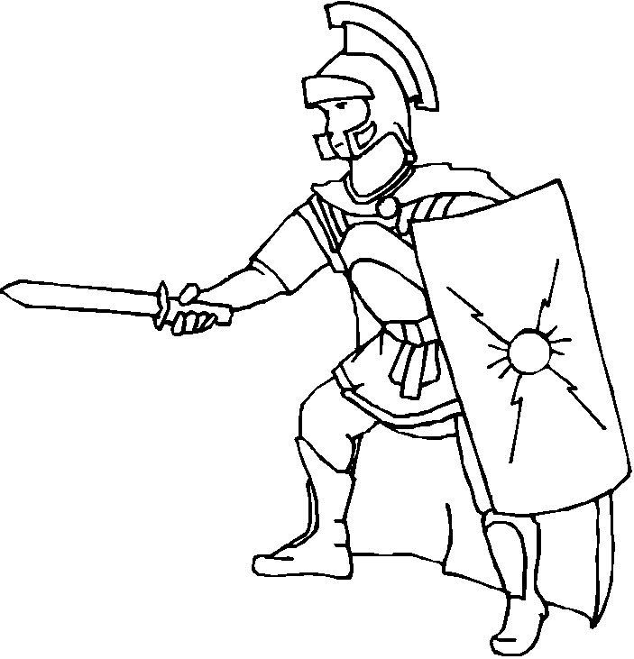
The Roman soldier did not have armor on his back – why? Because his friends were supposed to protect him and he was supposed to protect his friend. They fought back to back.

Who helps protect you?
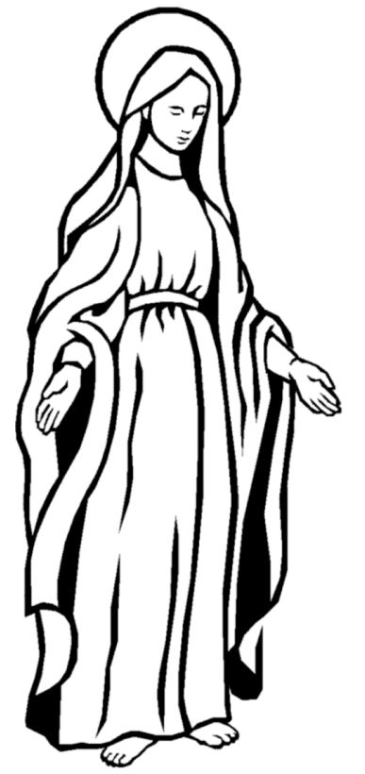
GOD
Family
Community
Friends
Mary
Guardian Angel
Saints in heaven
Go through examples and talk about each. Allow students to share how one or more example protected them or might protect them.

How do you choose good friends?
- Do they obey God’s rules?
- Do they help you feel safe?
- Do they show the Fruits of the Spirit in how they talk and treat you and others? (The fruits are charity, joy, peace, patience, kindness, goodness, generosity, gentleness, faithfulness, modesty, self-control, chastity)
- Do they listen to you? Not do they OBEY you. The question is asking if when you talk to this person, do they listen to your words and share in a discussion.
- Do they talk to you?
- Do they enjoy the same things you do?
- Do they like your other friends and your family?
- Are they your friends no matter WHO is around? A friend isn’t ‘two-faced’

Are you a good friend to others?
- Do you follow God’s rules?
- Do you visit the spiritual castle of your soul and talk to God?
- Do others feel safe around you?
- Do you keep your soul clean so the Holy Spirit can live in you?
- Do you listen to your friend? Again, NOT that you OBEY your friend. We need to pay attention to our friends when they talk to us.
- Do you talk to your friend?
- Do you pray for your friend?
- Do you help your friend?
- Do you invite other people to be your friend?
Go through each question and discuss for comprehension.
- Do you treat your friends the same no matter where or who you are around? Again that idea of being ‘two-faced’ or wearing ‘masks’

How do you avoid people your age who are not good friends?
Discuss the difference between the two questions. The first question addresses the response to someone who you just don’t want to be around because they aren’t very nice (or are rude, or don’t love God, etc.) whereas the second question is a person who is NOT SAFE. Remind them that at each step they still need to love the person they are trying to avoid. We don’t have to FEEL love for someone to want what is best for them. This means praying for the person and making sure our heart isn’t turning mean regarding this person.

Step 1-The first step is to ignore the person. Don’t look at the person or think about what the person is doing. If that doesn’t work then…

Step 2-Move away or turn your body away if you can’t walk away. If that doesn’t work then…

Step 3- Talk friendly by saying, “Please stop____.” If that doesn’t work then…

Step 4- Talk firmly and politely by saying, “I don’t like that”. If that doesn’t work then…

Step 5- Go to “How do you avoid people you do not feel safe around” If you’ve tried the first four steps then you need the help of an adult.

How do you avoid people you do not feel safe around?
Talk to an adult you trust immediately!! David didn’t fit into Saul’s armor so he picked up five stones in order to slay Goliath. Do you have five people that you trust to help you feel safe? Write their names in the stones… If you have time and the students haven’t heard about David and Goliath, you could give a quick summary (age appropriate). Discuss how we are sometimes faced with a person or situation that is way BIGGER than we can handle. These situations require us to call on HELP from those we trust. Have them write the name of five people they trust on the stones below, like David choosing the five stones for his sling.

Prayer to Put on the Armor of God
Heavenly Father, in the Name of Jesus, I ask you to put on me and those I pray for: the helmet of salvation, which is hope; the breastplate of integrity and justice, which is love; the shield of faith; the two-edged sword, which is the Word of God; the belt of honesty; the skirt of purity; and shoes to spread the Gospel of peace. Amen.

