First Communion 2015

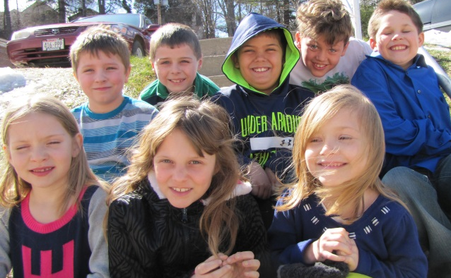

My Jesus, I believe that You are in the Blessed Sacrament. I love You above all things, and I long for You in my soul and souls of these children. Since they cannot yet receive You sacramentally, come at least spiritually into their hearts. May they embrace You and unite themselves entirely to You; never permit them to be separated from You. AMEN

First Communion 2015

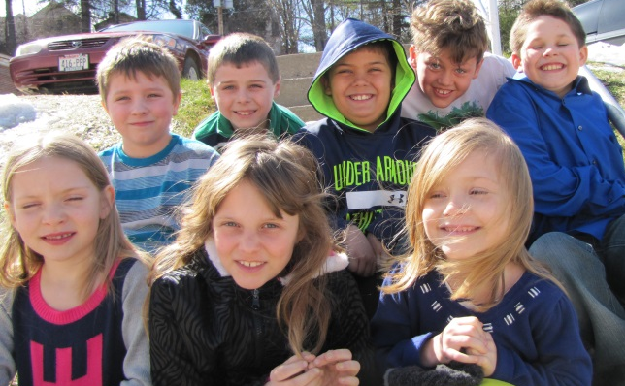

My Jesus, I believe that You are in the Blessed Sacrament. I love You above all things, and I long for You in my soul and souls of these children. Since they cannot yet receive You sacramentally, come at least spiritually into their hearts. May they embrace You and unite themselves entirely to You; never permit them to be separated from You. AMEN

First Communion 2015

My Jesus, I believe that You are in the Blessed Sacrament. I love You above all things, and I long for You in my soul and souls of these children. Since they cannot yet receive You sacramentally, come at least spiritually into their hearts. May they embrace You and unite themselves entirely to You; never permit them to be separated from You. AMEN

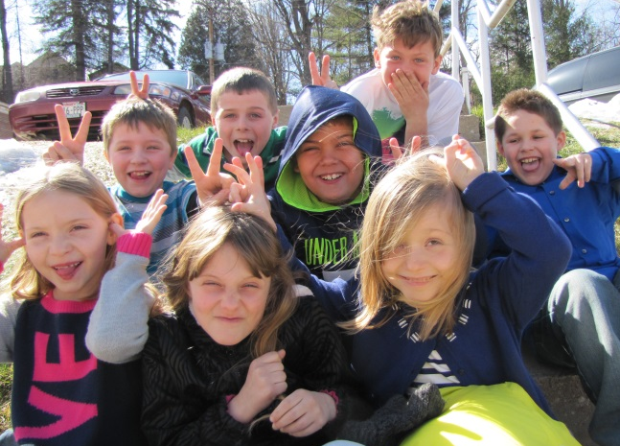

Back Row: Preston, Alex, Dante, Tommy, Michael

Front row: Justine, Alison, Emma

Back Row: Preston, Alex, Dante, Tommy, Michael

Front row: Justine, Alison, Emma

Back Row: Preston, Alex, Dante, Tommy, Michael

Front row: Justine, Alison, Emma

