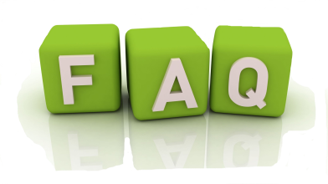
FAQ on Religious Education Accreditation

- What is accreditation?
Ever wonder what a great Religious Education program looks like? The accreditation process uses a team of people from within the diocese to affirm, encourage, and challenge parishes to evengelize with enthusiasm, pray with intentionality, and catechise with truth and charity according to the Diocesan Quality Indicators. The Diocean Quality Indicators highlight 12 general areas and corresponding subpoints which outline what a great program looks like. The accreditation members visit the parish and affirm and challenge them using the Diocesan Quality Indicators as a basic rubric.
- Why Accreditation?
For years, public and private schools have been invited to participate in the accreditation process. This process allows for each school to be reviewed objectively using a set of standards. Using this tool, the team is able to objectively give schools tangible affirmations, suggestions, and areas for improvement according to an ideal set of quality indicators. The Education Department in the Diocese of Green Bay observed very little recognition and ability for parish programs to review their program as a whole. Thus, the accreditation process was created to support, affirm, and renew our religious education programs within the Diocese and with our dependence on the Lord, make each program a quality “school” of evangelization and discipleship!

- Is it mandatory for every parish in the diocese?
At the present time, parishes are not required, but rather are invited to embark on this accreditation process.
- Why are you asking so much of parishes?
No parish is perfect and this process isn’t expecting that. The process is the just that – a process to improve our catechesis, total formation, prayer, discipleship, and evangelization with new ardor, methods, and expressions. Taking into consideration the messiness of people’s lives, the over secularization of the culture, demands on schedules, lack of funds, and countless other issues, with God, we are confident in the task he has given us! We aim not to demand adherence to quality indicators that are irrelevant. These quality indicators truly help build, encourage, and enliven a parish program and centers it around Christ.
- Will this overtake my year? How much work is involved?
If you have a quality program right now, chances are, it’s more about organizing and recording what you already do than it is actually overhauling your whole program.

- How do I know when our parish is ready?
You can look at the requirements on our website- www.gbdyouthalive.weebly.com/accreditation.
You are able to see what would be expected in order for a program to be ready for accreditation. This doesn’t mean you have to meet every subpoint under the quality indicators, but there is a valid attempt to do the best you can with the resources, community, and parish funds you have at your disposal.

- How do we officially apply?
A parish willing to begin the accreditation process is asked to submit a letter to the education department (a sample letter is listed on our resource website www.gbdyouthalive.weebly.com/accreditation).

