Earn-a-Patch Family Faith Activity

With the cancellation of many Vacation Bible Schools (VBS) and the closure of Camp Tekakwitha this summer of 2020, the Office of Families & Schools of Discipleship wishes to direct families to some summer activities through which children in grades 1-12 can grow in their faith and earn patches.

All children, youth and adults – Scouts or non-Scouts, Catholic or non-Catholic, male or female – are welcome to participate in these activities. These activities may also be used by groups, and/or families.

The activities and patches are offered through the National Catholic Committee on Scouting (NCCS) and the National Federation of Catholic Youth Ministry (NFCYM). Patches may be ordered directly from those organizations, and the average cost per patch will be $3-$4 plus postage.

Click on the patch images below to access the activity sheet/site for each patch. Once the required activities are successfully accomplished, contact the organization directly to order the patch. Payment will be due at the time of ordering.

Patches could be collected in a scrapbook, sewn onto a banner, or however you’d like to display them!

For more information, please e-mail [education@gbdioc.org](mailto:education@gbdioc.org). Have fun!

**Patches available from NCCS:**

[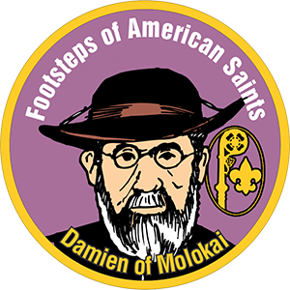](https://www.nccs-bsa.org/index.php/damien-of-molokai-may-10th) [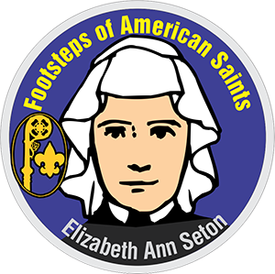](https://www.nccs-bsa.org/index.php/elizabeth-ann-seton-jan-4th)[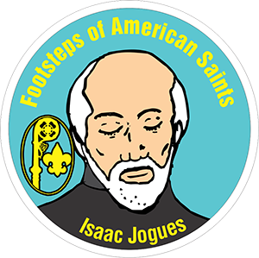](https://www.nccs-bsa.org/index.php/isaac-jogues-oct-19th) [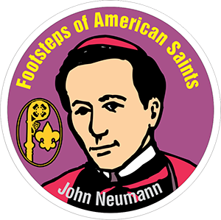](https://www.nccs-bsa.org/index.php/john-neumann-jan-5th)

[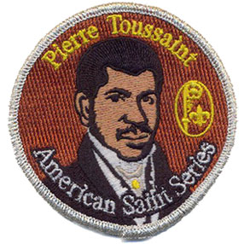](https://www.nccs-bsa.org/index.php/pierre-toussaint)[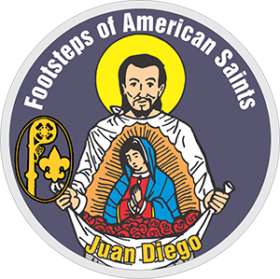](https://www.nccs-bsa.org/index.php/juan-diego-dec-9th) [](https://www.nccs-bsa.org/index.php/kateri-tekakwitha-jul-14th)[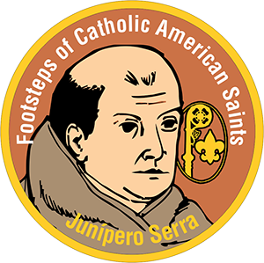](https://www.nccs-bsa.org/index.php/junipero-serra-jul-1st) [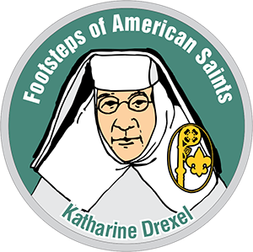](https://www.nccs-bsa.org/index.php/katharine-drexel-mar-3rd)[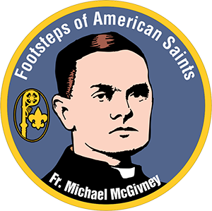](https://www.nccs-bsa.org/index.php/michael-mcgivney) [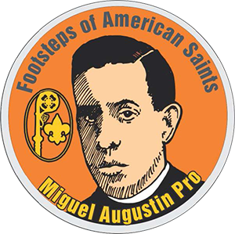](https://www.nccs-bsa.org/index.php/miguel-pro-nov-23rd) [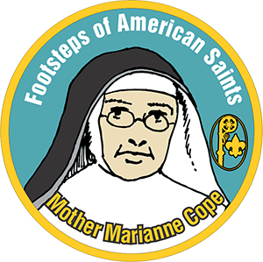](https://www.nccs-bsa.org/index.php/mother-marianne-cope)

[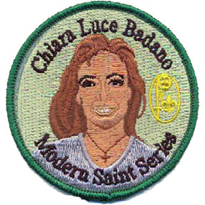](https://www.nccs-bsa.org/index.php/religious-activities/footsteps-of-modern-saint-series/chiara-luce-badano)[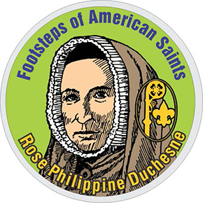](https://www.nccs-bsa.org/index.php/rose-philippine-duchesne-nov-18th) [](https://www.nccs-bsa.org/index.php/saint-george-apr-23rd) [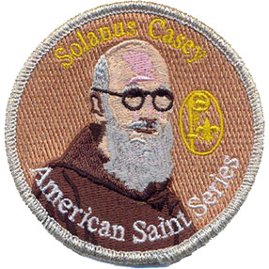](https://www.nccs-bsa.org/index.php/solanus-casey)

[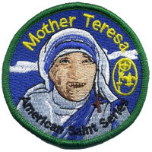](https://www.nccs-bsa.org/index.php/religious-activities/footsteps-of-modern-saint-series/mother-teresa)[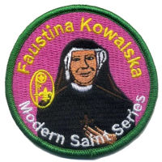](https://www.nccs-bsa.org/index.php/religious-activities/footsteps-of-modern-saint-series/faustina-kowalska) [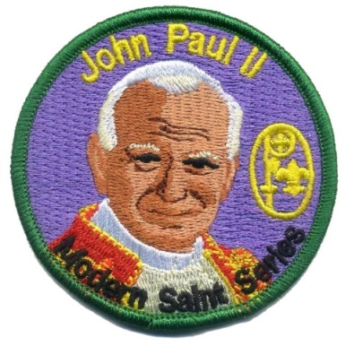](https://www.nccs-bsa.org/index.php/religious-activities/footsteps-of-modern-saint-series/john-paul-ii) [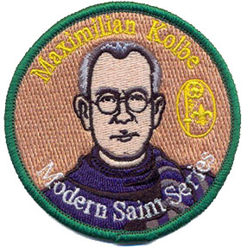](https://www.nccs-bsa.org/index.php/religious-activities/footsteps-of-modern-saint-series/maximilian-kolbe)

[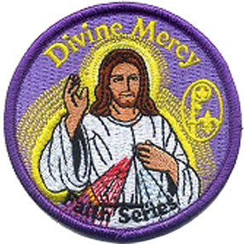](https://www.nccs-bsa.org/index.php/religious-activities/faith-series/divine-mercy)[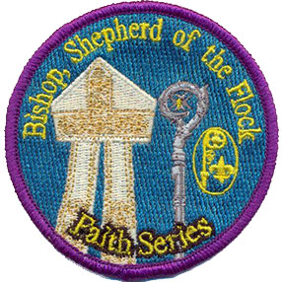](https://www.nccs-bsa.org/index.php/religious-activities/faith-series/bishop-shepherd-of-the-flock) [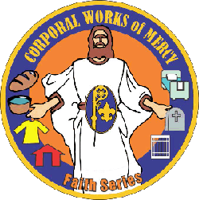](https://www.nccs-bsa.org/index.php/religious-activities/faith-series/corporal-works-of-mercy) [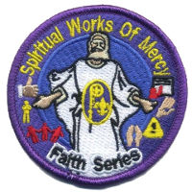](https://www.nccs-bsa.org/index.php/religious-activities/faith-series/spiritual-works-of-mercy)

[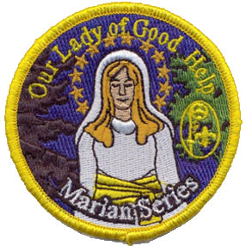](https://www.nccs-bsa.org/index.php/religious-activities/marian-series/our-lady-of-good-help)[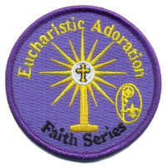](https://www.nccs-bsa.org/index.php/religious-activities/faith-series/eucharistic-adoration) [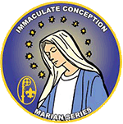](https://www.nccs-bsa.org/index.php/religious-activities/marian-series/immaculate-conception) [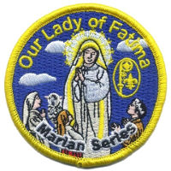](https://www.nccs-bsa.org/index.php/religious-activities/marian-series/our-lady-of-fatima)

[](https://www.nccs-bsa.org/index.php/religious-activities/marian-series/our-lady-of-sorrows)[](https://www.nccs-bsa.org/index.php/religious-activities/marian-series/our-lady-of-guadalupe) [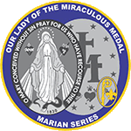](https://www.nccs-bsa.org/index.php/religious-activities/marian-series/our-lady-of-miraculous-medal) [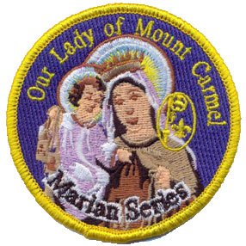](https://www.nccs-bsa.org/index.php/religious-activities/marian-series/our-lady-of-mount-carmel)

[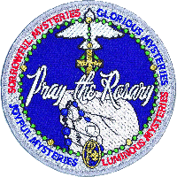](https://www.nccs-bsa.org/index.php/religious-activities/rosary-series/pray-the-rosary) [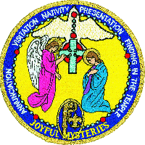](https://www.nccs-bsa.org/index.php/religious-activities/rosary-series/joyful-mysteries)

[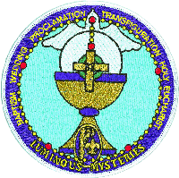](https://www.nccs-bsa.org/index.php/religious-activities/rosary-series/luminous-mysteries) [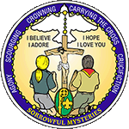](https://www.nccs-bsa.org/index.php/religious-activities/rosary-series/sorrowful-mysteries)

[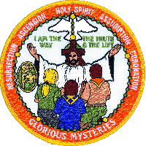](https://www.nccs-bsa.org/index.php/religious-activities/rosary-series/glorious-mysteries)

**Patches available through NFCYM:**

[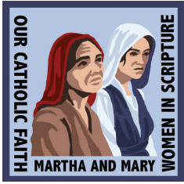](https://nfcym.org/wp-content/uploads/2019/10/MarthaandMary.pdf) [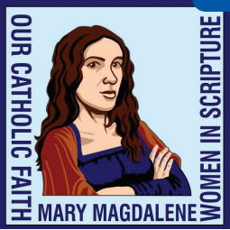](https://nfcym.org/wp-content/uploads/2019/10/MaryMagedalene.pdf) [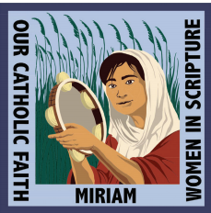](https://nfcym.org/wp-content/uploads/2019/10/Miriam.pdf)

[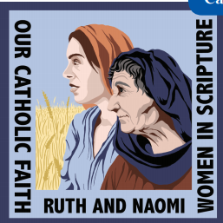](https://nfcym.org/wp-content/uploads/2019/10/Ruth_and_Naomi.pdf) [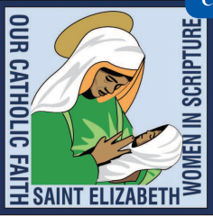](https://nfcym.org/wp-content/uploads/2019/10/StElizabeth.pdf) [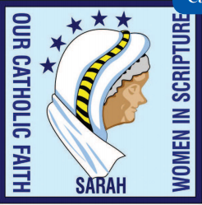](https://nfcym.org/wp-content/uploads/2019/10/SarahYounger.pdf)[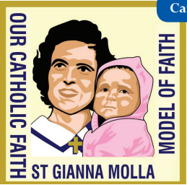](https://nfcym.org/wp-content/uploads/2019/10/GiannaMolla_Worksheet.pdf)[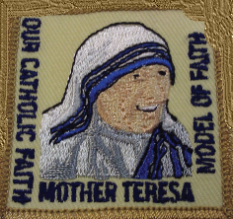](https://nfcym.org/wp-content/uploads/2019/10/MotherTeresa.pdf)[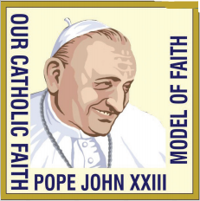](https://nfcym.org/wp-content/uploads/2019/10/Pope_John_XXIII_Worksheet.pdf)

[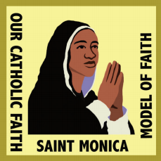](https://nfcym.org/wp-content/uploads/2019/10/Saint_Monica_Worksheet.pdf)[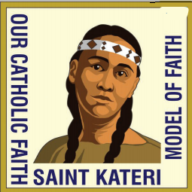](https://nfcym.org/wp-content/uploads/2019/10/Saint_Kateri_Worksheet.pdf)[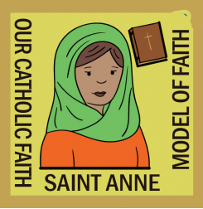](https://nfcym.org/wp-content/uploads/2019/10/StAnneWorksheet.pdf)

[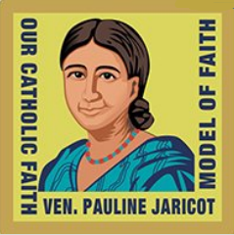](https://nfcym.org/wp-content/uploads/2019/10/Ven_Pauline_Jaricot1.pdf)[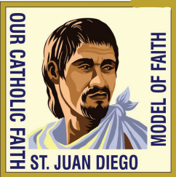](https://nfcym.org/wp-content/uploads/2019/10/Juan_Diego_Worksheet.pdf)

[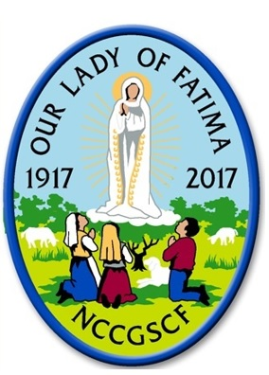](https://nfcym.org/wp-content/uploads/2019/10/OurLadyofFatimaPatchActivities.pdf)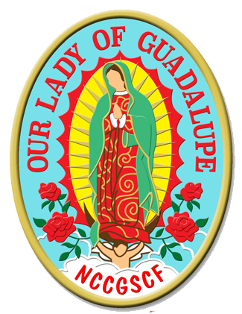

Our Lady of Guadalupe [Requirements in English](https://nfcym.org/wp-content/uploads/2019/10/OurLadyofGuadalupepatchrequirements.pdf)

Our Lady of Guadalupe [Requisitos en Espanol](https://nfcym.org/wp-content/uploads/2019/10/OurLadyofGuadalupepatchrequirementsSPANISH.pdf)