Habits of Discipleship: The Discipleship Wheel
Evangelical Catholic
The discipleship wheel is a tool to help us “categorize” the different habits of discipleship in such a way as to be able to grow in our relationship with God. It helps us to know where to begin to set realistic, concrete goals, while not getting overwhelmed. The Discipleship Wheel’s categories run parallel with the tasks of catechesis, listed in the GDC, 84-87.

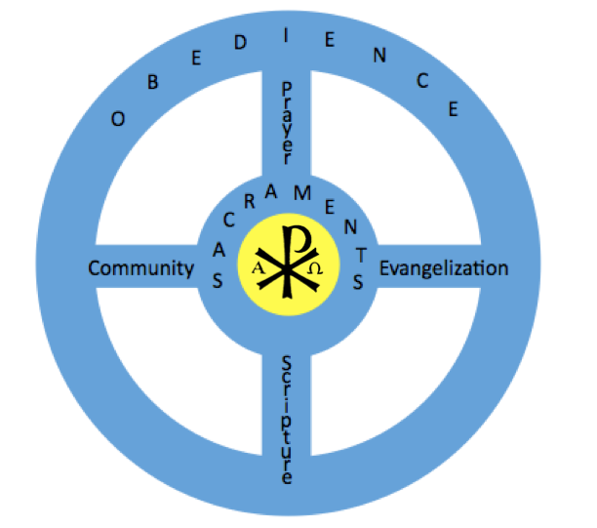
Tasks correspond to habits of the life of discipleship, together with suggested Scripture and CCC passages for discussion and meditation.

  - Christ at the Center; our Divine filiation: 2 Cor 5:17; Gal 2:20; Rom 8:14-17; Jn 15:1-5; 1 Jn 2:28-3:3; CCC 521, 305, 2830

  - Sacramental life = liturgical education: 1 Pt 2:5; Acts 2:41-42; Rom 6:1-11; Jn 6:22-69; CCC 1127-1129, 1324-1327, 1382-1405, 1427-1432, 1450-1460, 1468-1470

  - Prayer = teaching to pray: Phil 4:6-7; Mt 6:6; Mk 1:34-39; CCC 2559-2565, 2626-2643, 2650-2672, 2697, 2705-2708, 2725-2745

  - Word = promoting knowledge of the faith: (specifically devotion to Sacred Scripture and establishing the habit of spiritual reading) 2 Tim 3:16; Heb 4:12; Ps 119:105; CCC 2653-2654; Dei Verbum 25; CCC 131-133; (doctrine in general) CCC 88-89;

  - Obedience to Christ and His Church = moral formation: Rom 12:2; Jn 14:20-21; CCC 1691, 1694, 1776-1794, 1971-1972, 2030-2034

  - Community = education for community life: Heb 10:24-25; Acts 2:42-47; Mt 18:20; CCC 953

  - Evangelization = missionary initiation: Mt 4:19, 5:13-16; 10:26-27; Lk 1:39-56; 14:16-23; 15:3-7; Rom 1:16; Jn 4:3-43; CCC 831, 849-856, 863, 905

One should become familiar with books to recommend for each of the parts of the wheel to recommend for spiritual reading. Since many people struggle with daily prayer (“don’t’ have time” or “don’t know how”), you will likely be dealing with this first. Some books to recommend for PRAYER: Time for God by Fr. Jacques Philippe; Prayer Primer by Fr. Thomas Dubay, Prayer for Beginners by Peter Kreeft. DO NOT recommend a book you have not read yourself; and be prepared to read with or walk alongside with.

“All of these tasks are necessary… These tasks are interdependent and develop together… To fulfill its tasks, catechesis avails of two principal means: transmission of the Gospel message and experience of the Christian life…” (GDC 87)

EXERCISE:
- Make columns for each of the tasks
- Fill in your current habits with as much detail as necessary.
- What do you see?
- Choose one task to work on. Make one concrete goal to work on until it becomes habitual. Examples of goals that are NOT concrete: I’m going to pray more. I’m going to try to make it to Mass more. I’m going to try to go to Confession more. I’m going to read ___ book. I’m going to work on receiving Communion more fruitfully. Examples of goals that ARE concrete: I’m going to do mental prayer for 20 min a day. I’m going to make it to Mass one day a week in addition to Sunday. I’m going to go to Confession at least once a month. I’m going to read ___ book for spiritual reading 10 min a day. I’m going to make it to church at least 10 min before Mass begins to prepare for Mass to receive Communion more fruitfully.

