Blessed Chiara “Luce” Badano
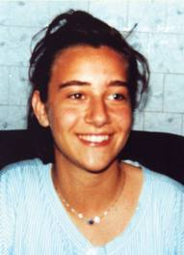
Chiara Badano was born in a small town, Sassello, in the province of Savona province (Aqui Diocese) on 29th October, 1971.

Chiara was the only child of a truck-driver, Ruggero Badano, and his wife Maria Teresa Caviglia. After 11 long years of marriage they were still childless, although their heart’s desire was to have children. It’s easy to imagine their tremendous joy when this baby arrived. From them she receives a solid Christian education.

Her life was full of little acts of love. One evening she wrote: “One of my classmates has chicken pox and everyone is afraid to go visit her. With my parents’ permission, I decided to do my homework over at her place so she wouldn’t feel lonely. I think that love is more important than fear.”

Chiara Luce is a girl like all the others: happy and lively, she likes music (has a beautiful voice), swimming, tennis and hiking in the mountains.Chiara Luce has a wide circle of friends. Especially during summer, they meet at a bar in Sassello which happens to be the only venue in town. Some youth open up with her, confiding their doubts and difficulties, sure they would feel welcomed and listened to. To her mother who asks her if she speaks to them about God, she answers: “I should not speak about Jesus, rather, I have to give him to them.” And how do you do so? “By the way I listen to them, by the way I dress and above all, by the way I love them.”

Chiara Luce is not alone along this journey. It is like walking along together with other youth: they do not miss a chance in “building this unity among them” – as one of them says – during their meetings, during which, they mutually share their concrete experiences on the Gospel, but also through telephone calls, visits, letters, parties, trips and gifts. Among these young people, the communion of goods is a reality: till death, Chiara Luce maintains in her room a list of all her things which she wants to share with all those who are in need.

Summer 1988. Then something totally unforeseen happened.
While playing tennis one day, Chiara Luce experiences a very sharp pain in her shoulder. At first she does not take much notice and neither does her doctor. However, since the pain persists, the doctor carries out further tests. The verdict: osteogenic sarcoma – one of the most serious and painful forms of cancer and it has already started spreading.

In February 1989, Chiara Luce undergoes her first surgery.
In June 1989, Chiara Luce undergoes a second surgery. This time, hopes are slim.
She is admitted to hospital many times and her kindness and unselfishness really stand out. Setting aside her own need to rest, she spends time walking around the wards with a drug-dependent girl suffering from serious depression. This meant getting out of bed despite the pain caused by the huge growth on her spine. “I’ll have time to rest later,” she says.

One day Chiara Luce writes: “Jesus sent me this illness at the right moment.”
Ferdinando Garetto, then one of the youth who shares the same choice of life as Chiara Luce, narrates: “At first we thought we would visit Chiara Luce to keep her spirits up, however, we soon realized that in fact, we were the ones who needed her. Her life was like a magnet drawing us towards her.” The cancer was spreading mercilessly, but Chiara Luce tried her best to live a normal and happy life.

In July 1989: the tumour spreads quickly. Chiara Luce is not yet 18 years of age and she loses the use of her legs. She tells her mother: "I really used to enjoy cycling around." And her mother replies, "If Jesus has taken away the use of your legs, he will give you wings."
When she lost the use of her legs, Chiara Luce said, “If I had to choose between walking or going to heaven, I would choose going to heaven.” With the last CAT scan, all hopes of remission disappeared.

She confides: “I no longer ask Jesus to come and take me away to heaven. I don’t want to give him the impression that I don’t want to suffer any longer”. She knows what lay before her and she does not want to change anything (she does not pray for a cure but to be able to do God’s will).

Chiara Luce passes away to Heaven on 7th October 1990.
Her last words to her mother Teresa are: “Goodbye. Be happy because I’m happy.”

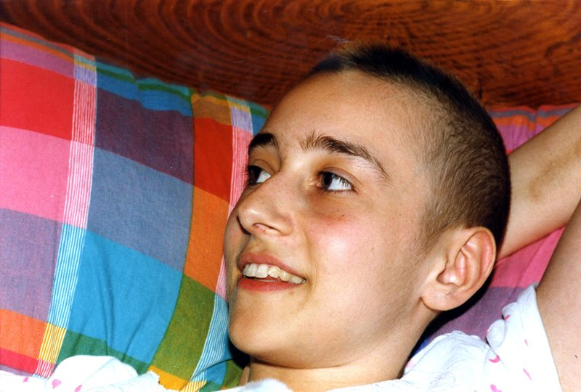
At the funeral, celebrated by H.E. Bishop Maritano, there are hundreds and hundreds of young people and many priests. A big bouquet of flowers and a telegram to Chiara Luce’s parents come from Chiara Lubich, foundress of the Focolare Movement, saying: “We thank you God for this bright masterpiece.”

On 3rd July 2008, Chiara Luce is proclaimed Venerable.
On 19th December 2009, with the consent of the Holy Father, the Congregation of the Causes of Saints proclaims the decree concerning the miracle attributed to the intercession of Chiara Badano. This miracle concerns the sudden healing of a child from Trieste, who was suffering from a severe of meningitis. The doctors had given him 48 hours of life.

Chiara Luce is beatified on 25th September 2010. Thousands of people, young and old, thronged this event and they have come from all over the world. There are many others connected via internet and TV.

This is how H.E. Bishop Maritano motivates his decision: “Her witness is of particular significance to young people. It’s enough to see how she lived her illness and how the experience of her death resonated with the youth. Such a shining example could not be neglected. There is a need for sanctity today. Young people yearn for direction, for a goal worth living for. They need a means of addressing their sense of insecurity, their solitude; they need an answer to the failures they experience, to suffering and death. But theory will never convince them; they need the witness of others.

