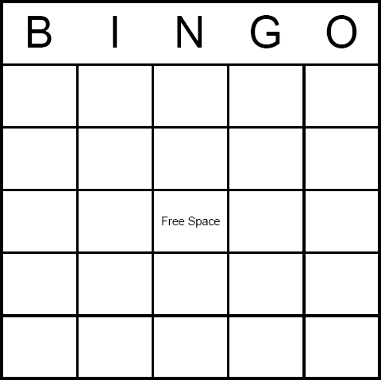
- Chalice
- Corporal
- Purificator
- Roman Missal
- Tabernacle
- Chasuble
- Altar
- Hosts
- Wine
- Ciborium
- Bells
- Cruets
- Baptismal Font
- Altar cloth
- Altar Stone
- Candles
- Cross
- Pew
- Paten
- Holy Water Font
- Stole
- Ambo
- Book of the Gospels

- Priest’s Chair
- Eucharist—FREE SPACE

