Advent Night Scripts
6:02 Deb: I’ll bet your families are really busy getting ready for Christmas! Tonight we want your family to take a break from the stress and hubbub of physical preparations and make room in your hearts and lives for Jesus. Tonight is about doing what Jesus tells us in Matthew,
³³ But seek first the kingdom of God and his righteousness, and all these things will be added to you.” Tonight we are going to learn some ways to put Jesus first. Cue video. “How to Have the Best Christmas Ever”
Maurine: Now it’s time to travel back in time to a place called Bethlehem. We will count off families into stations. Please stay in your station until the bell rings. Station One has two parts so there will be a signal half way through to tell you when to move.
6:15/6:45 Station One: (Fifteen families, 15 minutes)
- Holy Family Prayer (Lounge Nancy G.)
Supplies: Prayer sheet, bible and Holy Family prayer card
Families sit in pod of chairs together and Nancy begins.
Nancy says: Tonight let’s close our eyes and imagine we are walking into Bethlehem. It is crowded, because of the census requiring everyone to return to their families’ city of origin. Our feet are dusty and ache from a long journey. Walking ahead of us is a man leading donkey carrying a lady who is very pregnant. You recognize them right away! As you walk further into town many buildings have signs that read, “NO ROOMS AVAILABLE.” Everyone in the group looks worried, and after knocking on a door, the man leading the donkey, who you know is Joseph, goes around back of the buildings to a stable for animals. Joseph does his best to make a comfortable place for the woman to have her child. His voice is quiet and kind, but they both look very sad, because no one made room for them. (Pause here for a long moment, then continue.) What does this mean to us today? We dress up in clothes like they might have worn to try to look something like the Holy Family did and imagine what it must have been like more than 2000 years ago. There was no place for the Holy family that night. What about today? Is there room in your heart 2000 years later to be like the Holy Family, not just in your imagination and clothing, but in your heart and actions. Short pause.
Directions to Families:
- Families please look up scripture passage: Luke chapter 2, verse there is a post it on the page and verse is highlighted. Read the passage together within your family, in Bible found in pod.
- Families will then read Holy Family Prayer together
- Then discuss questions as time allows
  - How can our family be more like the Holy Family?
  - What is one way your family will welcome Jesus into your home this Advent?
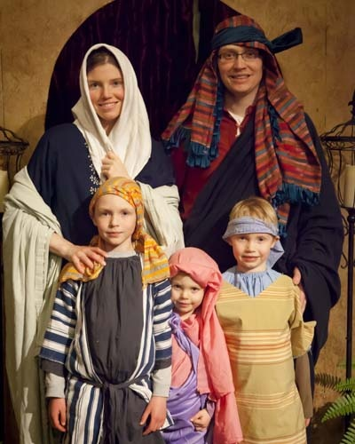
Station One: (15 families, 15 minutes)
- Holy Family Photo Booths (Erin)
Supplies: Costumes, props, back drops, hay bales, cameras
Erin says: Welcome to Bethlehem! We will help you dress up in clothing like people wore in Jesus’ time. Then we’ll take a picture. We have costumes for Mary, Joseph, angels and shepherds and a doll for Jesus (unless you have a baby or small child. While some people are getting their picture taken, the other families should be planning who will be which character. We need to move quickly to get all of you through in 15 minutes. There are 3 Photo booths, so you will get called to a booth as soon as the family ahead of you finishes. If you would like us to take your picture with your phone as well, have it ready when you come up. When your family is finished, move to table area until everyone is done. There will be a signal to tell you when to move to the next place. Let’s begin!
Station Two: Make a Christmas ornament and Assemble Donation (Barb and Rachel)
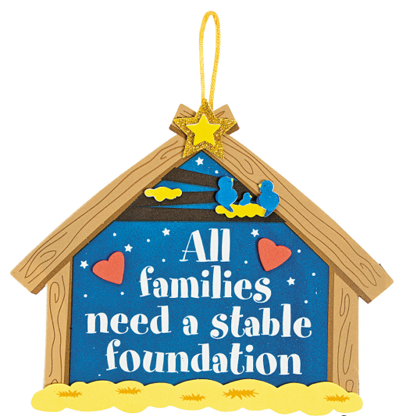
Supplies: Stable kits, glue bottles, permanent markers, cart with labels for grades
Rachel will ask families (while holding up a completed ornament):
- “Who thinks they know what this means?”
- Rachel will then explain what our theme means:
- “Who can name some of the ways we can be like the Holy Family?” (what they don’t guess…share with them)
        - We are to pray together
        - Be Grateful & Thankful : for all you are given and try to not keep wanting more
        - Be Quick to Forgive: Each other in your family
        - Live a Sacramental Life: Attend Mass, and then talk about how what you learned can help your family be more like the Holy Family. Make your church life important to your whole family
        - Read the Bible: Then talk about things that come up in your children’s lives in light of the Gospel. We see in Scriptures that Mary, Joseph and Jesus studied their Jewish faith, and then modeled their faith within the community they lived.
        - Love your Neighbor and model being a Holy Family. . . one that is NOT perfect, but is not afraid to be like Jesus at their jobs, in their schools, with their friends and to those they do not know. And when asked. . . they are not afraid to share with others that it is their belief in God makes a difference in their lives
        - Be a sign of Hope to others: Jesus and the Holy Family were a huge sign of Hope to the world. Be positive, generous and be open to helping those in need.
Barb: Share that each family will be making an ornament to remind them of how they are called to be a Holy Family:
1. All families, please put your last name and children’s grades on the back
2. Place the ornaments on a cart to dry according to grade of oldest child.
3. Tell families these will absolutely NOT go home yet tonight! (They need to dry
Completely, but they will get them

Louise: Share with the families: Donation Assembly (Louise, Tracy)
Supplies: sturdy ribbon, donated socks and peanut butter jars
“The Holy Family shared whatever they had with those around them that had little: In trying to be like the Holy Family, we also want to give to those in need in our community. Socks are not often donated to thrift stores like other items. For the month of November, the children learned about different saints and how they can also be role models for us. Some of us learned about a saint whose feast day is December 6. Ask: Does anyone want to guess who that saint is? ”Yes! St. Nicholas.
St. Nicholas was born in 270 AD in a country called Turkey. So many miracles were performed by him he was also called “Nicholas the Wonderworker.” People said he gave secret gifts to people in their shoes or socks. He was a bishop, so he is often shown wearing a mitre (Bishop’s hat) and carrying a crozier (staff).
We also asked you to bring peanut butter because it is always on food shelf lists, a great source of protein and a food many children love. So tonight we will tie the socks we brought to the jar of peanut butter.
IMPORTANT: Share that we will take our sock and peanut butter with us into church tonight. If there is extra time in this session, hand out Random Acts of Kindness Advent calendars to families and discuss possible ways to use it. For example, December 13th says “Candy can bomb a parking lot.” As a family, buy a box of candy canes and put them one by one on random cars in a school, church or grocery store parking lot.
7:13 All groups meet in church
After centers are complete, BELL WILL RING TO GO BACK INTO CHURCH. Deb will thank everyone for coming and suddenly there will be a disturbance. (Jim and/or Ben) (Lightning and/or thunder) St. Nicholas will come walking down the aisle. He will give a short talk about himself and then hand out trinket bags. Before he goes a kid (Connor) will run up and whisper to him that we have gifts for him as well. Children will walk up and put socks and peanut butter in his bag. St. Nick will leave.

Deb will lead families in the closing prayer, Holy Family prayer.

