First Eucharist Retreat
Sunday April 10, 2011
10:30am-12:00pm
10:30-10:45 Opening Prayer
10:45-11:05 Stop 1
11:05-11:25 Stop 2
11:25-11:45 Stop 3
11:45-12:00 Closing comments—Mass parts and prayer

Stop A—Tour of Church—Joe Zenk—Church
Stop B—Bread Making—Danielle Ehlenbeck—Church Kitchen
Stop C—Craft—Sue Thorson—Gym
Handprints on priest’s vestment
Red Group Blue Group Green Group
Alex Kleinhans Gage Lecher Gavyn Schmitz
Analiese Olig Elizabeth Suchan Ellie Mueller
Travis Kohlman Brandon Stephany Jacob Mooren
Logan Kalista Keenan Manz Christopher Muhs
Andrea Voland Andie Meyer Megan Thiry
Erin Swanson Emily Westphalen Heidi Koeser
Emily Swanson Caitlyn Muten Victoria Stock
Jason Klauck Alex Muten Claudia Noordyk
OPENING PRAYER

Danielle-- How do we prepare ourselves for supper at home? We wash our hands! When we come to the Lord’s supper we too should wash our hands. We should wash ourselves clean from the wrongs we’ve done towards God and our neighbor.

Joe-- Psalm 26:6-11
I will wash my hands in innocence and walk round your altar, Lord,
Lifting my voice in thanks, recounting all your wondrous deeds.
Lord, I love the house where you dwell, the tenting-place of your glory.
Do not take me away with sinners, nor my life with the violent.
Their hands carry out their schemes; their right hands are full of bribes.
But I walk without blame; redeem me, be gracious to me!

Danielle-- Today as we begin this retreat we take time to wash our hands to symbolize our desire to become clean in God’s eyes. Parents you have a special role, helping your child understand what it means to be clean of sin.

As we call your family name we invite the parents to have their hands washed by myself and Mr. Zenk then in return to wash your child’s hands. We will then hand back the commitment sheet that the parents signed at the parent meeting as a reminder of their promise to be the example to their son and daughters of what a follower of Jesus looks and acts like.

Parents and child come forward—Joe and Danielle wash and dry parent’s hands then they wash their child’s hands.

Play “Wash Me Lord” by Orin Richards

Joe-- Now with clean hands we join them together and pray to our Father with the words Jesus taught us.

ALL-- Our Father…
Amen!

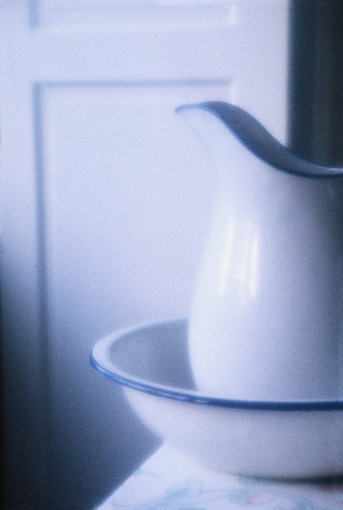
WASH ME LORD

By: Orin Richards

I am a sinful man
I wandered from your plan
But you’re a mighty God
You are a God of Love
You gave your cleansing blood
To wash away my sin
To wash away my sin

A sinner I may be
Shaped in inequity
Still you’re a mighty God
You are a God of Love
You gave your cleansing blood
To wash away my sin
Lord you washed away my sin

So wash me lord
Wash me lord
Come wash me lord
Hey wash me Lord
Wash me with your blood
And make me white as snow

I have transgressed your worth
Seventy times seven lord
Still you’re a mighty God
You are a God of love
You gave your cleansing blood
To wash away my sins
You washed away my sins

A lesson I have learned
Now I forgive in return
Just like my mighty God
Just like my God of love
Who gave his cleansing blood
To wash away my sin
To wash away my sin

So wash me lord
Come wash me lord
Come and wash me lord
Wash me with your blood and make me white snow

Wash me lord
Father come bleach me Lord
Come down and bathe me Lord
And make me white as snow

What can wash away my sins?
Nothing but the blood of Jesus
What can make me whole again?
Nothing but the blood of Jesus

I tell you precious is the lord
That makes me white as snow
Nothing but the blood of Jesus!

