Prayers borrowed from the following:
https://stushie.wordpress.com
http://www.jesuswalk.com
http://www.how-to-pray-the-rosary-everyday.com
http://christthekingparish.blogspot.com
http://www.catholic.org
http://www.fillthevoid.org
https://www.umcdiscipleship.org
http://www.faithandworship.com

PRAYING THROUGH THE TRIDUUM
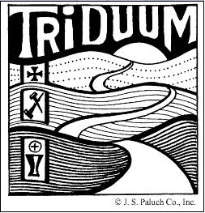

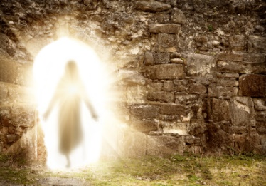
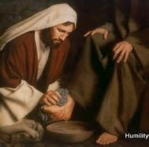
Washing of Feet
Altar server’s room
Ritual---Wash each other’s feet

Explanation---At the last supper Jesus washed the feet of his disciples. He did this to be a living example of what a true servant looks like. He was training his disciples to go out and serve. Washing each other’s feet is a very humbling experience. Our feet are often covered and very sensitive. When we allow others to see and cleanse them it opens us up to be vulnerable to the touch of others. What do your feet say about you? Where have your feet taken you?

Prayer--- Lord Jesus, washing the feet of others is not something that we naturally want to do. We all have trouble with humility and service, esteem and pride. Help us today to become less of ourselves and more of You. In Your Holy Name, we pray. Amen.

___________________________
___________________________
___________________________
___________________________
___________________________
Resurrection
Mary’s Altar
Ritual---Take an empty water bottle and fill it with Holy Water
Explanation---He is risen! The Tomb is Empty! He is Alive! Just as the tomb is empty so too is our holy water bottle, as we fill it up help us to understand that we are to share this holy water with others and bless those people and things around us. May we constantly strive to be filled with the love of Jesus and share it with all those in our lives.

Prayer---Almighty God, who through your only-begotten Son Jesus Christ overcame death and opened to us the gate of everlasting life: Grant that we, who celebrate with joy the day of the Lord's resurrection, may be raised from the death of sin by your life-giving Spirit; through Jesus Christ our Lord, who lives and reigns with you and the Holy Spirit, one God, now and forever. Amen.
___________________________
___________________________
___________________________
___________________________
___________________________
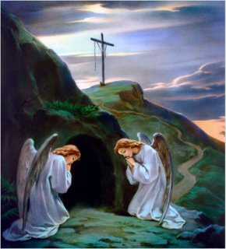
Waiting
Pews
Ritual---Kneel and pray about something you are waiting for
Explanation---Waiting is hard, instant results are what most of us desire. But Jesus knew that during this time of waiting people would reflect on their lives and examine what they did that hurt Jesus. We too need to take time and reflect on the things we’ve done. Waiting can be hard but if we truly believe in Jesus’ love for us we know that the result he gives us is what’s best for us. How can you be more patient and accepting of what Jesus has in store for you? What is one area in your life that you are waiting for?
Prayer---God, your testimonies are true. Ezekiel's graveyard, Lazarus' tomb, and the empty tomb are reminders that you are the Lord of Life; that not even death can stop your purposes. So, today, God, we ask that you prepare our hearts for resurrection as we sit by the tomb, waiting to feel the wind and hear you call us forth by name. Amen.

___________________________
___________________________
___________________________
___________________________
___________________________
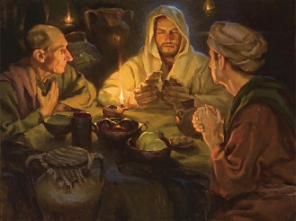
Breaking of Bread
Altar
Ritual---Partake in a piece of bread

Explanation---At the last supper Jesus broke bread, as it was custom at the Jewish Passover celebration, but this time he wasn’t just giving bread to his disciples, he gave them his body and blood. Through the partaking of the Eucharist every week we are able to be joined together with all those who follow Jesus. Do you truly believe the Eucharist is Jesus’ Body and Blood? How can you more reverently receive Jesus’ Body and Blood?

Prayer---Lord, you’ve given us the best gift, you! Give me the desire to receive you more often and reverence when I do. Help me to grasp the beauty of the Sacrament of Eucharist and fully understand what you’ve given me! In your name, Amen.

___________________________
___________________________
___________________________
___________________________
___________________________
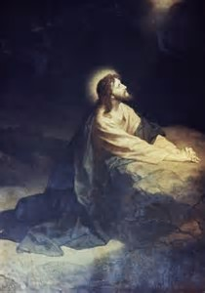
Praying in the Garden
Tabernacle
Ritual---Kneel and pray

Explanation---After the last supper, Jesus stepped away and prayed to his heavenly father. Jesus knew what was to come, his death on a cross, he prayed to God to give him the strength to endure this pain and to do God’s will. When you struggle do you try to fix it by yourself or do you let God help? What is one thing you want to ask God for help with? ASK HIIM!! He’s listening!

Prayer--- Father, the more I try to imagine what it was like that night in Gethsemane, the more I weep for you and Jesus. I weep for the love you have for me and my kind. To face what Jesus faced, to go through what he went through in order to purify and set me free is amazing. I am weak, but I seek to become strong like Jesus. Please teach me to pray earnestly that I might not enter into the temptations that constantly pester me. Make me like Jesus. And thank you that I can call you my Father. What a blessing! In Jesus' holy name, I pray. Amen.
___________________________
___________________________
___________________________
___________________________
___________________________
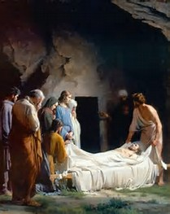
Clothing with white linen
Baptismal Font
Ritual---On a piece of white linen write one way you will return to living a life for Jesus then hang it on the rope.
Explanation---When Jesus was laid in the tomb he was clothed in white linen, this was done to show respect for the deceased body. When Jesus rose from the dead these white linens were folded neatly not just thrown to the side, this represents that he was coming back. Jesus calls each of us to constantly return to him. What areas in our life could we turn away from to bring us back to Jesus? What could you do more of to show Jesus we love him?
Prayer--- Lord God. I come to You a sinner and I humbly repent of my sins. I believe that Jesus is Lord and I believe You raised Him from the dead. I ask that Jesus will come into my life and be my Lord and Savior. I receive Jesus to change and take control of my life that I may live for Him from this day forth and from now on. Thank You Lord Jesus for saving me and cleansing me with Your precious blood. In Jesus name, Amen.
___________________________
___________________________
___________________________
___________________________
___________________________
Death on the Cross
Reconciliation Room
Ritual---Sit in SILENCE reflecting on ways we may be suffering or how we may be causing pain to others.

Personal Prayer
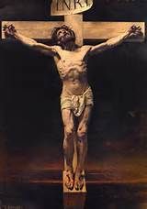

___________________________
___________________________
___________________________
___________________________
___________________________
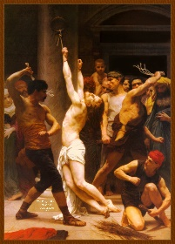
Scourging at the Pillar
St. Joseph’s Altar
Ritual---Take the cord in your hands and feel the sharp ends.

Explanation---After Jesus was sentenced to a death by crucifixion he was taken to be scourged. This is part of the normal Roman crucifixion ritual. Scourging consisted of Roman Soldiers whipping Jesus with a leather cord that had sharp objects at the end of the cord, these objects tore open Jesus’ back. His back was bleeding and sore and they continued to mock him, they placed a purple robe on him and put a crown of thorns on him, mocking him by saying “all hail King of the Jews” How do our words and actions scourge others? Do we realize that whenever we mock others, it hurts Jesus?
Prayer---Dear Lord, because of the cruel torture Jesus underwent when He was scourged, I will strive, with Your grace, to keep my thoughts, words and deeds pure. Thank you for enduring such tortures for my sake and please never let me forget what you went through when I am going through my own trials. I love you Jesus. Amen.

___________________________
___________________________
___________________________
___________________________
___________________________
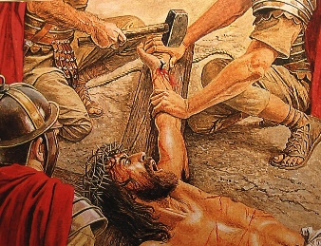
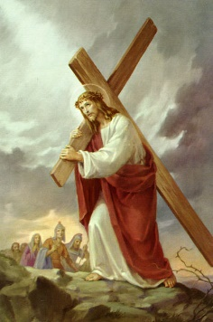
Carrying of the Cross
Center Aisle
Ritual---Take a candle and write one way you hurt Jesus and one way you can change this behavior and bring light into the world. Then walk slowly down the center aisle, placing your candle along the path.

Explanation-Jesus walked, carrying the very item that was going to put him to death. We too carry things that can lead to our spiritual death. As you place your candle down, reflect on how you can become a better person on your journey in life.

Prayer---Crucified Jesus, help us to take up our cross day by day. Through these crosses we can grow closer to you. Help us to lean on you and to learn from you. May we not give in to self-pity or self-doubt. Rather, let us trust in your presence which strengthens us. Amen.

___________________________
___________________________
___________________________
___________________________
___________________________
Crucifixion of Jesus
Gathering Space
Ritual---Take the hammer and pound the nail on the cross.
Explanation---Jesus knew what he was doing, he knew he was going to die a painful death, and yet he didn’t stop them. He knew that in order for us to be saved he had to endure this pain. We must remember that he not only allowed them to nail him to the cross for the people of that time but for each one of us. He loves us so much that when we hammer the nail into one of his hand with our sins he is reaching over with his other hand loving us!
Prayer---Here I am, good and gentle Jesus, kneeling before you. With great fervor I pray and ask you to instill in me genuine convictions of faith, hope and love, with true sorrow for my sins and a firm resolve to amend them. While I contemplate your five wounds with great love and compassion, I remember the words which the prophet David long ago put on your lips: "They have pierced my hands and my feet, I can count all my bones." (Psalm 22/17-18). Amen.

___________________________
___________________________
___________________________
___________________________
___________________________

