Personal Spiritual Growth

- Do I take time daily to develop my personal spiritual growth
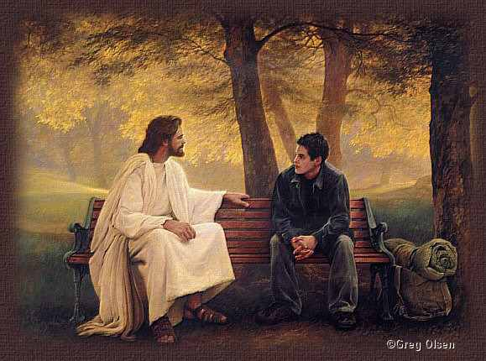
  - When is my best time to take some quiet time with the Lord?
(morning, afternoon evening)
  - Do I read Scripture daily?
(Readings of the day, reflection book on the daily readings)
  - Do I do some type of spiritual reading?
(Saints, spiritual growth book, book on prayer, etc)

- Do you take time for …
  - Day of Reflection (planned whether formal or informal blocks of time to be refreshed in the Lord)
  - An Annual Retreat: weekend, 2-3 days, or a week retreat

- Spiritual Direction
  - Way to grow closer to God
  - Sharing with a qualified spiritual director so that you can explore the ways that you are experiencing God as He interacts with you on a daily basis
  - Two important criteria to ask yourself:
    - At the present time, do you want to deepen your relationship with God?
    - At the present time, would meeting regularly and talking about your spiritual journey with a train director sound beneficial?

- Spiritual Companionship
  - Mutual sharing of your spiritual journey with another person
  - Mutual sharing on
    - Prayer life at the present time
    - Spiritual reading to share on a deeper level with someone

- Spiritual Reading
  - Lives of the saints
  - Spiritual books by great saints
  - Recent books:
    - Catholicism by Father Robert Barron
    - A Biblical Walk Through the Mass by Edward Sri
    - Walking with God: A Journey through the Bible by Jeff Cavins & Dr. Tim Gray
    - To Know Christ Jesus by Frank Sheed
    - Inviting the Mystic, Supporting the Prophet: An Introduction to Spiritual Direction by L. Patrick Carroll and Katherine Dyckman

