sy01491_**Order of the Passover**

**1. Kiddush (KIH-**doosh**):** The blessing of wine.

**2. Urehatz (**oo-reh-**HATZ):** Washing of the hands.

**3. Karpas (KAHR-**pahs**):** Eating a green herb.

**4. Yachatz (YAH-**chatz**):** Breaking the middle Matzah, the Afikoman

**5. Maggid (MAH-**gid**):** The Passover story.

**6. Rahatz (**rah-**HATZ):** Washing of the hands.

**7. Motzee-Matzah (MOH-**tzee-**MAH-**tzah**):** Blessing over the Matzah

**8. Maror (**mah-**ROHR):** Eating the bitter herb.

**9. Korekh (KOHR-**ech**):** Eating the bitter herb and matzah together.

**10. Shulhan Orehk (**Shool-**HAHN** ohr-**ECH):** The Passover meal.

**11. Tzafun (**tzah-**FOHN):** The Afikoman.

**12. Barekh (**bahr-**ECH):** The blessing after the Passover meal

**13. Hallel (HAHL-**el**):** Recital of the psalms

**14. Neertza (NEAR-**tzah**):** Conclusion of the Seder

**Welcome:**

Welcome to our Passover Seder. Let us celebrate the liberation of Israel from slavery and spiritual misery.

Passover starts with the lighting of two candles accompanied by a blessing. It is traditionally done by the mother of the house. To make ourselves ready, let us keep silent to receive the Passover Celebration in peace and quietness.

**Lighting of the Festive Candles:**

Blessed are you, O Lord our God, King of the Universe. You have made us holy by your commandments and have commanded us to kindle the festival lights.

bd00112_

**Blessed Are You, Lord God,**

**Ruler of the Universe,**

**Who has brought us life and sustained us,**

**And enabled us to reach this season of joy.**

**The Seder Symbols:**

Tonight we celebrate the Passover, the feast of freedom and redemption, and we read from the *Haggadah. Haggadah* is a Hebrew word meaning “story.” It is a special story. It relates our history: enslavement in Egypt, freedom, the holy commitment at Mount Sinai, and the return to the Promise Land. The *Haggadah* ritual is called *Seder* meaning “order” in Hebrew.

We have gathered here this evening to ask questions about our past and the meaning that it can have for the quality of our lives. Our ancestors have always gathered us together to honor the meaning of this day by remembering the past of our people and our feelings for each other. We have come to ask questions about our lives, our meaning to ourselves and each other, the times in which we live, the meaning of our present and the

promise of our future; and to seek some responses to the feelings they create in us. This night is also a sacrament of the strength we can gather from each other and the love we share for each other. We start by remembering how much pleasure there is for us to know that we can be together on this special night and can share this time of memory and memorial. We seek questions and answers for our times as our ancestors have done for as long as mankind can remember.

The various parts of the Seder are symbolized on this special plate.

**The Seder Plate**

**Matzah** Bread made in haste – no yeast or leavening

Bread made with only flour and water.

**Maror** Bitter herbs – show the intense bitterness endured

by the Hebrew people during the days of captivity

in Egypt.

**Zeroah** Lamb shank – Lamb of the Passover.

Remembering the Sacrificial Lamb.

**Haroset** Sweet spread from fruits and nuts

Represents mortar and mud bricks from the days of

slavery in Egypt.

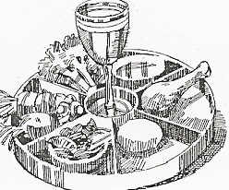 Sweetness – eternal Jewish Optimism

**Baytzah** Egg – Symbol of fertility and creation

Offering at the Temple

**Karpas** Green – Celery, parsley – new life

Dipped in salt water to represent the tears of the Hebrews.

**Kiddush: The Blessing of the Wine**

Each participant is expected to partake of four cups of wine/grape juice. This requirement is based on the biblical account of Exodus outlining the four stages by which Israel was delivered from slavery: “Therefore say to the children of Israel, ‘I am the Lord. I will free you from the burdens of the Egyptians and deliver you from their bondage. I will redeem you with an outstretched arm and with mighty acts of chastisement. I will take you as my people and I will be your God.” (Exodus 6:6-7)

The wine is usually red, recalling the color of the lamb’s blood that the Hebrew sprinkled on the doorposts of their homes so that their firstborn sons could be “passed over” as the angel of death took the firstborn of Egypt.

Blessed are you, Lord our God, Ruler of the unverse, creator of the fruit of the vine.

**Blessed Are You, Lord our God,**

**Ruler of the universe,**

**Who has chosen us among all peoples**

**And sanctified us with your commandments.**

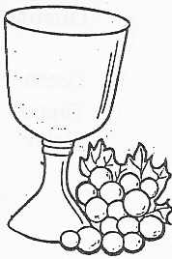 **With an everlasting love**

**You have given us holidays and seasons for rejoicing**

**And this day of the Feast of Matzah,**

**The time of our freedom,**

**In remembrance of Israel’s going out from Egypt.**

**Blessed Are You, Lord our God,**

**Who sanctifies Israel and the festival seasons.**

*(All drink the first cup/sip of wine)*

**Urehatz: Washing of the Hands**

*(Leaders wash hands – a sign of Purification)*

**Karpas: Eating the Green Herb**

Blessed are you, Lord our God, Ruler of the universe, creator of the fruit of the earth.

*(Everyone dips the green parsley on his/her plate*

*into the salt water and eats it.)*

**Yachatz: Breaking of the Middle Matzah,**

**The Afikoman**

The leader uncovers the Matzah, breaks the middle of the three Matzah, leaving one half on the plate. The other half, the Afikoman, is to be hidden and will be eaten after the children have found it, at dessert time.

**Maggid: The Passover Story**

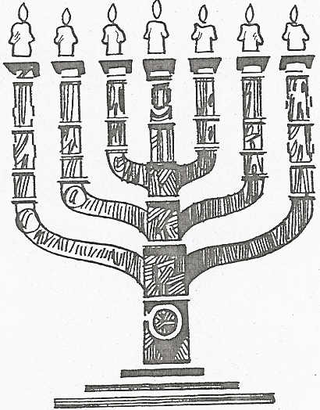**Bread of Affliction**

**This is the bread of affliction**

**which Israel ate in the land of Egypt.**

**It is a symbol of days of slavery and pain**

**endured by the Jewish people for centuries.**

**It is our hope that next year we will be free,**

**that next year humankind will be free from all oppression**

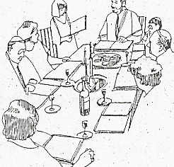

**Questions of the Seder**

It is the obligation of parents to share with their children the story of the Passover so that they in turn might recount it to their children.

*(The youngest child asks the questions at the Seder)*

***Child: Why do we eat Matzah tonight?***

When Pharaoh let our ancestors go from Egypt, they were forced to flee in great haste. They had no time to make leavened bread. They could not wait for the yeast to rise. As they fled in haste the sun beat down on the dough and baked it into flat bread called Matzah.

**Blessed Are You, O Lord Our God, Who has provided us with Bread.**

***Child: Why do we eat Bitter Herbs tonight?***

The Bible tells us that our ancestors were slaves in the land of Egypt and their lives were made bitter by their oppressors.

**Blessed Are You, O Lord Our God, Creator of the fruits of the Earth.**

***Child: Why do we have an egg on the Seder Plate?***

The egg is a symbol of fertility. All forms of birth and rebirth can be remembered if we think of the egg as the eternal symbol of new life. We eat the egg as a part of a ritual to show we are grateful for the gift of life.

**Blessed Are You, O Lord Our God, Creator of Life.**

***Child: Why do we have horseradish on the Seder Plate?***

When we feel the tang of the flavor we are reminded of the bitterness of life when one has no political or personal freedom. We know our ancestors were enslaved – our tradition teaches that we should feel as if we were also enslaved. When the bitterness of the horseradish sears our taste we have some foretaste of the continuing bitterness of slavery for any who exist without the rights to live in accordance with his own conscience.

**Blessed Are You, O Lord Our God, Who comforts us in Sorrow.**

***Child: Why do we have Haroset on the table?***

Haroset is a mixture of apples, spices, nuts and wine. It looks like the mortar the Hebrews used to build the Pharaoh’s cities while they were slaves. Even in slavery they had each other, the sweetness within oppression.

**Blessed Are You, O Lord Our God, Who brings sweetness out of our pain and suffering.**

Leader: Moses pleaded with Pharaoh; who stubbornly refused to free the Hebrew slaves. God afflicted him with ten plagues that left Pharaoh’s people and their land desolate.

We recall God’s ten plagues by placing a drop of wine on our plates as we mention each of them. We do not pour wine with joy. According to an ancient Jewish tradition, we express our compassion for the suffering of the Egyptians. Although they were enemies and tormentors, they were also children of God and fellow human beings.

*(As each plague is mentioned,*

*place a drop of wine on your plate.)*

**1. Blood 6. Boils**

**2. Frogs 7. Hail**

**3. Vermin 8. Locusts**

**4. Flies 9. Darkness**

**5. Cattle Disease 10. Slaying of the Firstborn**

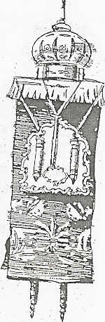***Child: Why do we have Lamb on the Seder Plate?***

Let us listen to the story of the first Passover.

**Exodus 12:1-14**

**Blessed Are You, O Lord Our God,**

**Who died to give us eternal life.**

**Second Cup of Wine: The Cup of Memory**

Leader: Not only our ancestors were redeemed by God from slavery; all of us also are now redeemed in spirit and by example. Each of us, each generation, is a beneficiary of God’s power of salvation. For this reason we raise our cup and drink the wine of memory, the memory of salvation.

**Blessed Are You, O Lord Our God,**

**Ruler of the universe,**

**Creator of the fruit of the vine.**

*(All drink the second cup/sip of wine.)*

**Rahatz: Washing of the Hands**

Leader: We are ready to enjoy the Passover meal. Before we eat let us wash our hands and say together:

**Blessed Are You, Lord Our God.**

**Ruler of the universe,**

**Who sanctified us with your commandments**

**And commanded us concerning the washing of the hands.**

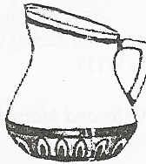*(The head of the table takes the bowl and towel*

*to each person at the table to wash his/her hands.)*

**Motzee-Matzah:**

**Blessing over the Matzah**

Leader: Blessed are you, Lord our God, ruler of the universe who brings forth bread from the earth.

**Blessed Are You, Lord our God,**

**Ruler of the universe,**

**Who sanctified us with your commandments,**

**And commanded us to eat of Matzah.**

*(Each person eats a piece of the Matzah.)*

**Maror: Eating the Bitter Herb**

*(Each person dips the herbs in Haroset.)*

**Blessed Are You, Lord our God,**

**Ruler of the Universe,**

**Who made us holy with your commandments**

**And commanded us to eat of bitter herbs.**

*(All eat the herbs.)*

**Korekh:**

**Eating the bitter Herb and Matzah**

Leader: Hillel did this in Temple days. He joined Matzah and bitter herbs in order to observe the biblical command: “They shall eat the Passover offering together with Matzah and Maror.” (Numbers 9:11)

*(Eat the Herbs and Matzah.)*

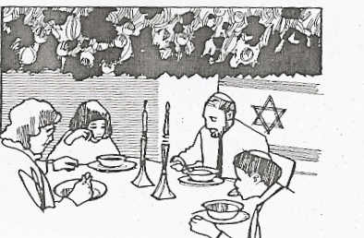

**Shulhan Orekh: The Passover Meal**

**Dinner is served,**

**Eat**

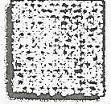**And enjoy the camaraderie!!**

**Tzafun: The Afikoman**

*(After the meal the children search for the Afikoman,*

*which the leader hid before the meal.*

*A reward is given to the one who finds it.)*

**Barekh: The Blessing after the Passover Meal**

Leader: The Bible indicates the obligation to say a blessing: “When you have eaten and are satisfied you shall thank the Lord your God for the good land which he has given you.”

(Deuteronomy 8:10)

**Praised be the Lord, our God, Sovereign of all, who sustains the world with goodness and gives us the food of the earth.**

**We thank you, Lord our God,**

**For all goodly land**

**Which you have given to our ancestors,**

**And for bringing us out from the land of Egypt,**

**And redeeming us from the house of bondage.**

**We thank you for the torah which you have taught us,**

**And for the life of grace and loving-kindness**

**Which you have graciously bestowed upon us,**

**And for the good we eat**

**With which you nourish and sustain us at all times.**

**Third Cup of Wine:**

**The Cup of Redemption**

*(Wine glasses are filled again.)*

Leader: The biblical text reminds us of God’s redemption: “I will redeem you with an outstretched arm and with mighty acts of judgment.” (Exodus 6:6)

**Blessed Are You, O Lord our God, Ruler of the universe, Creator of the fruit of the vine.**

***(All drink of the third cup of wine.)***

Leader: The cup of Elijah the prophet is full and sits in the middle of the table. Each year the Jewish people look for Elijah to come and announce the coming of the Messiah.

**On this night of the Seder we wait for Elijah. We remember with reverence those men, women and children who perished at the hands of tyrants more wicked than the Pharaoh who enslaved our ancestors in Egypt.**

**Hallel: Recital of the Psalms**

*(At this part of the meal Psalms 113-118 would be recited.)*

**Neertza: Conclusion of the Seder**

**Fourth Cup of Wine:**

**The Cup of Hope and Freedom**

*(The cups are filled for the fourth and final time.)*

**All lift up your cups:**

**We will partake of the fourth cup of wine, The cup of freedom. It is a reminder of freedom – Its hopes, struggles and dreams For so many enslaved nations and individuals. As committed children of God, We are called to witness this precious gift And make it known to all peoples of the earth: Those who seek justice, those who lack any rights And those who struggle for freedom.**

**Blessed Are You, Lord our God, Ruler of the universe,**

**Creator of the fruit of the vine.**

*(All drink the fourth cup/sip of wine.)*

Leader: May the Lord inspire us to nobler living

And draw us closer to Him.

May the battle-cry for all who seek freedom

Ever ring in our ears: Next year in Jerusalem!

**Pronunciation Guide**

**Afikoman (**ah-fee-**KOH-**mahn**):** Originally from Greek,

Literally meaning “dessert.” This refers to a special piece

of Matzah broken off and gidden and then returned after the

meal has been eaten. This Matzah is the last thing to be

eaten at the Seder.

**Baytzah (BAY-**tzah**):** An egg; reminder of roasted egg

Offered at the Temple of Jerusalem at the Passover festival.

The egg is also a symbol of the spring.

**Haggadah (**hah-**GAH-**dah**):** Meaning “the telling” of the

story, and thus the ritual text used at Passover that tells the

Exodus epic in prayer and proclamation.

**Hallel (HAHL-**el**):** Praise. This is the name given to

Psalms 113-118

**Hametz (HAM-**mets**):** Leaven or yeast. No leavened food

is to be present during Passover.

**Haroset (**hah-**ROH-**set**):** Mixture of chopped apples,

chopped nuts, cinnamon and wine; a visual reminder of the

mortar used by the forced Hebrew laborers in Egypt; its

sweetness represents freedom.

**Karpas (KARH-**pahs**):** A green herb; reminder of spring, the

season of Passover; used as a sign of gratitude to God for the goodness of the earth, for our bread and food.

**Kiddush (KIH-**doosh**):** Blessing of God recited over the

wine before the evening meals of the Sabbath and festivals.

**Maror (**mah-**ROHR):** Bitter herbs; reminder of bitterness

and hardship of slavery. Horseradish is often used as

Maror at the Seder.

**Manna (MAN-**ah**):** The bread with which God fed the

Hebrew people during their years of wandering. (Exodus 16)

**Matzah (MAH-**tzah**):** Unleavened bread or dough without

yeast that the escaping slaves took into the desert; a symbol

of haste and hope, linking exile and bondage with

redemption. The plural is *matzot*.

**Pesach (PAY-**soch**):** Passover. This is used to mean both

the festival and the Passover lamb (see Zeroah) that

symbolizes the Lord’s passing over the houses of the Hebrew

slaves in Egypt, which were marked with the blood of a lamb.

**Seder (SAY-**der**):** Order. This refers to the ritual followed

during the Passover meal celebration.

**Shalom (SHAL-**lohm**):** Peace.

**Torah (TOH-**rah**):** First five books of the Hebrew

Scriptures, the books of Moses.

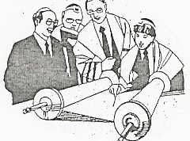**Zeroah (**ze-ROH-ah**):** Roasted bone, a reminder of the

sacrifice of the Passover lamb.

We are glad that you were able to join us this year for our Seder.

We hope that after tonight you have a better understanding of the night when Jesus gathered his friends together for the Passover Meal, which we now call The Last Supper.

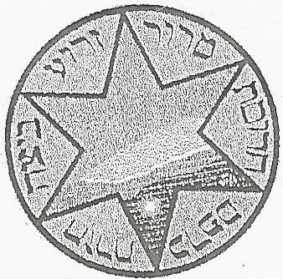

SS. Peter & Paul Religious Education