Retreat Leader’s Guide
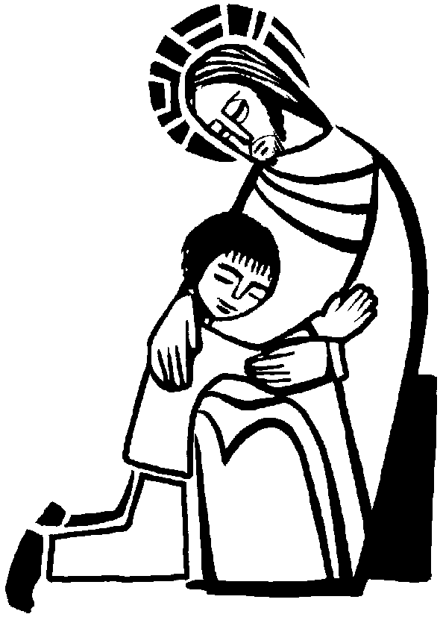

1st Reconciliation
Retreat

St. Thomas More Church, Room 222
Sunday, November 8, 2015
8:00am-12:00pm
First Reconciliation Retreat Itinerary
7:15-7:45 Set up for Retreat & Retreat Team Prayer
A light breakfast will be provided for you.
7:45-8:10 Students Arrive
Greet families, give students nametags, take attendance, seat them at their tables (they may begin working on the coloring pages at their table)
(8:00) (Retreat *technically* begins)
8:10-8:16 Our Father
Have the Students form a circle in an open area of the room (Emily will designate). Help them form a circle—they may need to join hands, go out as far as they can go while holding hands, and then drop hands. Make “praying hands” to begin the prayer, and all recite the Our Father together. Then students return to their seats.
8:16-8:26 Sin in Salvation History Lesson
Emily will begin by prompting them with questions about sin and our redemption. With any remaining time, have them complete their coloring pages, put them in order, and glue them onto their timelines. Leave projects at their tables during rotations.
8:26-9:15 Classroom Rotations (24 minutes each)
Rotation 1: Sin Backpack
Rotation 2: Rules to Live By
9:15-9:20 Large Group Discussion
Return to Room 222 and Emily lead discussion about the two rotations. Help students find their tables again.
9:20-9:40 “You are God’s Light in the World” Activity
Candle decorating activity. We will begin with a scripture passage (Mt 5:14-16) about not hiding our light under a bushel basket and then the students can use paint pens and foam stickers to decorate the outside of their candles. Then have them clean up their area and return to their seats. Sing “You are the Light of the World” if extra time.
9:40-9:45 Stretch and Bathroom Break (parents arrive)
9:45-9:50 Give Directions for Mass & Head to Church
Help set up snacks for after mass while Emily talks to families.
9:50-11:00 Mass & Enrollment Blessing
11:00-11:10 Snacks & Family Discussion
Dismiss families by table to choose their snacks, make an orderly line.
11:10-11:15 Sing “Loving and Forgiving” and Opening Prayer
Emily welcome parents to our retreat. Talk a little about the work they’ve been doing and what a pleasure it is to help prepare their students to receive their First Reconciliation. Thank them for coming and being a part of this important process.
11:15-11:35 The Choices We Make (parent/child activity)
11:35-11:45 Rite and Ritual of Forgiveness
Emily will lead families on a guided mental activity thinking about what they may need to forgive family members for. Then there will be a short sharing session between family members. Necklaces given to children by parents with a promise that they will always forgive their child.
Sing a reprise of “Loving and Forgiving” if time permits.
11:45-11:55 Reconciliation Roleplay w/Fr. Jim
Emily, Kiki, and Fr. Jim will give a short roleplay of what the children can expect to happen when they go to confession. Fr. Jim may take questions if there is time.
11:55-11:57 Blessing of the Necklaces and Closing Prayer
11:58-12:00 Announcements & Dismissal
Parents should turn in their remaining reconciliation packets and (for day school families) their sacrament registration fee. Remind them about the date and time of the Rite of Reconciliation and encourage them to invite their godparent, grandparent, or other active Catholic person to attend with them and show their support. Ask them to invite that person to pray for them leading up to the Rite. Give them an invitation to take home and send out and ask them to personally call the person as well.

Retreat Supplies

- Arrival
  - Attendance sheet
  - Pencils/pens (for signing in)
  - Name Tags
  - Table Designations (colored table tents)
  - Coloring pages
  - Crayons
- Sin in Salvation History Activity
  - Additional coloring pages
  - Bible (w/Genesis reading marked)
  - Long butcher paper for timeline
  - Glue sticks (1/student)
- Sin Backpack Rotation
  - Cans of “sin” (labels covered w/colored paper)
  - 2 empty backpacks
  - Masking tape (mark on floor)
  - Act of Contrition bookmarks (1/student)
- Rules to Live By Rotation
  - 11x17 paper
  - Markers
  - Act of Contrition Bookmarks
  - Crayons
  - Colors
  - Act of Contrition word scramble
  - Glue sticks
  - Purple paper
- You Are God’s Light in the World Activity
  - Candles (1/student)
  - Paint pens
  - Foam stickers
  - Labels (1/student w/name on them)
  - Bible (w/”light” passage marked)
  - Laptop
  - External speakers
  - Music playlist (w/songs about light)
- Enrollment Ceremony & Blessing
  - Script for presiding priest
- Snacks (assorted) + baskets, cups, water pitchers, napkins, small paper plates?
- “Loving and Forgiving” song lyrics (2/student)
- Parent/Child Activity—The Choices we make
  - Skit props
  - Bible
  - Script (2 copies)
  - Craft project
- Rite and Ritual of Forgiveness
  - Rings (1/student)
- Reconciliation Roleplay
  - Script (3 copies)
  - Any portable reconciliation kit items Fr. Jim wants to bring
  - 2 chairs
- Announcements & Dismissal
  - Invitations & Envelops to invite godparents or other Catholic friend/family
  - Checklist for day school families when they pay their fee
  - Checklist for reconciliation packet completion
  - Give Retreat Family Processing sheet (turn in at Rite of Reconciliation)
- Other:

Sin in Salvation History
Timeline Activity
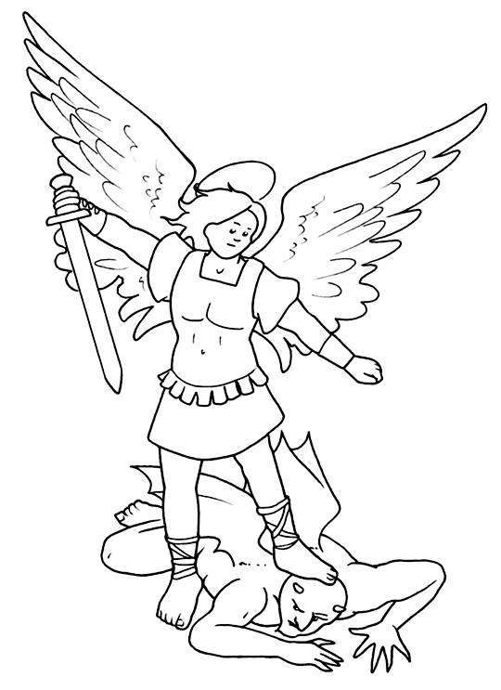
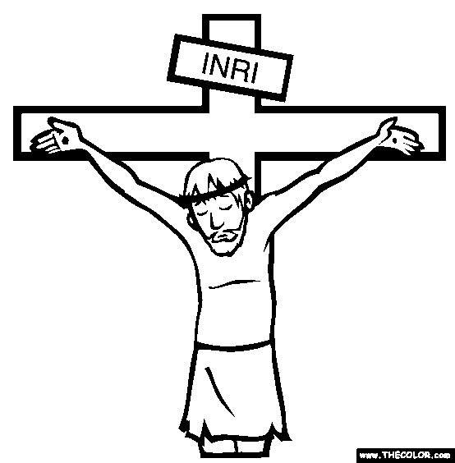
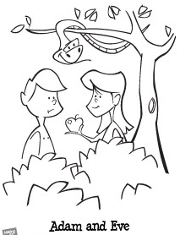

2
3
1

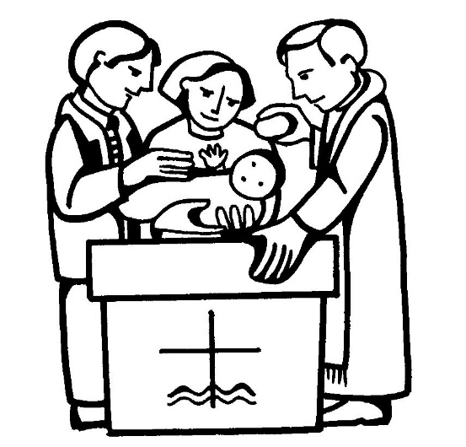
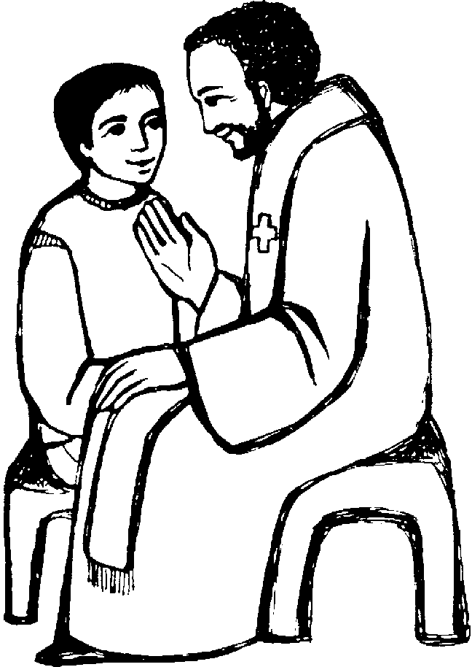

6
5
4

1st Reconciliation Retreat Rotation 1:
Unloading Our Backpack of Sin
Goal: Learn that by going to the Sacrament of Reconciliation we can “unload” our backpack and not have to carry so many heavy things around.
Materials: 2 backpacks, “Cans of Sin,” taped “path” on the floor, Act of Contrition bookmark, crayons
Engage:
- Welcome children into the room. Show them two backpacks. Say you are getting ready to go for a journey.
- Tell them this journey will take your whole life. Point out the lines on the floor. One end is labeled birth. The other end is labeled death.
- Tell children that when a person becomes a follower of Jesus, we know we will go to heaven when we die because Jesus suffered and died for us on the Cross.
- But even after choosing to follow Jesus we can still sin and mess up.
- Ask children how they feel after they have done something wrong. Wait for some responses. Stress keeping sin a secret makes us feel bogged down with fear and worry.
- Tell them we may feel embarrassed about our sins and want to hide them. We may be afraid to tell anyone about them. Ask children if they have ever felt this way.
- Whisper to them the good news: “We have the special sacrament of reconciliation. We can always ask forgiveness and we will be forgiven right then and there. We never have to be afraid to tell the priest our sins!”
Explore:
- Ask for two volunteers to help you.
- Say “Each of you is going to wear a backpack. You will start as this line and try to walk to that line.”
- “I will stop you and read some situations where you make an unloving choice and sin.”
- “One of you will confess your sin and ask for forgiveness and one of you will not.” (Give an example of what it would sound like to ask for forgiveness.) “Forgive me father, for I have sinned.” – have the child kneel down and hand you back the “can of sin.”
- “Ready…lets’ go.”
- Read the situations below and put a can of sin in each backpack. Then ask them to ask for forgiveness. Take the can of sin out of the backpack worn by the one who asks for forgiveness. You may need to “coach” the child who asks for forgiveness at first.
  - Your parents tell you not to watch a certain T.V. show but you watch it anyway.
  - You haven’t studied for a test and you cheat off of someone else’s paper.
  - You get mad at your brother and call him bad names.
  - You steal a candy bar from a store when no one is looking.
  - You keep the money you set aside to give to church and spend it on a new game instead.
- As the student progress, ask the one who has the heavy backpack how that feels.
Reflect:
- After the children have reached the end of the journey ask, “Both of you make it to the end of journey, but who had the better trip? Was it better to carry all those heavy cans of sin, or better to have an empty backpack?”
- When you are a believer in Jesus you can still sin. And that sin can weigh you down with guilt, worry, and embarrassment.
- But Jesus doesn’t want you to carry around all that sin and guilt.
- Anytime we sin and make a mistake Jesus is right there waiting to forgive us in the sacrament of reconciliation. All we have to do is go to him.
- We don’t need to be afraid. The priest will never tell anyone what we say.
- Not only will Jesus forgive us, but through the penance the priest gives us, Jesus will show us a better way to live.

Respond:
- If time allows, tell children there is special prayer we learn that we say at reconciliation that helps us tell Jesus how sorry we are for our sins.
- This prayer is called the act of Contrition.
- Hand out the Act of Contrition book mark.
- Once they have practiced, children can color in the bookmark to take home with them if time permits.
- They may complete the Act of Contrition word scramble and glue it to the purple paper half sheets if time permits.

1st Reconciliation Retreat Rotation 2:
Rules to Live By
Goals:
- Talk about the rules God asks us to live by
- Learn how to make up with others we may have hurt
Engage:
- Begin by welcoming students into a “story circle.” The children may sit on the floor.
- Tell the students you are going to read a story about loving and unloving choices. At the end you will ask them who made loving choices and who made unloving choices.
- Read aloud “Jesus and Zacchaeus” (Luke 19:1-10) from The Catholic Children’s bible. If the students seem confused, read the “understand it” paraphrase from page 1631.
- After you are finished reading, ask the following questions:
  - When Zacchaeus loved and cheated, did he make a loving or an unloving choice?
  - When people made fun of Zacchaeus, did they make loving or unloving choices?
  - What kind of choice did Jesus make? Why would he go to the house of a sinner?
- Say, “Jesus calls us to make loving choices every day and he even gives us some rules to help us make loving choices. We are going to learn more about that in our retreat today.
Explore:
- Now ask them go to their tables. Tell them you are going to discuss the rules God gives us to live by.
- Hand out a the paper called “My Family’s Rules.” Ask the children to write down some of the most important rules their families have. After each rule, write what happens when these rules are broken.
- If there is time, the sheet may be decorated.
- After about 5 minutes, have each child share.
- Ask the questions: Why do families have rules? What happens when family members don’t follow these rules? Listen to responses.
- Tell the children God has rules just like families have rules.
- Ask the children to turn their papers over to the “God’s Rules” side and write what they think are God’s rules for us.
- After about 5 minutes, have the group share.
- Ask the children if they learned about God’s list of rules before? (The 10 Commandments)
- Hand out prayer cards with the 10 Commandments on them. Compare their family rules and what they think God’s rules are to the 10 Commandments. Affirm what they have in common.
- Tell children that God and family rules guide our lives and help us make loving choices.
- Stress the following points in group discussion:
  - Sometimes we make mistakes. At times accidents happen and we feel responsible. These are not sins because we did not choose to do wrong.
  - Choosing to do something we know is wrong is a sin. (Ask students to give some examples of some mistakes, accidents, and sins so they know the difference.)

  - Write the following points on a white board or poster paper:
    - A sin is an unloving choice we know is wrong when we do it.
    - A sin is something we do on purpose.
    - A sin hurts our friendship with God.
Reflect/Respond:
- Say, “When we sin, we can always ask for forgiveness. God and the people we love will forgive us if we are truly sorry. Just like Jesus forgave Zacchaeus.
- Hand out the Flower of Forgiveness worksheet to each child. Have the children complete the sentences at the top of the page and color in the flower as they go. (Go around and help if they require assistance.)
- If time allows, have them share some of their responses.
- Thank the children for coming and instruct them where to go for the other rotation (or back to room 222 if it is the second time.)

God’s Rules

----------------------------------------------------------------------------------------------------------------------------------------------------------------------------------------------------------------------------------------------------------------------------------------------------------------------------------------------------------------------------------------------------------------------------------------------------------------------------------------------------------------------------------------------------------------------------------------------------------------------------------------------------------------------------------------------------------------------------------------------------------------------------------------------------------------------------------------------------------------------------------------------------------------------------------------------------------
My Family’s Rules
Consequence
Rule

- ___________________ _______________________
- ___________________ _______________________
- ___________________ _______________________
- ___________________ _______________________
- ___________________ _______________________
- ___________________ _______________________
- ___________________ _______________________
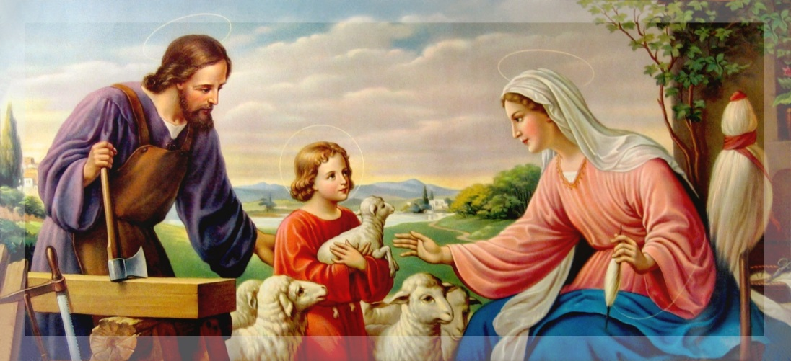

Flower of Forgiveness
Zacchaeus was forgiven. He made up for any wrong he had done by paying back what he had taken. We can make up with the people we love when we sin too!
Complete the following sentence and then color in 2 flower petals for each sentence you complete.

- When I hurt someone in my family, I can make up by:
__________________________________________________________________________

- When I don’t follow a family rule, I can make up by:
__________________________________________________________________________

- When I am mean to a friend at school, I can make up by:
__________________________________________________________________________

- When I lie about something I did so I won’t get in trouble, I can make up by:
__________________________________________________________________________

I forgive you!

1st Reconciliation Parent/Child Activity:
The Choices We Make
Goal: Talk about consequences of loving and unloving choices, discuss ways to show we are sorry for our choices and complete the family rite of forgiveness.
Materials: Children’s story of the Prodigal Son, choices we make grid, choices we make game, rings for each child.
Engage:
- Read aloud the story of the Prodigal Son
- Put up the three character names. Ask who made a loving choice.
- How did the three choices impact their lives?
- What happened when the younger son was sorry? Did his father forgive him?
- What were the ways he showed he was sorry? (Words, actions, prayer to God)
- Tell students when we all have opportunities to making an loving or an unloving choice, when we make an unloving choice, we can always ask for forgiveness. We can do this through words, prayer, and actions.
Explore:
- Present the making choices grid. Ask families to talk about the first choice and then discuss as a group.
- Have families do the second two choices and discuss as a group at the end.
- Hand out the “making choices” game. Have each family play the game in the following way:
  - One person reads the card
  - The next person says what the choice would be
  - If it is a loving choice put in one pile/unloving choice in the other pile.
Reflect:
- When about 10 minutes remain, collect the cards.
- Tell families we are now going to have a quiet time of prayer together.
- Invite families to make small circles with their chairs, facing one another.
- When they are settled as a volunteer to hand out a ring to each family.
- Complete the rite and ritual as scripted.

Rite and Ritual of Forgiveness
Leader: The sacrament of reconciliation celebrates the gifts of God’s love and reminds us that God asks us to be loving and forgiving. There is a story in the Bible about a Father who loves and forgives his son, when he expresses he is sorry. We read this story today
Leader: I am going to ask everyone to close their eyes right now. I would like you to close your eyes and think about the loving and unloving choices you have made in the past week and one way you will try to make more loving choices in the future. (pause to let people think)
Leader: Open your eyes. Children, if there is an unloving choice you have made recently that you would like to say sorry for, whisper that into your parents’ ear now, or tell them one way you will try to make loving choices in the future. (wait)
Leader: Children, when the father put a ring on his son’s hand, what did that mean? (wait for responses) Each of your parents has a ring to put on your finger. This is a symbol that they will always love you and forgive you and that God will always love you and forgive you. Parents, put this ring on your child’s finger now, look into their eyes and say, “I will always love you and forgive you.”
Leader: Children, grownups sin too. We can also do things that hurt others. Parents, if there is an unloving choice you have made recently that you would like to ask forgiveness for, whisper it in their ear now. If not, tell them one way you are going to try to make loving choices for your family.
Leader: Children, let your parents know you will always love them and forgive them. Look into their eyes and say this to them now, “I will always love you and forgive you.
Leader: Later we will all got to Mass together. Be sure to wear your ring into Mass where Father will give us a special blessing.

Reconciliation Role Play
Five-Finger Memory Activity
Goal: Learn the steps to going to reconciliation and see a role play of the sacrament of reconciliation
Materials: Role play, paper, pencils, art materials, A “Handy” Way to Remember sheet, scissors
Engage:
- Welcome Fr. Jim and transition from forgiveness activity with our parents to how God forgives us in the sacrament of reconciliation.
- Call attention to a hand you have drawn on the board or white paper.
- Tell students you are going to give them a “handy way” to remember the steps to the sacrament of First Reconciliation
Explore:
- Ask each child to trace their parent’s right hand on a piece of paper.
- Tell families you are going to talk about the five easy steps to reconciliation and talk about what they mean. Parents should write the steps in the hand as you discuss them. Briefly describe each step.
  - Thank God for His gifts and examine your conscience (Think about the things you have done wrong and want to do better.)
  - Pray an act of contrition saying you are sorry.
  - Promise to do better in the future.
  - Confess your sins to God in the presence of the priest.
  - Do the penance the priest gives you.
- After you have gone over the steps, tell the families they will watch a role play of these steps and that the child should color in the finger if they think the step has been done.
- Introduce Emily as the “child,” Kiki as the “narrator,” a parent volunteer as the “parent,” and Fr. Jim as himself—the priest.
Reflect:
- Ask children to give the thumbs up if they think that the person in the role play followed all the steps.
- Tell children to keep their hand as a way to review what they have learned. Ask them to recite the steps with you aloud as they hold out their hand.

Reconciliation Role Play Script

Narrator: In our role play, We will watch as a family goes to reconciliation for the first time. Pay attention to what each person does.

Child: Sits in chair and bows head to pray.

Narrator: First, Hana will think about the sins she is sorry for so she knows what she wants to talk to father about.

Child: (Praying) Dear God, thank you for all the gifts you have given me. This week I wanted to be the first person to use the monkey bars, so I pushed my classmate. I know it wasn’t a loving choice to make.

Narrator: Before we go to confession, Father will invite us all to pray the act of contrition together.

Father: Everyone lets stand and pray our act of contrition together.

Narrator: (Invites everyone in the room to stand and pray the act of contrition the cards you have available)

Narrator: Next 3 things will happen

- Families go to a reconciliation station and introduce
their child to the priest. Use the paper with the sin to be confessed written on it to help you with your confession.

2. As the child sits down with the priest, parents step away from the reconciliation area to provide privacy while the child talks to the priest.

3. Parents are invited to celebrate the sacrament after their children.

Parent: Approaches the priest with child- Hi, Father. This is, Hana. (Then the parents step back as the child goes to reconciliation)

Priest: Welcome, Hana I’m happy to see you. Let’s make the Sign of the Cross together.

Priest and Child together: In the name of the Father, and of the Son, and of the Holy Spirit. Amen.

Child: Father, forgive me, for I have sinned. This is my first confession.

Narrator: Then Father will say a short prayer—something like this.

Priest: May God, who has enlightened every heart, help you to know your sins and trust in his mercy.

Narrator: Then Father will ask you to talk about unloving choices you have made—unloving choices that are sins. This is called your confession. Before coming to celebrate the Sacrament of Reconciliation, think about what you will tell the priest when you make your confession. Tell him your sins and things you’d like to change so that you can better follow Jesus. If you forget what to do when you sit down with Father, what can you do?

Priest: “Tell me, Hana, what sins would you would like to talk to Jesus about?

Narrator: Hana thinks a minute. Does she have to tell EVERYTHING she has done wrong in her whole life? What do you think?

Child: Father, I want to try to be more thoughtful and kind. It is hard for me to let others go first. It is hard for me to share.

Narrator: Father will talk to you about what you want to change in your life and ask you to do something special to show Jesus how much you love him. Father may give you some suggestions about ways to change. He might ask you to do an act of kindness or say a prayer. This is called your penance.

Priest to Child: God understands that it is not always easy to be kind, especially if the other person is not nice to you. But God told us to love others and treat them just as we would like to be loved and treated. This week, try asking Jesus to help you be kind to others, even when it is difficult. How do you think you can do this?

Child: Thank you, Father, I will do that. And I am going to try to do better. I think I can do this by letting other people go first on the playground instead of me.

Priest: When you leave, I’d like you to go back to your seat and take some time to think about how much God loves you and the ways you will try to make more loving choices. Now it is time to recite the Act of Contrition

Narrator: Then Father will bless you.

Priest: (makes the Sign of the Cross) I absolve you from your sins in the name of the Father, and of the Son, and of the Holy Spirit. God bless you and go in peace.

Child: Amen. Thank you, Father.

Narrator: Then, Hana’s parents will go to confessions. When they are done, they will go back to their seats. After that, the next family will go to confession when they see Father is free. The family will wait until everyone is finished going to confession. Does anyone have any questions?

Retreat Rite for Reconciliation ©LoyolaPress.

