First Eucharist Parent Meeting
January 5/6, 2016
4:15/5:30
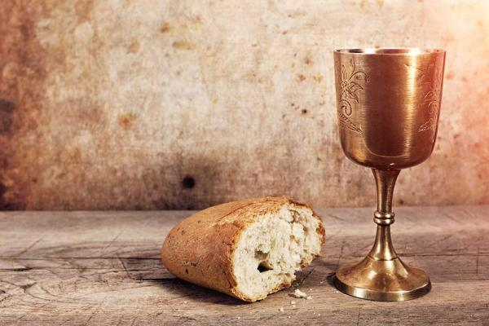
- Welcome/Introductions/ Prayer (5 min)
- The Epidemic (9 min)
- The ONE thing (6 min)
- Reflection and Small Group Discussion (7 min)
- Parent Panel: Learn from the Experts! (10 min)
- Come to the Feast of heaven and earth! (20 min)
  - Family Sessions, classroom preparation, community preparation
  - Sign up for retreat and First Communion Dates, to be turned in by the end of the meeting.
  - Questions
  - Thank you for coming. We are on a wonderful journey together with the Lord!
Luke 24: 28-31
So they drew near to the village to which they were going. He acted as if he were going farther, ²⁹ but they urged him strongly, saying, “Stay with us, for it is toward evening and the day is now far spent.” So he went in to stay with them. ³⁰ When he was at table with them, he took the bread and blessed and broke it and gave it to them. ³¹ And their eyes were opened, and they recognized him.

