Protective Behavior Booklet

St. Anthony Parish
Niagara, WI

11th – 12th Grade

A Safe Environment Curriculum

Protective Behavior
A Safe Environment Curriculum
11th – 12th Grades

Learning Objectives:
- God made us for happiness
- We do not always know what will make us happy
- God reveals His will for our life and we need to discern and accept His will in order to be happy
- We put on the Armor of God in order to protect ourselves from the lies of our enemies who promise happiness, but don’t deliver
- We learn the 3 modes of discernment taught by St. Ignatius of Loyola

Song "Place In This World"
The wind is moving - But I am standing still - A life of pages - Waiting to be filled - A heart that's hopeful - A head that's full of dreams - But this becoming - Is harder than it seems

Feels like I'm - Looking for a reason - Roamin' through the night to find - My place in this world - My place in this world - Not a lot to lean on - I need your light to help me find - My place in this world - My place in this world

If there are millions - Down on their knees - Among the many- Can you still hear me - Hear me asking - Where do I belong? - Is there a vision - That I can call my own?

Show me, I'm Looking for a reason - Roamin' through the night to find - My place in this world - My place in this world - Not a lot to lean on I need your light to help me find - My place in this world - My place in this world

Prayer from Most Reverend David Ricken
Lord, help me to do your will, nothing more and nothing less. Help me to do your will, not a moment sooner nor a moment later that you will it. AMEN

What is God’s will for YOU?
God creates Adam and Eve and wants them to be happy. God wants you to be happy. God is love and love seeks the GOOD of the other. God does this perfectly because He is perfect.

God creates men and women in His own image. This means humans have an intellect and free will. They are able to reason and are free to choose the greater good. Adam and Eve make a selfish decision as they chose to disobey God and GRASP for themselves what they THINK is good for them. This causes a rift in the relationship between God and humans; it causes a rift in the relationships among people; it even causes a rift between our own body and spirit. This is known as the Original Sin.

Only Jesus, who is fully God and fully man, is able to heal this rift between God and humans. Jesus teaches men and women how to live as children of God; how to love even if it hurts; and how to make good decisions despite the temptations from the world, the flesh, and the devil.

We still suffer from the effects of Original Sin, but now we have the GRACE of GOD to be victorious in our battle. God wants us to FIGHT for our HAPPINESS; God wants us to receive His love and respond to His love with love.

Discussion Questions:
Do you believe God wants YOU happy? Answers may vary. If someone doubts this truth, ask why not. You may need to respond to this or just let it go and pray for this student.

How do you use your intellect and free will in your daily life? Every decision we make, the habits we’ve formed,

Why did Adam and Eve’s betrayal cause such a HUGE problem? They did not suffer from concupiscence (an inclination to sin) when they made the decision to not trust God. Their betrayal KILLED the life of grace in their soul. This break is inherited by all human kind. If you need more information regarding Original Sin see CCC 385-401

What are the effects of Original Sin that we still struggle with? Concupiscence, suffering, death, clouded intellect, veiled relationship with God, (See CCC 402-406)

What did Jesus’ sacrifice on the cross accomplish? It bridged the relationship between God and man allowing man to receive God’s life back into his/her soul. We still suffer from the effects of Original Sin, but now we are able to live a life of grace and go to heaven (most likely through purgatory first) If we so choose. (See CCC 410-412)

What is a ‘GOOD’ DECISION?
A good decision is when a person chooses to do God’s will in particular situation so as to receive from God and give to God LOVE to the MAX. Go through this definition. Point out that there are good decisions, BETTER decisions, and the BEST decision. In our discernment process coming up, we are going to discuss how to choose the BEST. This means we will need to give up all decisions that in any way could be considered BAD – these will not even be on the table!

Doing or accepting God’s will is the ONLY way to perfect happiness! When God made you, He purposely put a deep desire in your soul that only HE can satisfy. You may feel this deep desire as emptiness or sadness despite having all your material needs met. People tend to seek to satisfy this desire with things that make them briefly happy. You will not be PERFECTLY happy until you see God face-to-face in heaven, but you can get really close to happiness while living your life on earth as you get closer and closer to God in friendship.

Discussion Questions:
What are the things people THINK will make them happy? Money, power, pleasure, spouse, health, good reputation, lots of friends, Discuss how each of these can only satisfy a person BRIEFLY.

How do we grow closer to God in friendship? By being obedient to God’s commands. Jesus said we are His friend if we do what He commands (cf. Jn 15:14). Prayer, Mass attendance, frequent confession…

Why is it so difficult to know & do God’s will?
God knows you are faced with enemies who want to take away your happiness. These enemies promise comfort and security, but their promises are lies! You may be tempted to believe these lies because in the short term they appear to be true. You may struggle with waiting for a profound happiness when an easy, quick happiness appears within your grasp.

Note: we will introduce St. Ignatius of Loyola later, but for now tell the students this story…
When St. Ignatius was healing from a serious wound he received while fighting in a battle, he was convalescing at a home that primarily had books about God. St. Ignatius was more interested in tales of chivalry and romance. However, due to the boredom, he started reading these other books. He noticed that his heart lifted with books about God and the saints and stayed lifted as often as he remembered them; Whereas the tales of chivalry lifted his heart quickly and left him feeling empty afterwards. This brought St. Ignatius to an understanding of the spiritual life: the things of God bring a lasting happiness and peace while the things of the world only bring a temporary happiness.

Jesus sends the Holy Spirit and founds His Church to guide His brothers and sisters into TRUTH. God calls you to live with dignity as His adopted son or daughter.

Sometimes it isn’t very comfortable to live in this world as God’s child. This is why Jesus sends the Holy Spirit to live in the souls of His faithful. By living in a State of Grace, which keeps the Holy Spirit dwelling in your soul, you put on the Armor of God. This Armor protects you from the lies of the world, the flesh, and the devil.

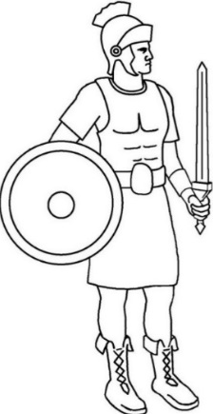
Discussion Questions:
Why isn’t it possible to have permanent comfort and security in this life? This world in constantly changing, only God is immutable. We are growing older and life situations are always in flux – this is just the reality of living on earth.

Why is it difficult to live as a child of God in this world? The enemies of the world, the flesh, and the devil, are constantly attacking.

Have you ever experienced waiting for something that was worth the wait? Answers may vary

How do we live with ‘DIGNITY’ as God’s adopted children? Simply by living we have a dignity of being made in the image and likeness of God. As God’s child we have even more dignity because our home is heaven. We live this out by following God’s commands (10 Commandments, law of love in the Beatitudes, precepts of the Church, practicing the corporal and spiritual works of mercy)

How do you put on the ARMOR OF GOD?
You put on the helmet of salvation when you guard your thoughts and senses so as to keep out evil. This includes guarding what shows you watch, what internet sites you visit, what music you listen to, what books you read, what thoughts you dwell on, etc. Our hope is in God; not in the fleeting distractions of the world, the flesh, and the devil. How do YOU put on the helmet of hope? Answers may vary.

You put on the breastplate of integrity and justice when you guard your heart so as to love God first and other people second. If you give your heart away to another person or an inordinate attachment, then you are not FREE to LOVE God with ALL your heart, soul, mind, and strength. Even if God is calling you to a vocation of marriage, your heart needs to be centered on God, THEN you will love your spouse and potential children with an even greater love. What is an inordinate attachment? Inordinate attachment refers to holding something or someone closer than God.

You put on the shield of faith when you are obedient to the teachings of the CATHOLIC CHURCH. Our FAITH is grounded on the foundation laid by Jesus. Jesus called Peter the ROCK on which the Church is built. Like the parable of the house built on rock versus the house built on sand, a FAITH built on the ROCK of Peter will withstand the assaults of the world, the flesh, and the devil (cf. Mt 7:24-27). What are the precepts of the Church? Are you living these?
CCC 2041-2043
The Precepts of the Church
2041 The precepts of the Church are set in the context of a moral life bound to and nourished by liturgical life. the obligatory character of these positive laws decreed by the pastoral authorities is meant to guarantee to the faithful the indispensable minimum in the spirit of prayer and moral effort, in the growth in love of God and neighbor:

2042 The first precept (“You shall attend Mass on Sundays and holy days of obligation.") requires the faithful to participate in the Eucharistic celebration when the Christian community gathers together on the day commemorating the Resurrection of the Lord.

The second precept (“You shall confess your sins at least once a year.") ensures preparation for the Eucharist by the reception of the sacrament of reconciliation, which continues Baptism's work of conversion and forgiveness.

The third precept (“You shall humbly receive your Creator in Holy Communion at least during the Easter season.") guarantees as a minimum the reception of the Lord's Body and Blood in connection with the Paschal feasts, the origin and center of the Christian liturgy.

2043 The fourth precept (“You shall keep holy the holy days of obligation.") completes the Sunday observance by participation in the principal liturgical feasts which honor the mysteries of the Lord, the Virgin Mary, and the saints.

The fifth precept (“You shall observe the prescribed days of fasting and abstinence.") ensures the times of ascesis and penance which prepare us for the liturgical feasts; they help us acquire mastery over our instincts and freedom of heart.

The faithful also have the duty of providing for the material needs of the Church, each according to his abilities
You wield the two edge sword of God’s WORD when you read the Bible and pray. Do you read the Bible daily? Do you pray? Answers may vary.

You put on the belt of honesty when you seek and speak the truth at all times. The world, the flesh, and the devil are master liars and encourage dangerous SECRETS. Learn to recognize their lies and bring their secrets into the LIGHT. Their lies make it difficult sometimes to discern God’s will. We’ll discuss a means of discerning God’s will in a little bit. What have you recognized as a LIE? How did you feel when you discovered the TRUTH? What are examples of secrets that need to be brought into the light? Answers may vary. Dangerous secrets include anything that may cause harm to yourself or another person. The harm could be physical, emotional, psychological, or spiritual.

You put on the skirt of purity when you live a chaste life. Chasity is for EVERYONE. Even a married person is to live a chaste life. This includes dressing modestly, speaking with purity, living our sexuality that is in accord with God’s laws, respecting our bodies as temples of the Holy Spirit, respecting other people’s bodies as temples of the Holy Spirit, and so on. Here is one quote from Catechism of the Catholic Church which points to the necessity of chastity if we wish to form real friendships with God and others:
The virtue of chastity blossoms in friendship. It shows the disciple how to follow and imitate him who has chosen us as his friends, who has given himself totally to us and allows us to participate in his divine estate. Chastity is a promise of immortality.

Chastity is expressed notably in friendship with one's neighbor. Whether it develops between persons of the same or opposite sex, friendship represents a great good for all. It leads to spiritual communion. (CCC 2347)

What does it mean to dress modestly? What does it mean to speak with purity? How is chastity a promise of immortality? Dressing modestly involves dressing in a way that doesn’t attempt to elicit sexual desire in another person (i.e. no low neck lines, no tight clothing, skirts at or below the knee, no spaghetti straps or sleeveless, etc.)
Speaking with purity means you do not use foul or suggestive language. Flirting is NOT speaking with purity!
Chastity is a promise of immortality because it points to our home in heaven. “Blessed are the pure in heart, for they shall see God” (Mt 5:8). Chastity requires self-mastery and helps us see others as persons and not objects to be used.

We put on the shoes to spread the Gospel of peace when we successfully discern God’s will concerning our VOCATION. What does it mean to ‘discern’? ‘see’ (as in seeing the right path to take),

Discussion questions:
Which piece of armor is the easiest to ‘wear’? Answers may vary.

Which piece of armor doesn’t seem to fit you right now? Answers may vary.

What is a vocation?
A vocation is the state of life you live as either a priest, religious, married person, or consecrated single person. Your choice of vocation may also affect other life decisions such as: Should I go to college? Which college should I attend? Who should I marry? Which job offer should I accept? How many children should we raise?

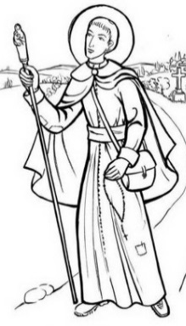
In the late 1500’s there was a man who was a soldier and then became the founder of the Jesuit order. His name is Ignatius of Loyola. St. Ignatius had many decisions he needed to make. St. Ignatius noticed, with himself and other people, some patterns in how God revealed His will. We will take the rest of our time together to go over what Ignatius discovered about DISCERNING THE WILL OF GOD…

(Taken from Discerning the Will of God by Fr. Timothy Gallagher)

TO BEGIN: The discerning process is only for choosing between two or more GOOD decisions. IT IS ALWAYS GOD’S WILL THAT YOU OBEY HIM! Jesus said we are His friends if we DO what He commands (cf. Jn 15:14).

If you are trying to decide things like: Should I sleep with my boyfriend/girlfriend? Should I steal shoes at the store? Should I get drunk this weekend? Should I look at risqué photos that elicit a sexual desire? Should I gossip about someone? Should I skip Mass on Sunday? Should I cheat on my test? Should I lie about where I was on Friday night? Then the answer is NO – you shouldn’t do these things. God’s will is VERY CLEAR on certain matters and there is NO discernment of HIS will that is necessary.

Including a SINFUL choice as an option is…
Discernment of YOUR will
NOT a Discernment of GOD’S will
Reread that…

If you need help finding where God is VERY CLEAR on certain matters, talk to your teacher about getting more information. (The Bible and Catechism of the Catholic Church are two wonderful resources. The section in the Catechism that discusses the 10 Commandments are especially helpful – CCC 1691-2550.)

Remind the students that it is NOT easy being a faithful Christian in this life. A general rule of the spiritual life is that the more difficult the path is, the more likely it is that this is the path God is calling you to follow. “Enter through the narrow gate; for the gate is wide and the road broad that leads to destruction, and those who enter through it are many. How narrow the gate and constricted the road that leads to life. And those who find it are few.” Matthew 7:13-14.
Ask the students to reflect on the worth of something that is difficult to attain versus something that is easy. Give some concrete examples like: playing an instrument, playing a sport, giving birth to a child, finishing school, staying married for 50 years, etc.

Discernment of God’s will begins with an awareness of God’s VERY GREAT LOVE for you. This awareness elicits a desire to do God’s will because you know He only wills YOUR GOOD; your eternal happiness.
After this awareness, then you need to be properly disposed to HEAR God talking to you; responding with LOVE to God’s love and being open to WHATEVER God reveals.

You can do this by receiving Jesus in the Eucharist, going to Confession, reading the Bible, taking moments to be SILENT, and seeking counsel from a wise spiritual guide.
?
FIRST MODE:
Sometimes God speaks very clearly about what is BEST for you. You have absolutely NO DOUBT what God wants for you. This clarity is a great gift from God – it isn’t always this easy. If this is the case, then SEEK the counsel of a wise spiritual guide to confirm the message; THANK God for the clear answer; and ACT on it!
Some examples might include: knowing what college you are attending because you just received a full scholarship to attend; having absolutely NO doubts about marrying your boyfriend who just proposed; hearing God call you to the priesthood or religious life and all the doors opening to allow you to do just that. Talk about the different ways God might ‘speak’ to us: through His providence, through others, in our ‘heart’, (rarely) as spoken words; through a deep sense of peace, etc.

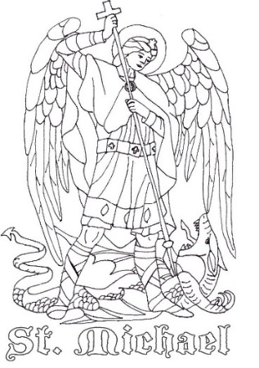
SECOND MODE:
Use this mode only if you did NOT receive the answer in the FIRST MODE…

The Second mode is not only a discernment of God’s will; it is also a discernment of SPIRITS. In our spiritual battle against the world, the flesh, and the devil we are often pulled one way by God, who wants us to be happy, and another way by the forces of evil who are against our happiness. If we are in a STATE OF GRACE, then we will find peace in the presence of God revealing His will and be agitated when the forces of evil try to pull us away from doing God’s will.

Ask the students to reflect on times they were at complete peace. What was the situation? What did it feel like?

(SIDE NOTE: If you are not in a State of Grace - meaning, if you are not obedient to EVERYTHING God clearly commands, then you will experience just the opposite. There will be disquiet and obstacles when God is calling and pleasure when the forces of evil are calling. We will continue this booklet by assuming the person discerning God’s will IS in a State of Grace) THIS IS IMPORTANT!!! If a person is leading a life that does not involve regular Mass attendance, frequent confession, daily prayer, and avoiding ALL serious sin, then it is possible the consolation is from the enemy and not God. If this is the situation, then these modes will NOT work for this person. Our obedience to God’s CLEAR commands are necessary before we can filter through a good, better, best choice scenario. It would be like trying to pick out splinters from our right eye while there is a beam in our left eye (cf. Mt 7:1-5).

Begin by asking the right question. What two (or more) GOOD things might God want you to do? Then spend time in prayer; paying attention to what message you hear when you are in a state of consolation versus when you are in a state of desolation. This is going to take some time – possibly months. Consolation means you have a spiritual joy, love, hope in God, tears of happiness, warmth in the presence of God, etc. Desolation means you experience sadness, lack of confidence, lack of love, dryness, aridity, etc. When you are in desolation the message usually ATTACKS whatever message you discerned in the time of consolation. Keep a journal to track the messages during consolation and desolation.

Throughout this process you might need the help of a good spiritual guide to help you ‘hear’ these messages. This guide can help you determine a pattern to the messages received in consolation versus desolation.

Once you have determined God’s will through the pattern of messages in consolation versus desolation, then thank God and ACT on it!
An example of this at work: Sue wants to discern God’s will on whether to go to Green Bay or Madison for college. Both colleges accepted her and she just needs to decide which one God is calling her to attend. She likes the idea of going to Green Bay because it is closer to her home and would be less expensive. Madison appeals to her because it provides a more challenging academic program in the exact field of her interest. As she prays about this she notices that whenever she decides Madison is the school for her, she experiences a sense of trust in the providence of God and is at peace. Sometimes, however, she starts to have doubts and fears that she won’t be smart enough for the program and will be too homesick or simply run out of money. When the doubts come in, Sue decides she should just go to Green Bay. Knowing about this discernment process, she realizes that it is God showing her that He is calling her to Madison whereas the evil spirit is trying to derail that plan. Sue accepts the invitation to attend Madison and is at peace about her decision.
Use this or another example for the students to understand this concept.

THIRD MODE:
Use this mode only if you did not discern God’s will through the first or second mode.

The third mode has a six step process:
- ASK THE QUESTION: At this step you may need more data to properly form your choices between GOOD option A or GOOD option B. State specifically the question you are asking God to answer.

- HAVE THE RIGHT ATTITUDE/DISPOSTION: If you go into this mode with the wrong attitude you will block the message God wants to communicate to you. You’ll need to have the following dispositions:

  - No disordered attachments to one choice or the other A disordered attachment is if a person desires and wants to possess something that is not appropriate for him/her (i.e. a sinful desire for one choice)
  - Completely free (externally and internally) to choose either one freedom suggests that there is no addiction to one item or another
  - Have the focus of giving GOD GLORY in this life decision If there is a selfish motive in one direction or another, this won’t work.
  - No inclination or predetermined direction to one way or the other This requires really knowing your heart- You need to be able to pick up even the slightest leaning in one direction or another. Another person may be able to help pick out a particular leaning
  - Recognize that this choice is a MEANS to an END (which is heaven) What decision is the best when considering the ultimate goal is heaven (not wealth, fame, or any other worldly pursuits)

- ASK GOD WHICH ONE TO CHOOSE: At this step you are spending time in prayer.

- LIST OUT THE ADVANTAGES AND DISADVANTAGES: In turn look at each option and list out how this decision will help or harm you in your faith life. The advantages and disadvantages keep your goal of friendship with God clearly as the focus. Finances, comfort, security, pleasure or any number or self-serving criteria may not necessarily need to be considered (although parents are morally responsible for providing for their family and may need to consider these factors).

- NOTE WHICH CHOICE IS HEAVY ON THE ADVATAGE SIDE: God willing, a clear choice will come to the foreground as the better decision.

- PLACE THIS CHOICE BEFORE GOD: Once a clear choice is made, bring this to God in prayer and place it before His throne. Thank God for any answers you may have received.

An example of this third mode: 1. Joe wants to discern God’s will on asking June to marry him or not. 2. Joe reflects that his heart is open to whatever God asks of him, he just wants what is best for June and himself. 3. Joe brings this question to God while he visits the adoration chapel. 4. Sitting before Jesus in the Blessed Sacrament, Joe makes a list of the advantages and disadvantages of proposing to June. 5. Joe notes that he can name many advantages to a marriage with June and all of them point to their commitment to one another and to God. 6. Joe lays this list on the floor in-between himself and Blessed Sacrament. A deep sense of peace and purpose flood his soul as he realizes it is God’s will that he propose to June.
Use this or another example to see these steps at work.

If you go through this THIRD MODE and are still not sure what is GOD’s will, then St. Ignatius gives us a

SECOND WAY…
- Place yourself in God’s presence and recognize that you are loved by God. Return this LOVE with love.

- Ask yourself what advice you would give to a stranger who asked YOU for advice on this exact same choice.

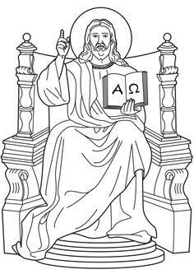
- Ask yourself what you would choose if you KNEW you were about to die.

- Ask yourself which decision would bring you greater joy if you were in heaven on the day of judgement. Which decision is fully loving God and neighbor?

- Present this choice before the throne of God.

Discovering the vocation God calls you to live may be challenging, but doing what you are made to do is a path to a rich and fulfilling life. Go through this discernment process before making any major life decisions.

How do I accept God’s will when I don’t like it?
We can’t leave without discussing some other important information on God’s will. Let’s begin by noting that, with God, there are two aspects to His will: active and passive.

God ACTIVELY wills the good for everyone. This means that, if God took complete control of everyone there would never be any evil, illness, or bad decisions in the world.

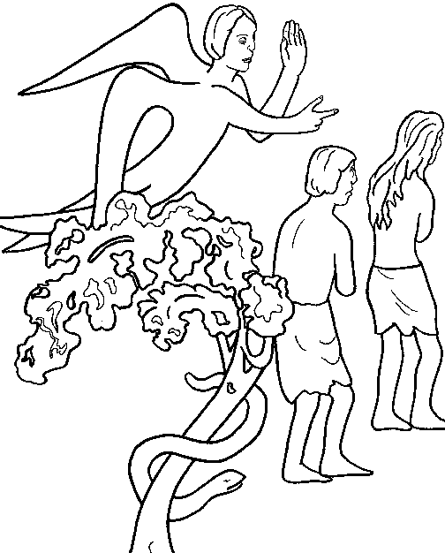
As we discussed earlier, God gives humans an intellect and free will. The dark side to this truth is that God ALLOWS angels and humans to CHOOSE to reject Him. This brings about a loss of GOOD; evil is an absence of the GOOD.

Because of this freedom of choice, Lucifer goes from being an angel close to God’s heart to Satan. Adam and Eve go from living in the Garden of Eden to being banished.

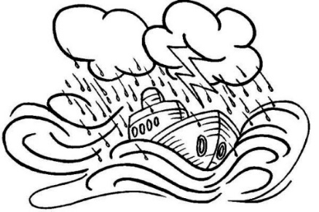
Throughout your life you are touched by evil. This might mean a bad storm, stubbed toe, illness, hurt feelings, pain, suffering, death, etc.

God does not ACTIVELY choose these evils on you, but He does PASSIVELY allow them. This means that because of God’s GREAT LOVE and POWER, God can turn the evils in your life to your GOOD and therefore ALLOWS the evil.

“We know that all things work for good for those who love God, who are called according to his purpose” (Rom 8:28).
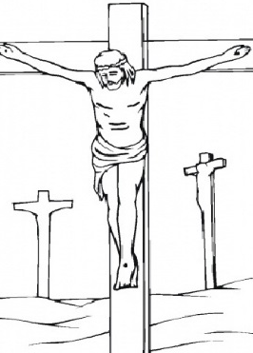
This is a great mercy of God to bring good to His children, even out of evil. So God ALLOWS these evils to touch us, as He did His Son, in order to bring about a greater GOOD.

The question was how do I accept these situations in my life? Practically speaking, you must fight against evil: you must bring good where there isn’t any. Sometimes this means you avoid a situation, sometime this means you attack the situation, and sometimes this means you endure the situation. No matter which response you discern is correct, TRUST in God who loves you.

Jesus in the Garden of Gethsemane, right before He KNEW He was to be arrested, tried, scourged, and crucified said,
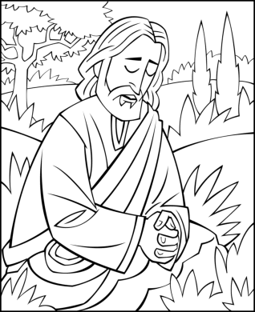
“My Father, if it is possible, let this cup pass from me; yet, not as I will, but as you will” (Mt 26:39)

Pray for help from God, but if He ALLOWS the trial in your life, then thank and praise Him for the GOOD that will eventually come. Living with a deep abiding TRUST in God brings peace and joy, even in the midst of suffering.

John, the Apostle wrote

“We have come to know and to believe in the love God has for us” (1 Jn 4:16)

He wrote this even after seeing and experiencing great suffering.

St. Paul wrote,

“What will separate us from the love of Christ? Will anguish, or distress, or persecution, or famine, or nakedness, or peril, or the sword?” (Rom 8:35).
He goes on to say…

“For I am convinced that neither death, nor life, nor angels, nor principalities, nor present things, nor future things, nor powers, nor height, nor depth will be able to separate us from the love of God in Christ Jesus our Lord” (Rom 8:39).

Prayer to Put on the Armor of God
By Dr. Carol Masuga
Heavenly Father, in the Name of Jesus, I ask you to put on me and those I pray for: the helmet of salvation, which is hope; the breastplate of integrity and justice, which is love; the shield of faith; the two-edged sword, which is the Word of God; the belt of honesty; the skirt of purity; and shoes to spread the Gospel of peace. Amen.

