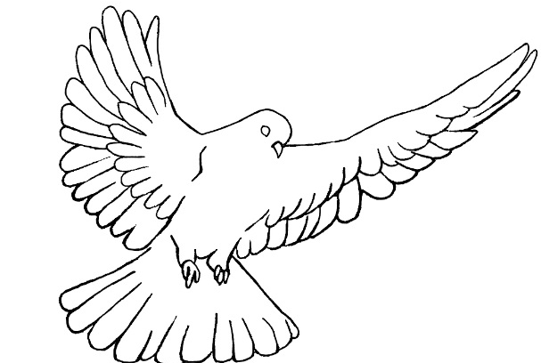
Protective Behavior Booklet

St. Anthony Parish
Niagara, WI

3rd – 4th Grade

A Safe Environment Curriculum

♪ Fruits of the Spirit ♫
The fruit of the Spirit’s not a coconut – coconut (watermelon, banana, etc.)
The fruit of the Spirit’s not a coconut – coconut. If you want to be a coconut – coconut - you might as well hear it; you can’t be a fruit of the Spirit. Because the fruits are love, joy, peace, patience, kindness, goodness, faithfulness, gentleness, and self-control.
Love, joy, peace, patience, kindness, goodness, faithfulness, gentleness, and self-control

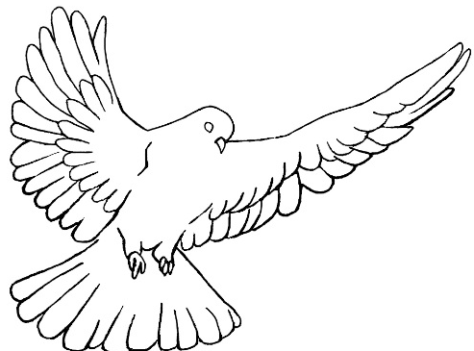
Prayer:
Breathe into me, Holy Spirit, that my thoughts may all be holy. Move in me, Holy Spirit, that my work, too, may be holy. Attract my heart, Holy Spirit, that I may love only what is holy. Strengthen me, Holy Spirit, that I may defend all that is holy. Protect me, Holy Spirit, that I may always be holy. (Saint Augustine)
We are Temples of the Holy Spirit
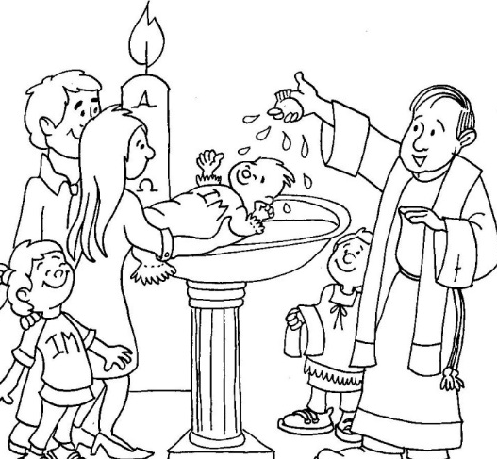
At our baptism, the Holy Spirit came into our souls to live. We are embodied souls – our soul isn’t IN our body. A scientist or doctor can’t SEE our soul and we can’t SEE other people’s souls. God creates our soul when we are first conceived by our parents. A soul is what gives LIFE to our body. Our soul lives forever; it is immortal.

Humans are made in the image and likeness of God. This means God gave us a free will and an intellect. We are free to know, love, and serve God. We can also choose to reject God and refuse to serve Him. The angels were given this choice and their decision was final. The good angels live in heaven with God. We decide either for or against God every second, minute, and hour of every day; but our decision isn’t final until our life on earth is complete.
Our soul is like a spiritual castle where we have a room for God to live. We enter into this castle when we pray (Mt 6:6). We decide how to decorate the rooms of this castle and we decide how clean or dirty it is.

Just like the castles from years past, we need to protect our body and soul from the attacks of our enemies. We protect the Holy Spirit’s home when we protect our body and soul from harm.

How do we protect our body from harm?
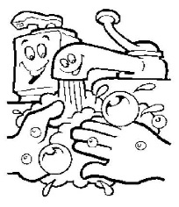
Safe environment
Good decisions
Good health

How do we protect our souls from harm?
Pray
Go to Mass Confession

Sacramentals Good decisions
Cleaning day …

When we choose to sin, we clutter our soul with junk and crowd out the Holy Spirit.

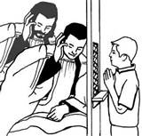
Going to confession cleans our souls and makes room for the Holy Spirit to live. This is especially important when Jesus comes “under our roof” in Holy Communion.
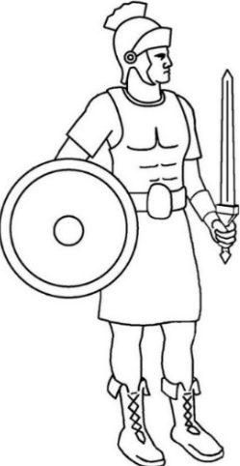
Roman soldiers wore armor for protection. St. Paul compared this physical armor to the armor a Christian needs to wear in order to protect himself or herself both physically and spiritually (Eph.6:13:17).

The Helmet protects our eyes, ears, and mind. We need to be careful about what shows we watch, the games we play, the words we hear, the songs we listen to, the pictures we see, the internet sites we visit, and the thoughts we think. Have you ever watched a show that gave you a nightmare? It is really hard to take those images, sounds, and ideas out of our head. How can we avoid seeing, hearing, or thinking what might harm us?

The Breastplate protects our vital organs (like our heart). In our heart we desire either to do good or bad. We are free to choose the good only when we don’t let our hearts get attached to anything that is bad. Have you ever tried to get rid of a bad habit? A bad habit makes it really hard to choose what we know is best for us (like the habit of biting our nails can cause painful sores on our fingers; we need to discipline ourselves in order to stop the habit). Can you name other bad habits or attachments that are hard to detach from?
What does it mean to “discipline ourselves”?
The Shield is our Faith in God. God loves us and wants only what is good for us. This shield helps us believe in God in order to follow His rules. God’s rules help protect us from harm just like a shield. What are some of God’s rules that protect us from harm?

The Sword is the WORD OF GOD. Reading the Bible and praying teaches us what God wants us to do. When we enter into our spiritual castle to pray, we can talk to the Holy Spirit. This means sometimes we talk and sometimes we listen. What does the Holy Spirit tell you to do in some “What If” situations?

The belt is for honesty. We need to speak the truth at all times. Lying may put our body and soul at risk. You need to tell someone you trust if you don’t feel safe. God is truth, so His children should always speak the truth. Who are God’s children?

The “skirt” like armor protects our private parts. We need to wear our clothes and not let others see or touch the private areas of our body (unless a doctor or parent needs to help you because of a medical condition). We shouldn’t try to see or touch the private parts of other people’s bodies either. It is important to wear clothes that are modest and respectful of our body’s privacy. What does “modest” mean?

Shoes protect our feet so we can travel only to the places God sends us. We need to make sure we don’t go places that God wouldn’t want us to be. Let your parent or guardian always knows where you are. What places might cause you harm if you went there?

It is NOT GOOD to be ALONE
In the beginning, as God created the whole world, He said it was “GOOD”. When he saw Adam without another person in the world, God said it was “NOT GOOD FOR MAN TO BE ALONE” (Gen 2:18). Then God made Eve to be Adam’s companion. This teaches us that we need friends. We need our family and people around us who love and care for us.
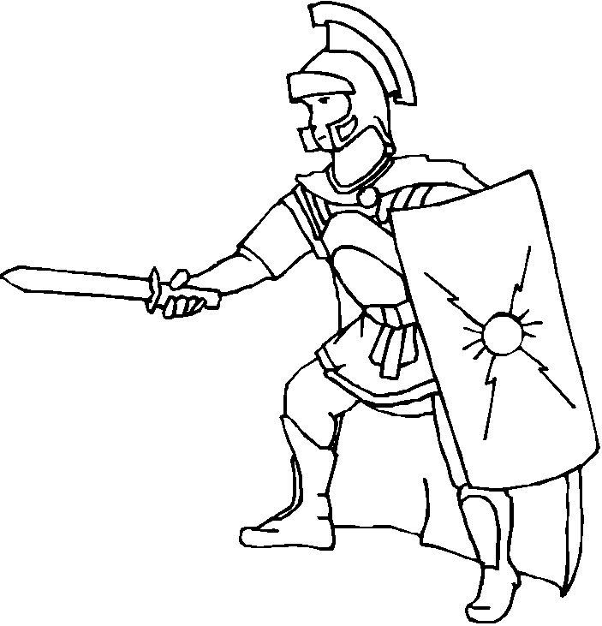
The Roman soldier did not have armor on his back – why? Because his friends were supposed to protect him and he was supposed to protect his friend. They fought back to back.

Who helps protect you?
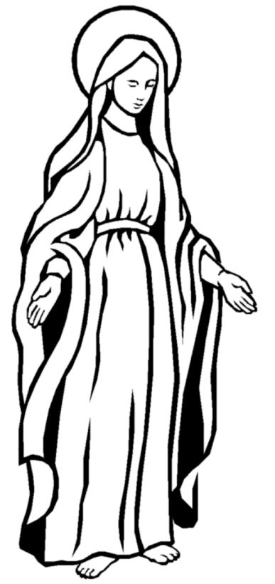
GOD
Family
Community
Friends
Mary
Guardian Angel
Saints in heaven

How do you choose good friends?
- Do they obey God’s rules?
- Do they help you feel safe?
- Do they show the Fruits of the Spirit in how they talk and treat you and others? (The fruits are charity, joy, peace, patience, kindness, goodness, generosity, gentleness, faithfulness, modesty, self-control, chastity)
- Do they listen to you?
- Do they talk to you?
- Do they enjoy the same things you do?
- Do they like your other friends and your family?
- Are they your friends no matter WHO is around?

Are you a good friend to others?
- Do you follow God’s rules?
- Do you visit the spiritual castle of your soul and talk to God?
- Do others feel safe around you?
- Do you keep your soul clean so the Holy Spirit can live in you?
- Do you listen to your friend?
- Do you talk to your friend?
- Do you pray for your friend?
- Do you help your friend?
- Do you invite other people to be your friend?
- Do you treat your friends the same no matter where or who you are around?

How do you avoid people your age who are not good friends?

Step 1-The first step is to ignore the person. Don’t look at the person or think about what the person is doing. If that doesn’t work then…

Step 2-Move or turn away. If that doesn’t work then…

Step 3- Talk friendly by saying, “Please stop____.” If that doesn’t work then…

Step 4-Talk firmly and politely by saying, “I don’t like that”. If that doesn’t work then…

Step 5- Go to “How do you avoid people you do not feel safe around” If you’ve tried the first four steps then you need the help of an adult.

How do you avoid people you do not feel safe around?
Talk to an adult you trust immediately!! David didn’t fit into Saul’s armor so he picked up five stones in order to slay Goliath. Do you have five people that you trust to help you feel safe? Write their names in the stones…

Prayer to Put on the Armor of God
Heavenly Father, in the Name of Jesus, I ask you to put on me and those I pray for: the helmet of salvation, which is hope; the breastplate of integrity and justice, which is love; the shield of faith; the two-edged sword, which is the Word of God; the belt of honesty; the skirt of purity; and shoes to spread the Gospel of peace. Amen.

