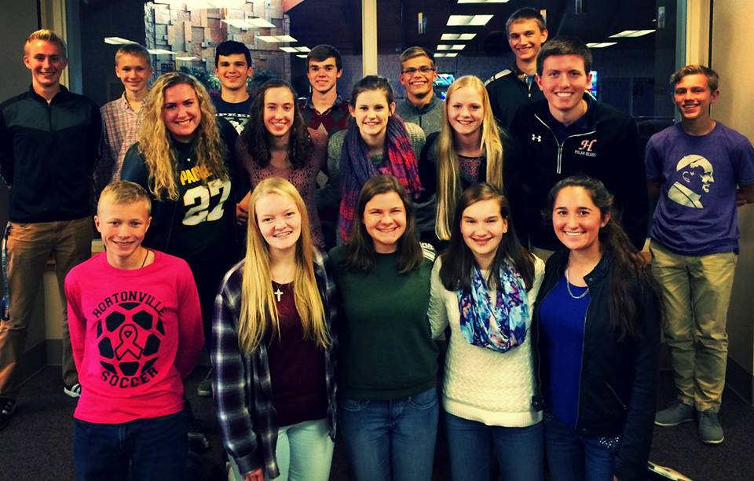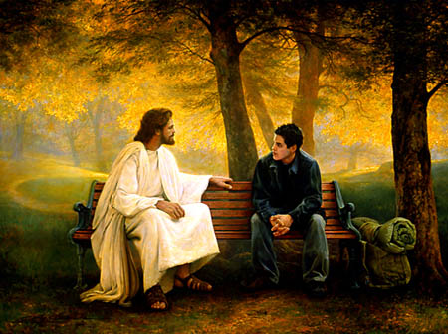

Religious Education and Youth Ministry

Maria Schuette – [mschuette@gbdioc.org](mailto:mschuette@gbdioc.org) 920.272.8285

Sr. Jacqueline Spaniola – [jspaniola@gbdioc.org](mailto:jspaniola@gbdioc.org)

920.272.8288

### Website of Resources

www.gbdyouthalive.weebly.com

### Potential Core Teams

* Couples to mentor other couples through the Baptism prep process
* High school teens willing to teach, lead small groups, etc for middle school students
* 6 months before the mission trip, conference, or retreat, form a team of adults or high school students
* Catechists
* Small group leaders for Confirmation
* Families to mentor new families in the RE program

Convocation, October 2015

Why Jesus Didn’t

Burn Out

*Building and Maintaining Core Teams*

*Education Department*

*Diocese of Green Bay*

### Teen Core Team

* Incorporate prayer into a seemingly secular activity – go to adoration followed by half price appetizers at Applebees, pray a decade of the Rosary on your way to hike, make a meal for a homeless shelter and then pray for those who will receive it
* Involve the parents of the core team who will host a night at their house
* Utilize DVD formation series such as Y Disciple, T3 Bible Series, Chosen, Decision Point, Theology of the Body, etc. to introduce the content and then follow up with discussion
* Build male/female communities
* Listen to the teens and appeal to their interests while evangelizing
* Go on retreat together
* Pilgrimage to a shrine, retreat center, etc.
* Visit with the students in pairs or small groups at a coffee shop or for dinner
* Initiate a core team who prepares for upcoming trips or pilgrimages facilitated by the parish
* Help form the students to teach elementary and middle school students
* Give students the ability to help plan service trips or projects
* Form students on how to be witnesses and examples to their peers
* Pray together
* Share inspirational messages with them – continue to inspire them even when you’re not meeting with them!
* Give the teens confidence in their gifts, abilities and personalities to share their stories

### Catechist Core Team

* Greet catechists at the door
* Ask catechists about their family, interests, and life before or after class
* Build in time during the year for sharing on a personal level between catechists
* Offer catechist formation, fellowship, and prayer time once a month instead of having classes (start early Sept and go until April or May!)
* Give catechists time to share their faith story with another catechist
* Have your catechists meet to pray as a group before or after class
* Have the catechists share one blessing from their class that night immediately after class concludes
* Be intentional about planning inservices – make them relational
* Take your catechists on a retreat/visit a shrine
* Invite your catechists to core team dinners or fellowship dessert time!

### Teen Core Team

* Identify 3-5 students who would be open and ready to go deeper
* Invite the team to do things together – hike, visit a corn maze, go canoeing, play games, pilgrimage to a place outside of their daily life
* Especially in the beginning, make the meeting times closer together and more consistent

## Discipling a Core Team