First Reconciliation
St. Raphael Parish
Family Sessions
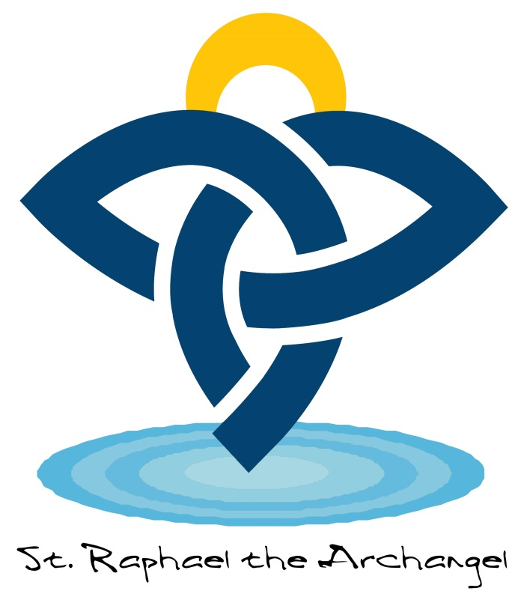

Therefore, if anyone is in Christ, he is a new creation; the old has gone, the new has come!

2 Corinthians 5:17

Session 1: God Calls Us Friends
Goal: Your child will understand That God is his/her friend
Step 1: 3 Minute Family Retreats
- Gather in a comfortable place
- Ask your child, “Who is one of your very best friends, what do you like to do when you spend time together?” Write the name of that person and the fun things you do with them on page 1.
- Tell them God gave them the gift of friends and that God is our best friend.
Step 2: Let’s Imagine
- Read pages 1-3 together.
- Ask your child what happened when Adam and Eve didn’t follow the rules. Talk about a time when they were tempted to not follow rules. What happened?
Step 3: Let’s Dig In
- Read pages 4-6 together.
- Ask “Who did God send us to help people fix their friendship with God when they get stuck?”
- Talk about three ways to fix a friendship (say you are sorry, repair what went wrong, try to do better next time.)
- Say just like when we hurt a friend we can fix our friendship with God.
Step 4: Prayer
- Tell your child when we sin God always forgives us and wants to be our friend.
- Turn to page 8-9 and say the prayer together, or say your own prayer.
*For extra ideas, check out the activities following each lesson.
Session 2: Jesus Saves Us
Goal: Your child will learn that Jesus saves us and continues to be with us in the sacraments.
Step 1: 3 Minute Retreat
- Gather in a comfortable place
- Ask your child, “When was a time you were really nervous or were scared of something? Whom did you trust? Who did you go to for help? “
- Tell them just like they trust that person, they can trust God to help them.
Step 2: Let’s Imagine
- Tell them Jesus is our friend and gave us the sacraments to remind us of God’s love and to teach us to live. They are like a road map to keep us from getting lost when we go on trips.
- As a family read pages 12-13.
- Ask them what Jesus taught and how people reacted to Jesus’ teaching. (He taught God’s love and many people turned away and arrested him.)
Step 3: Let’s Dig In
- Tell them the sacraments are times when we know God is near to us. Read pages 14-16 together.
- Discuss any questions your child has. Then say, “the sacraments are special and ways for us to experience God’s promise. This year your child will be celebrating reconciliation.
- Ask your child to complete the picture on page 17 or draw together as a family.

Step 4: Prayer
- Tell your child that you can always count on God to be there for you.
- Say the prayer on pages 18-19 or say one in your own words.

Session 3: Jesus Forgives Us
Goal: Your Child will understand Jesus sees the good in our hearts and there is a four step process to help us make decisions.
Step 1: 3 Minute Retreat
- Gather in a comfortable place
- Ask your child to think of a time he/she needed a second chance when they’ve made a mistake and hurt someone. Ask him/her to make a fist and imagine holding that wrong thing really tight. Is their arm starting to hurt?
- Tell them just like when we make a fist, when you carry a wrong thing to God, your heart hurts. Ask your child to open his/her fist. When you relax your fist and show God the wrong thing God reaches out to hold your hand.
- Tell them God is always reaching out to help us and give us a second chance.
Step 2: Let’s Imagine
- Ask your child to read pages 22-23 about Matthew’s second chance.
- Ask your child how Jesus treated Matthew even if he had done some wrong things. Tell them Jesus saw the good in Matthew’s heart just like Jesus sees the good in our hearts.
- Talk about a time when we made a wrong choice, but Jesus saw the good in our hearts.
Step 3: Let’s Dig In
- Tell your child that when want to make a good choice there are three things we can do:
  - Stop
  - Think
  - Ask
  - Pray
- Read aloud page 24 together. Talk about what making a moral choice means and times they can stop, think, ask, and pray.
- Read aloud page 24, talk about when you’re not sure what is right or wrong think of what the loving thing to do is.
- Read page 26 together, talk about how Jesus always sees the good in our hearts. If you choose to, have your child complete the picture on page 27.
Step 4: Prayer
- Tell your child we always get second chances.
- Say the prayer on page 28-29 or say your own.
*For extra ideas, check out the activities following this lesson.
Session 4: Jesus Heals Us
Goal: Jesus longs to heal us in body, mind, heart and soul.
Step 1: 3 Minute Retreat
- Gather in a comfortable place.
- Ask your child if they have ever done anything wrong and felt embarrassed and that someone would never forgive you if they knew? Discuss this together.
- Tell them that even if you really want to disappear someone who loves you will find you, like hide and seek. That is what God does. He is always searching for us, he wants you to be with him NO MATTER what!
Step 2: Let’s imagine
- Ask your child to imagine they hear some beautiful music. Everyone is singing in harmony and then all of a sudden they hear someone singing off key. What would a good choir director do? (He would pull them aside quietly and help them get back in tune.)
- Explain that is what God does for us. When we sin we are out of harmony with one another, but God is always reaching out to us in the Sacrament of Reconciliation to help us be in harmony with him and one another. The sacrament of reconciliation helps us get our life back in tune.
- Ask your child to turn to pages 32-33 in his/her book. Read aloud the scripture story, “Healed through forgiveness.”
- Discuss the following questions with your child:
  - When Jesus met the man who was paralyzed what did he do first?
  - What did the people around Jesus say?
  - How was Jesus able to forgive sins? (Jesus was God)
Step 3: Let’s Dig In
- Tell them when we do something that we feel bad about we often want to avoid it, but we need to fix the problem because it won’t go away. It is like we tear a hole in our relationship. It also affects our relationship with God who tells us to love others like we love ourselves. (Tear a hole in a piece of paper to show this.)
- The way we can fix this hole is by going to confession and having the sacrament of reconciliation. (Use some tape to fix the hole to show how reconciliation fixes the hole.)
- Read aloud pages 34-36 with your child. Focus on the words confession and forgiveness
- Stress the sacrament is a celebration. It is a way to repair our relationship with God who loves us.
Step 4: Prayer
- Turn to pages 38-39 in your book.
- Say the prayer together or make up your own family prayer.

Session 5: The Holy Spirit Guides Us
Goal: God meets us where we need him most, in our pain and failings.
Step 1: 3 Minute Retreat
- Gather in a comfortable place.
- Ask your child what they do when they need help and need advice. Where do they go?
- Tell them when you’re not sure what to do you can ask the Holy Spirit. All you have to do is pray. The harder part is listening. Sometimes the answer does not come right away or it is not what we expect.
Step 2: Let’s Imagine
- Ask your child to imagine having a magic flashlight that helps them find their way in the dark or when they are lost. Tell them they are going to hear a story about a young man who found his way home.
- Read pages 42-43 together.
- Ask your child to explain how the young man changed at the end of the story and how his father reacted.
Step 3: Let’s Dig In
- Tell your child that as they are getting older they are starting to understand right from wrong. That is called a conscience, or a voice inside that tells you what is right and wrong.
- Open to pages 44-45 and read about examination of conscience. This is a way for us to think about what we have done right or wrong.
- Read pages 46-47 together.
- Tell your child we will talk and practice more about what happens at the sacrament of reconciliation at our retreat.
Step 4: Prayer
- Turn to pages 48-49 in your book.
- Say the prayer together or make up your own family prayer.

Session 6: God is Always With Us
Goal: God always forgives us. God is a shepherd that always searches for his lost sheep.
Step 1: 3 Minute Retreat
- Gather in a comfortable space.
- Ask your child what is like to play with a yo-yo. If you have one, allow your child to experiment with it.
- When you flick your wrist the yo-yo goes away but it always comes back to you because it is connected by the string. Tell your child God is like that. When we sin we turn away from him, but we are always connected to him.
- It is Gods’ promise that he will never forget us and always love us.
Step 2: Let’s Imagine
- What would it be like to have a box with a magic doorbell inside? Every time we rang the bell we would instantly be home? (Discuss this.)
- It would be nice to be home whenever we wanted, right? Can you think of sometimes you would like a magic doorbell?
- God is our Father and always welcomes us home. Let’s read how God is like a shepherd who protects his sheep.
- Read aloud pages 52-53 and then discuss the following questions:
  - What is the job of a shepherd?
  - What did the shepherd do when one was missing?
  - How did the shepherd feel when the lost sheep was home safe and sound?
Step 3: Let’s Dig In
- Say: God not only welcomes us back when we sin, but he goes looking for us.
- Say: God loves us so much he will look for us wherever we are. He is in charge of everything in heaven and earth but we are so special to Him, he would drop everything to come looking for us.
- Read pages 54-56 with your child.
- Say: If we are lost we can always ask for directions. Who are some people you can ask for directions when you are lost? (Discuss)
- Say: When we are spiritually lost we can always ask a priest to help us with directions. Through our parish community and the love of God, we will find our way again.
- Say: The sacrament of reconciliation is a way for us to find our way back to God.
Step 4: Prayer
- Turn to pages 58-59 in your book.
- Say the prayer together or make up your own family prayer.

