Experiential Education 101 Handout

Experiential education- is a philosophy that informs many methodologies in which educators purposefully engage with learners in direct experience and focused reflection in order to increase knowledge, develop skills, clarify values, and develop people's capacity to contribute to their communities.
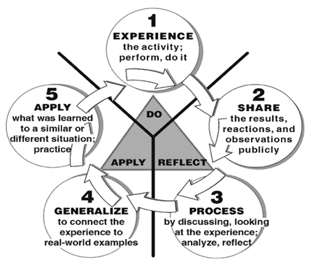
Experiential Education is based on:
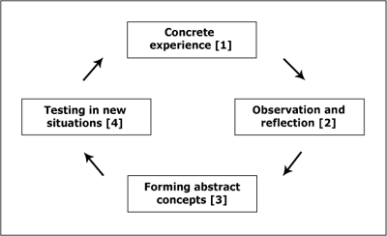
Experiential learning cycle
“Tell me and I’ll forget; Show me and I may remember; Involve me and I’ll understand.” – Chinese Proverb
Why Experiential Education? This is what Jesus and his disciples did. They lived with Jesus, walked with Him and then He sent them out to teach others by walking with them. We do this all the time without even realizing it. When we share stories and get to know each other we are sharing our experiences and learning from each other. We want to bring this intentionally into our classroom in order to connect and grow with each other through a shared experience.
How to use Experiential Education:
1) Know your students- where are they at? What are they experiencing in everyday life? What are their struggles, hopes, and dreams? Who are they and how can you walk with them?
2) Pick a specific lesson/goal/topic you want them to learn about. Keep it simple…. i.e. trust, community, etc. (if you don’t know your students the goal would be to get to know them)
3) Find an experience/activity that will help your students figure out the main points of your goal. This means it must be age appropriate, challenging but not impossible, and doable for you and what you have available. (It is important that they can figure the points of the lesson as much as possible. You act more as a facilitator than a teacher. You are guiding them. Depending on the age you will be more or less hands off.)
4) Frontload- this means to tell your students in advance the goals of the day. (This step can be skipped depending on your students. This is helpful for younger students. Also this does not mean you are giving away the answers, it is the sharing of the topic i.e. “today we are going to learn what it means to trust others and to trust God)
5) Do the Activity- Location is important for this part. Is the environment safe? Do I have enough room. Will my students be distracted?
6) Talk about the activity and what they learned from it. Start with the experience itself, what was it like? Hard or easy? Then help then connect to everyday situations. Sometimes they will be quiet, that is ok, wait for them. It will feel uncomfortable. They are used to someone telling them the answers. Listen and affirm them. There are a lot of great books and resources on how to do this. The biggest thing is that it takes practice.
Resources
http://www.wilderdom.com/experiential/ - Explains in depth what experiential education is and why it works. Also has some great resources for games that you can do that are simple.
http://www.cgsusa.org/ - Catechesis of the Good Shephard website, this program uses the Montessori approach for learning catechesis.
Google – Montessori and Waldorf styles of teaching for more on a classroom approach to experiential education.
www.CMDNET.org – This is where we got the Lasagna Night and the Quilting All Soul’s project. Has some great idea and you can modify as desired.
https://www.pinterest.com/ - find projects on sites like Catholic Icing which is where we got the Stations of the Cross egg project.

