This craft project is to help children understand that Jesus is truly present in the Holy Eucharist. Although Jesus is hidden, He is truly there. This reality is something very difficult for we as simple humans to comprehend. Sadly, it is a teaching of the Catholic Church which many Catholics do not have enough faith to believe. Lets help our children to believe, understand, and remember it.
Supplies:
- Glue
- Scissors
- Clear tape
- Printable Chalice and Host -Click Here
- Sheet of construction paper for the background (blue or black look nice)
- Decorative items like glitter/glitter glue, gems, sequins, etc.
- Crayons to color the chalice and Eucharist’s rays. (yellow, orange, & red)
- Extra Idea...
- Print the chalice/Eucharistic rays sheet onto yellow paper and cut out. (No coloring necessary.)
- Another Extra Idea...
- Use the chalice/Eucharistic ray sheet as a coloring page and add your decorations. (This is nice if you hate cutting.)

- Instructions:
- If you are not using this printable as a coloring sheet, cut out your chalice and Eucharistic rays. Color them if you did not print them out on colored paper. Glue the chalice and rays onto the construction paper.
Now decorate the chalice and rays with the glitter, gems and sequins or whatever else you choose. You may also decorate the construction paper background, if desired.
Glue the Jesus resurrected circle on top of the Eucharistic ray circle. With a small piece of clear tape attach the Eucharist to create a door that opens to reveal the image of Jesus.
- Through this art project, children can imagine how this simple bread and wine is truly Our Almighty Lord
- 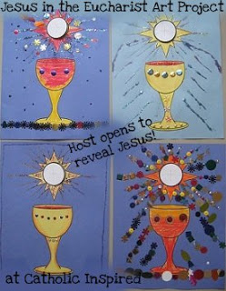
- Through this art project, children can imagine how this simple bread and wine
- is truly Our Almightly Lord, Jesus!

I have already added our "Jesus in the Eucharist ~ Body and Blood Craft" to help teach kids about the true presents of Jesus in the Eucharist. This Monstance Craft is a different variation of the same idea using a image of the Blessed Host in a monstrance.
Pick which variation of this craft you like best based on the topic you are teaching.
~*~
Children who are preparing to receive First Communion may be better
to do the Bread and Wine Craft: Click Here.
~*~
Children who are learning about Adoration or Holy Hours
may be better with this Monstrance Craft.....
Click Here for printable monstrance and host.
~~~~~~~~~~~~~~~~~~~~
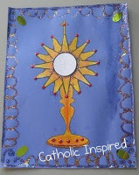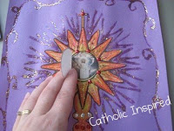

Supplies:Glue
Scissors
Clear tape
Printable Monstrance and Host - Click here
Sheet of construction paper for the background (blue or black look nice)
Decorative items like glitter/glitter glue, gems, sequins, etc.
Crayons to color the Monstrance. (yellow, orange, & red)

Extra Idea...
Print the Monstrance sheet onto yellow paper and cut out. (No coloring necessary.)
Another Extra Idea...
Use the Monstrance sheet as a coloring page and add your decorations. (This is nice if you hate cutting.)

Instructions:If you are not using this printable as a coloring sheet, cut out your Monstrance. Color it if you did not print them out on colored paper. Glue the Monstrance onto the construction paper.
Now decorate the Monstrance with the glitter, gems and sequins or whatever else you choose. You may also decorate the construction paper background, if desired.
Glue the Jesus resurrected circle on to the Monstrance's center circle. With a small piece of clear tape attach the Eucharist to create a door that opens to reveal the image of Jesus.
