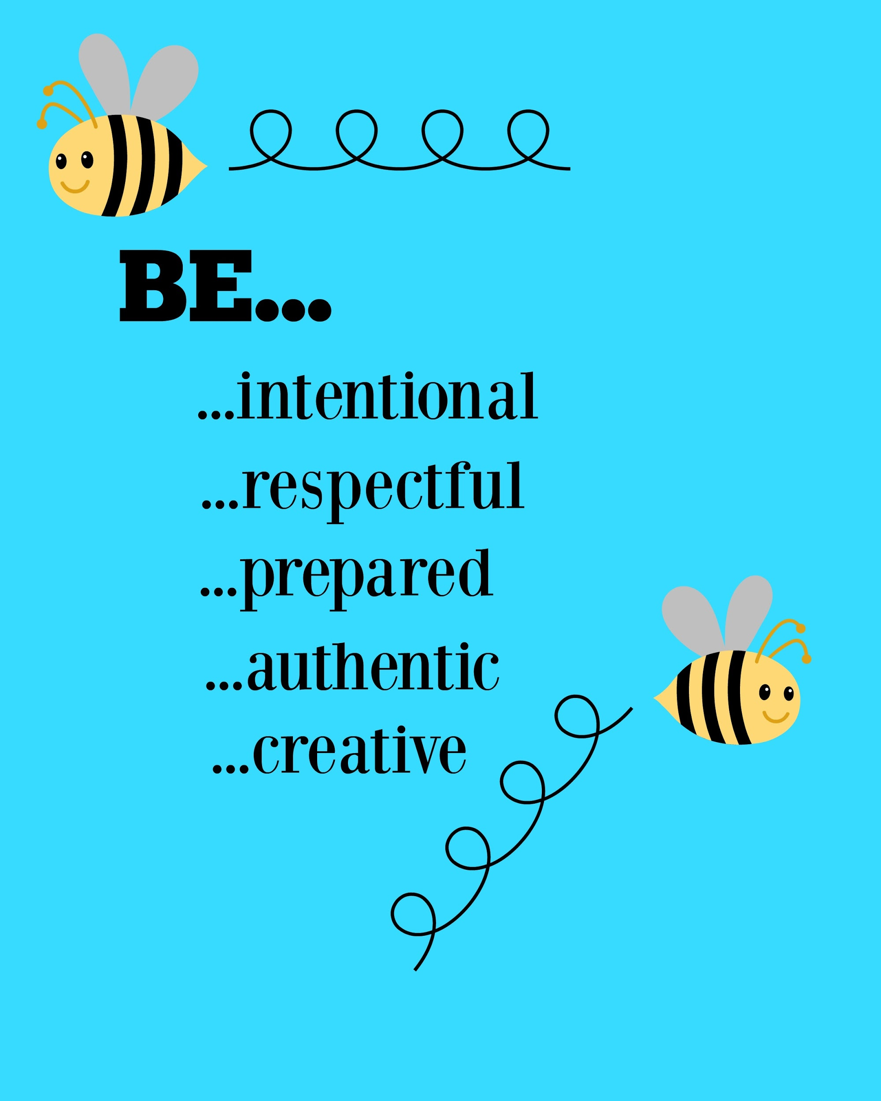

Classroom Management Tips
By: Stephanie Rottier

Think of the many things that annoy you or are difficult within a classroom setting…
- Chair rocking  - Blurting out  - Attention Span or lack thereof | - Volume of students voices  - Students wandering around | - Personal Technology Usage - i.e. texting, tweeting, snapchatting, etc.

These are just a five things that might get in the way when trying to catechize our youth. Here are some suggestions on what you can do…

Chair Rocking/Student Wanderers:
- Description: These students are typically our active students who need different active learning strategies used within the classroom or personal accommodations to help them remain focussed.
  - Ideas:
    - Take the chairs out of your classroom and replace them with exercise balls that the youth can sit on. This is especially helpful for the active students because they need to focus on balancing on the ball as well as on what is being said in the classroom.
      - NOTE*** I don’t have full classes that need the exercise balls so I simply have an exercise ball for those who need it, but allow everyone in the class to try it out at some point. I also explain that we all learn differently and that “Mike” might need the exercise ball to learn better just like “Cathy” might need her glasses in order to learn better. We wouldn’t take “Cathy’s” glasses away so we shouldn’t take the ball away from “Mike.”
    - Allow your students to chew gum. Chewing on something is an active movement and helps those who need something with activity a sense of satisfaction. It helps them focus better on the lesson that is being taught.
      - NOTE*** This can easily be a whole class activity and is fairly inexpensive. However the expectation that the gum must stay in their mouth and bubbles and snapping of gum is unacceptable should be addressed prior to starting this activity.
    - Give your wanderers or students who move and groove throughout your class different active jobs. For example, have them bring something to the coordinator. Allow them to pass out the books. Allow them to erase the board. By keeping them up and active with a specific task you are helping them and yourself at the same time.

Attention Span or Lack thereof
- Description: Students who have a hard time paying attention due to lack of interest or hyperactivity. The following active learning games might help engage the youth. The use of Gardner’s Multiple Intelligences also may help when designing your lessons. Be sure to use a variety of intelligences not the same one all the time. As educators we are stronger in some more than others and we tend to gear our lessons to what we are strong in, however we have to assess what the students need and create lessons geared towards them. I recommend this website to help you figure out the multiple intelligence strengths of your youth - http://www.lauracandler.com/free/misurvey
  - Play active learning games that help emphasize your lesson.
    - Four Corners - ask the youth a multiple choice question with 4 choices to choose from. Assign each choice a corner. Ask the students the question and then have them go to the question they think resembles the answer. Be sure to discuss why or why not something is an answer if the answer is not opinion oriented or black or white.
    - Pass the Marker - split the class into two teams and have them make two lines on opposite sides of the room facing the whiteboard. Give the first person in each line a dry erase marker. Ask a question and then have the first person go to the board. If they know the answer they should quickly write it on their side of the board with the marker, if not, they should touch the board with the marker and scurry back to their line and hand the marker to the next person who will then go up and answer or touch the board and pass off the marker to the next person. First team with the correct answer written gets the point.
    - Flyswatter game - Purchase two fly-swatters at the dollar store. Write a bunch of vocabulary words on the board. Choose two people to go to the board and ask them a question or give them a definition. The two people with the flyswatters should then swat the word that answers the question or definition. First person to swat the correct word gets the point.
    - Snowball - Hand each youth a piece of paper. Ask a question and have the youth write the answer in the top left corner. Then have the youth crumple the paper into a ball and on the count of three have the youth throw the paper somewhere in the room. Then on the count of three again, ask the youth to go and grab a snowball and uncrumple it. Read off the different answers, discuss the correct answer, and then repeat this whole process using another corner of the paper or the middle of the paper.
      - NOTE*** In March I have the snowballs become “Basketballs” and hang over the door basketball hoops for the youth to try and shoot a basket.
    - Have the youth create something and then explain the background behind what they have created.
      - Spoon saints - Wooden spoons, felt, scissors, and glue and information about different saints. The student makes the spoon look like their saint and then they study about the saint and present the information they learned to the class.
      - Lego Resurrection - Give small groups a handful of legos. Ask the youth to create something that relates to the resurrection. When they are finished, ask them to explain their creation and why it represents the resurrection.
      - 4 Marks of the Church Canvases - Give youth sharpie markers and a painters canvas. Ask them to decorate their canvas describing the 4 marks of the church in an aesthetically pleasing way.
      - Read Pete the Cat’s Groovy Guide to Life. Then give the youth different Bible quotes and have them break it down into something simple that they would say as teenagers.
        - I.e. “Make each day your masterpiece.” ~John Wooden
          - Look for the good in every day! ~Pete
      - Bible Scavenger Hunt - Pick a theme and find different biblical quotes that fit within that theme. Then give the youth the different scripture notations and have them find them in the Bible. Tell the youth that their goal is to figure out the theme that weaves throughout all of the scriptures they look up.

Blurting out
- Description: These are the youth that are so excited about their answers or are in desperate need of attention that they try to get attention by blurting out. Here are some ideas of how to control this…
  - If it is an individual student, I would give them a certain number of popsicle sticks at the beginning of each class. Explain to the students that each popsicle stick represents the number of times they can blurt out in class. Every time the students blurt out, you take a popsicle away. If there are any popsicle sticks left at the end of class, the student should earn something - (i.e. 5 minutes to talk to you 1 on 1, the student can lead a class game, the student can tell a story to the class, etc.) As the student begins earning many different incentives, start giving him less popsicle sticks to start with until you can completely wean him/her off of the popsicle sticks.
  - If it is a class problem, write a class word on the board. (HINT - study the word and make sure that there are no sassy words within the word). For example - JESUS - then explain that the class can earn an incentive if they can manage to keep at least one of the letters in Jesus’ name on the board. Each time someone blurts out, the teacher needs to erase one of the letters. If the entire word ends up erased, then there needs to be a class consequence - i.e. homework, a letter to the parents, etc.

Volume of Students Voices
- Description: This is how loud or soft the students are talking and how to get the students to stop talking when you need their attention.
  - Getting the students attention is a constant challenge. There are a few ways you can do this that tend to be highly effective:
    - The attention countdown. Raise your hand in the air and say - “I need your attention in 5 & in 4, I need your attention in 3 & in 2, I need your attention in one…(brief pause)...I need your attention.”
      - This method allows the students to quickly finish their conversations and turn to the teacher to listen to what he/she has to say.
    - Another immediate attention getter to get students to stop talking is a call and response method...some that have been used include
      - You say: Praise God They say: Now and Forever
      - You say: God is good. They say: All the time
      - You say: 1, 2, 3 eyes on me They say: 1, 2 eyes on you
      - You say: All set They say: You bet!
      - You say: Tootsie Roll, Lollipop They say: We’ve been talking. Now let’s stop.
  - Making your expectations clear about the voice volume level in a classroom is incredibly important and needs to be intentional. If the students are doing an activity be sure to tell the students before they start what volume they may talk at.
    - 0 Voice Volume - The students can not talk, it should be silent.
    - 1 Voice Volume - The students can talk at a whisper.
    - 2 Voice Volume - The students may talk at a normal conversational volume.
    - 3 Voice Volume - The students should talk in a presentation or teacher volume.
    - 4 Voice Volume - The students should be louder than a level 3 but less than a level 5.
    - 5 Voice Volume - The students should be yelling and screaming like at a Packer Game.
      - To use this, I might say,
        - “Okay we are going to read from the book right now, so the person reading may use a voice volume 3 voice but the rest of us should be at a voice volume 0.”
        - “We are going to take a break be sure to use a voice volume 1 in the hallway so we don’t disturb other classes.”
        - “We are going to do a partner activity. You may use a voice volume 2 during this activity.”

Personal Technology Usage - i.e. texting, tweeting, snapchatting, etc.
- Description: Students are using their personal devices throughout class and appear to not be paying attention.
  - My advice would be make the personal technology a part of class. You can do this by making different parish accounts that might help aide in this process…
    - Twitter - Ask the students a question on twitter and ask them to reply to your tweet. OR encourage the students to tweet something that they learned in class. Create a class hashtag phase to summarize what the class has learned.
    - Facebook - Challenge the students to inspire someone else about what they learned tonight.
    - Edmodo - Open an edmodo account and have your students download the app. This is a friendly educational app much like facebook but made for the classroom.
    - Snapchat or Instagram - Have the students go on a photo scavenger hunt throughout the parish. Tell them they must take a picture of what they searched out and a team member from the class must be in the picture.
    - Weebly - create a class website that they can go to, to access resources and other things for class.
    - GroupMe - allows the teacher to send out a group text to the students in class. This can be reminders or any other thing that is important for them to know.
  - Have the youth download apps they can use in class:
    - Laudate is a Catholic App for both Apple and Android that has a plethora of different prayers, readings, saints and more that the students can use as reference materials. It also has the Catholic Catechism on it.
    - The Pope App- The Official Pope Francis App that allows the youth to incorporate what the Pope is doing and saying into what they are learning.
    - Divine Mercy App - Guides you through the divine mercy chaplet with the prayers.
    - Have the youth download a free Catholic Bible on their phone.
- Sometimes instead of fighting the technology, we can utilize it to help engage the students and give them an opportunity to grow in their faith in ways that is real to them.

TWO GREAT BOOKS TO HELP WITH CLASSROOM
MANAGEMENT STRATEGIES ARE:
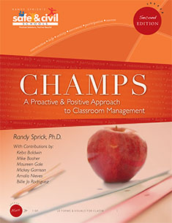
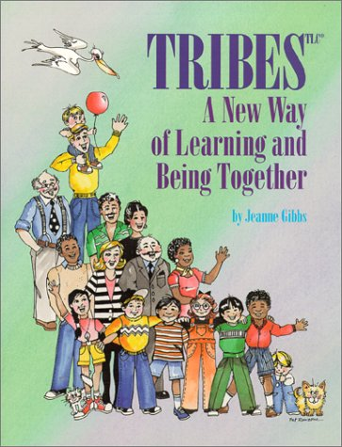

CHAMPS -

Champs premise teaches you to be intentional. Be sure as a catechist you know what you expect and then convey your expectation clearly to the youth you are working with. This ideally should be done during every transition throughout your time together, however realistically that takes a lot of time. THerefore, if you are able to intentionally explain to the students your expectations during the “Majority” Times - those times that take up the most of your class - you will be setting yourself up for success. For example -

C - Conversation Level - How Loud are your students permitted to talk?
H - Help - How do your students get help if they need it?
A - Activity - What are we doing? When Do these rule apply?
M - Movement - Where am I allowed to Move during this time
P - Participation - How Can I Participate?
S - Success - If we do all of the Above we will have success!!

TRIBES -

The TRIBES premise gives you a foundation of classroom management and teaches how to keep things interactive yet positive within the classroom. It provides opportunities for classroom lessons as well as different energizers that help the youth learn. Tribes institutes the idea of i-messages and agreements. Instead of rules - things we are told to do - we use agreements which are guidelines we all agree to in the classroom. I-messages are tools to help confront behavior that is not appreciated. An example might be I don’t like it when I see things being disrespected. This statement is fully focussed on your feelings and does not put blame on any one person, but does state how the teacher and/or student is feeling. In tribes there are 4 agreements.

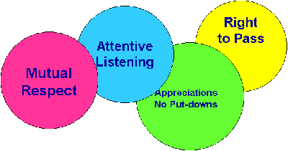

- Mutual Respect - this is we respect ourselves and others, we live out the Golden Rule.
- Attentive Listening - we listen with our eyes by looking at the speaker, we listen with our ears, and we are empathetic and listen with our hearts.
- Appreciations/No Put-Downs - we remain positive and give authentic positive feedback to each other
- Right to Pass - I have the right to not participate and pass, but I do not have the right to disrupt the class.

