Thinking Question:
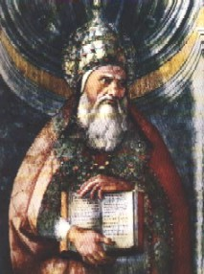
It is very important for Christians to realize the significance of the Old Testament and all that it has to teach us. An example of someone who didn’t is Marcion, who was born in 110 A.D. Marcion believed that the Old Testament was so scandalous and crude that it should be cut out of Christianity completely, and that the New Law of Christianity rendered the Old Testament void anyway. He demonstrated that God changes between the two testaments.
- Using the Catechism of the Catholic Church (paragraphs 121- 123), how does the Church respond to this way of thought? Was Marcion’s way of thinking correct? How did his thinking differ from that of the Church?
______________________________________________________________________________________________________________________________________________________________________________________________________________________________________________________________________________________________________________________________________________________________________________________________________________________________________________________________________________________________________________________________________________________________________________
__________________________________________________________________________________________________________________________________________________________________________________________

Marcion was excommunicated (which means out of communion – literally, it is when a person is not able to receive the sacraments or participate in the community) in 144 A.D. because of these beliefs.

